
IDBI APIM Platform

WebMethods APIM Installation Guide and Operations Manual

Software AG

Introduction

The purpose of the document is to describe the step by step approach for the containerization of the webMethods 10.7 product required for the APIM solution. The document covers mainly three sections.

- Setup of Reference Environment
- Webmethods Docker image creaion
- Understanding the Webmethods Kubernetes Templates
- Deployment of webMethods conatiners on Kubernetes
- Maintenance and Operations

Setup of Reference Environment

The reference environment is where the webmethods products are installed and it will act as the base for the creation of the webmethods docker images. Currently the reference environment is setup in the GITREPO SERVER (10.142.15.240).

The below webmethods products are installed in the base VM.

API Gateway Advanced (APIGW)
Integration Server (IS)
DB Configurator (DBC)
Microservices Runtime (MSR2)
Terracotta (TSA)
Universal Messaging (UM)
My Webmethods Server (MWS)

Installing APIGW (Advanced Edition)

Before running the APIGW installation. Some OS level parameters have to be set.

Login to the server 10.142.15.240 as root

Add the below in the file /etc/sysctl.conf

fs.file-max=65536
vm.max_map_count=262144

then execute sysctl -p for these changes to take effect

Update below ulimits for the user sagadmin in the file /etc/security/limits.conf

# End of file
sagadmin soft nproc 65536
sagadmin hard nproc 65536
sagadmin soft nofile 65536
sagadmin hard nofile 65536

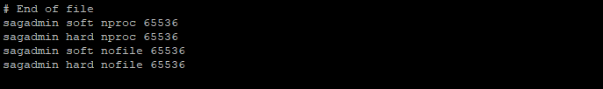
Create the user “sagadmin” in the
Create the directory /data/softwareag and change the ownership to sagadmin:sagadmin

Create the below sub directories. Ensure that the sub directories are owned by user “sagadmin” and not root

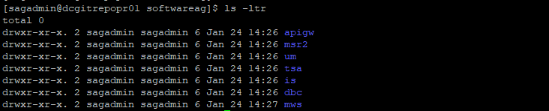
Copy the necessary product licenses, installer and SAG image to /data/binaries

Run the below command to start the installation

./SoftwareAGInstaller20210826-Linux_x86_64.bin -readImage ./SAG_Linux_10.7_x64-9SEP.zip

Follow the instruction.

When prompted for the installation directory give the below for apigw

/data/softwareag/apigw

Press enter for the host name

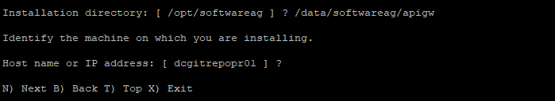
When the below list appears enter again to go the main menu.

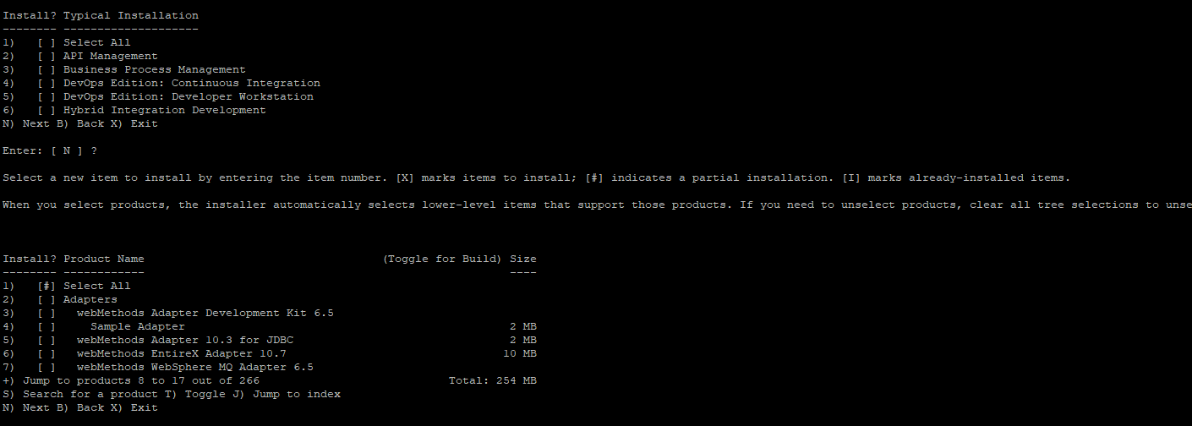
Using + and – options you can navigate through the menu.
Give + and press enter till you see the option for API Gateway
Then select the # 10 for selecting the API Gateway components
Select Y to select all the dependencies and press enter

It will select the below.
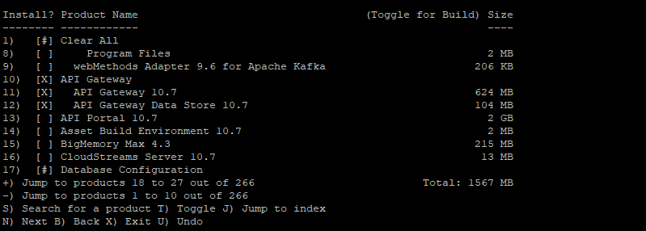
It will then show the list of fixes that will be installed along with the apigw product

Press enter and proceed

Press enter for accepting the License agreement

For sudo select N and press enter

Give the API GW advance license location

/data/binaries/licenses/Development/0000628047_APIGatewayAdvanced107.xml

Select the options as below and proceed.

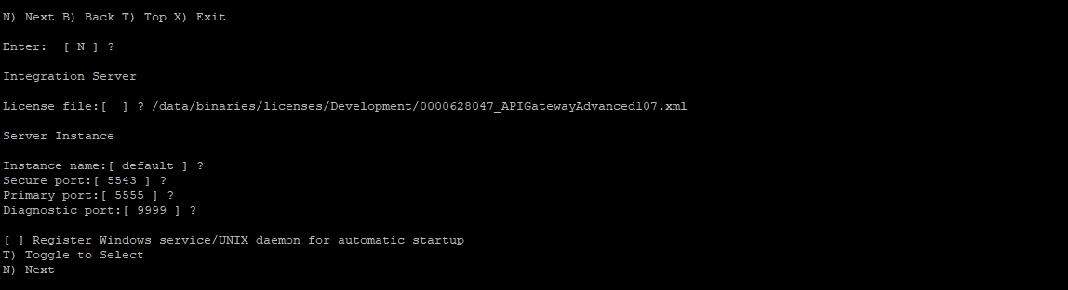

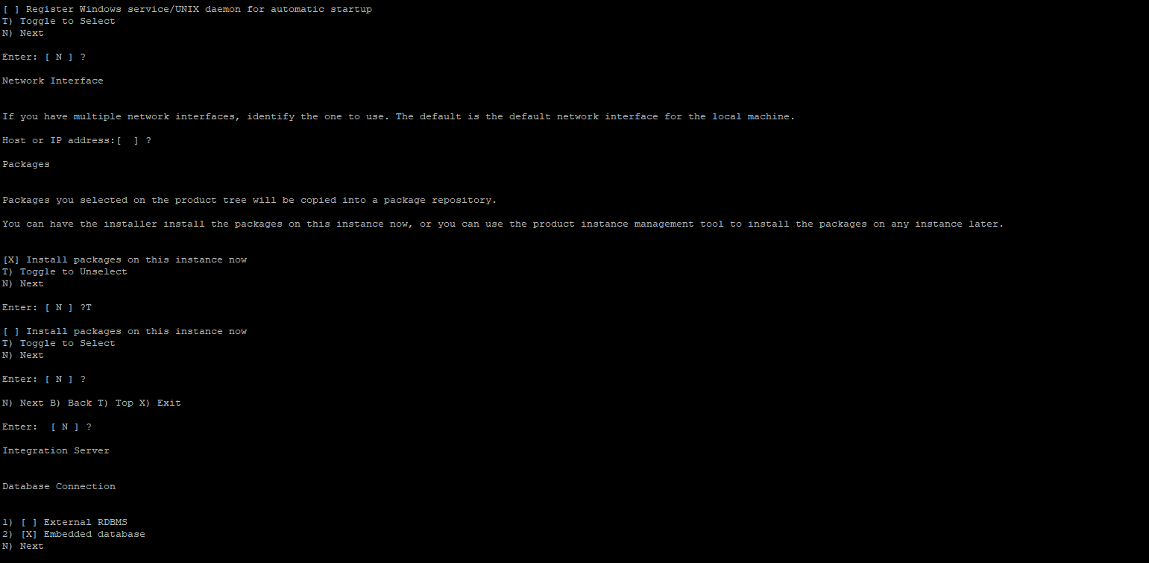
For DB select Embedded DB and proceed.

For other option proceed as per the below screen shot

Toggle to Unselect Command Central installation
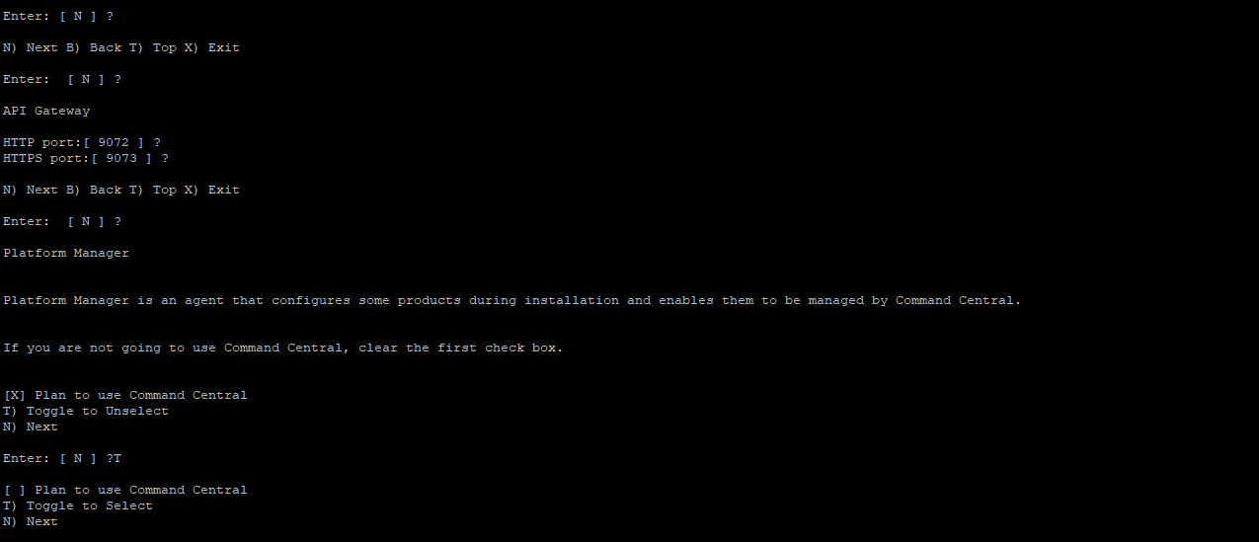

Follow the further instruction as per the screen shot below
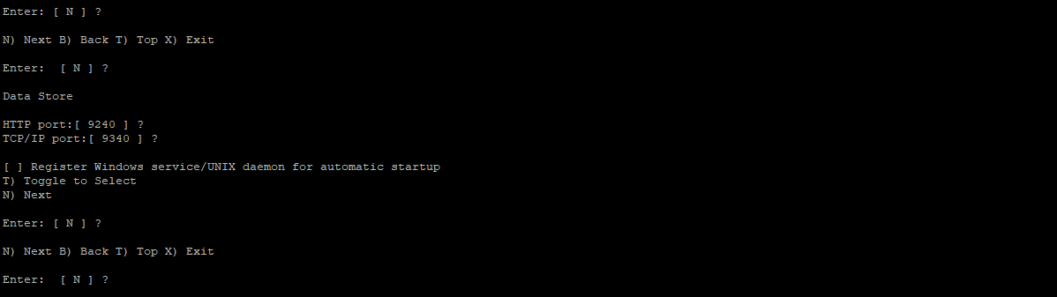
For Database choose the default option and proceed. No need to give any inputs. DB details will be configured through the Admin UI once the installation is completed.

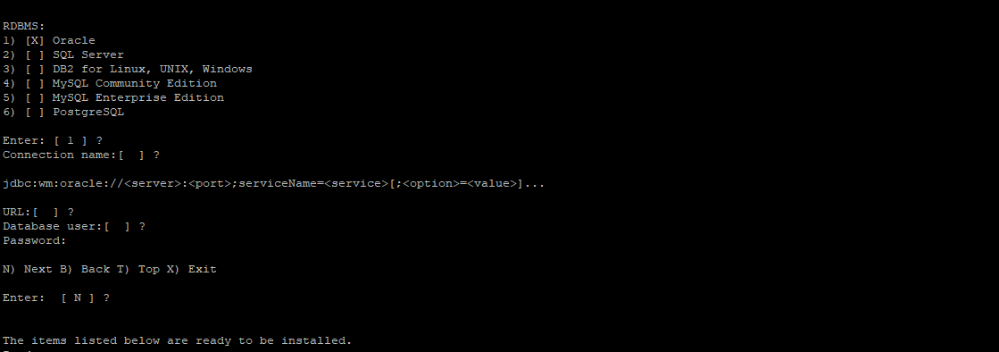
It will give the final list of products and fixes that it is going to install.

Press enter and proceed. The installer will start the installation. Wait for it to end.

Installing Integration Server (IS)

Begin the installation as per the steps mentioned in the APIGW installation by runing the SAG installer.

Go to the directory /data/binaries and execute the below command.

./SoftwareAGInstaller20210826-Linux_x86_64.bin -readImage ./SAG_Linux_10.7_x64-9SEP.zip

Ensure that both the installer file SoftwareAGInstaller20210826-Linux_x86_64.bin and the image file SAG_Linux_10.7_x64-9SEP.zip are copied to the /data/binaries

Give the Installation directory as /data/softwareag/is and follow the remaining instruction as per the screen shot below.

Installation Directory for IS: /data/softwareag/is
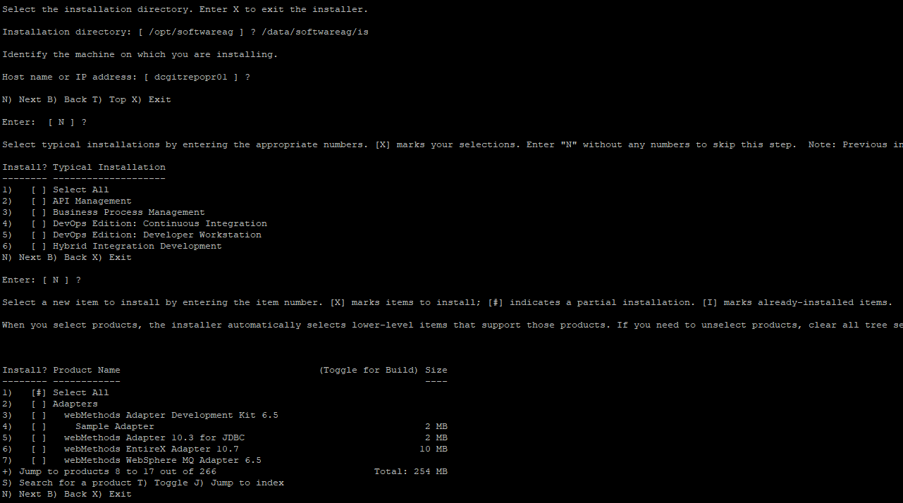
Navigate the product menu by typing + and pressing enter till you see the below option.

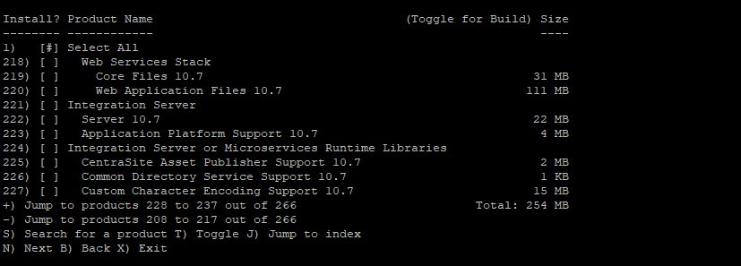
Select option 221 and press enter. Choose Y for selecting all the dependencies, along the core Integration Server product.

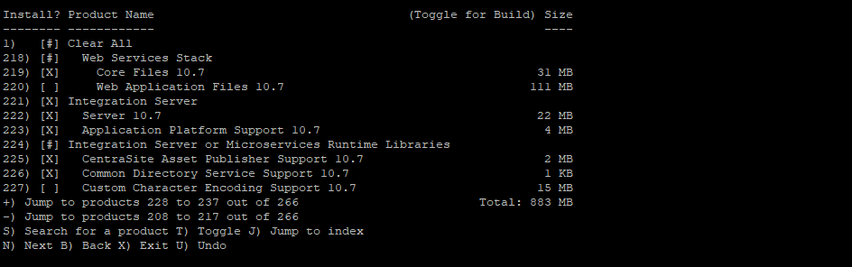
Now enter – and go back to the start of the Menu to select the Adapter.

- [ ] webMethods Adapter 10.3 for JDBC 2 MB

Enter # 5 and press enter to select the JDBC Adapter

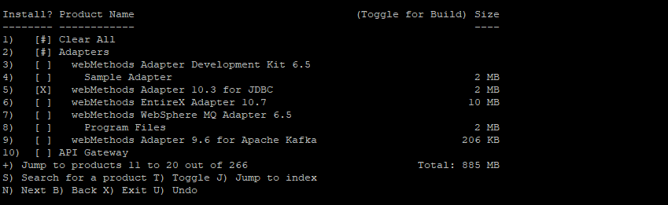

Press enter. It will show the list of Fixes that will get installed along with the product

Select Y to choose the License agreement

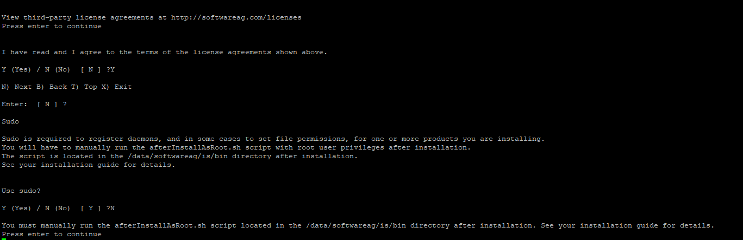
IS License: /data/binaries/licenses/Development/0000628050_Integration_Server100.xml

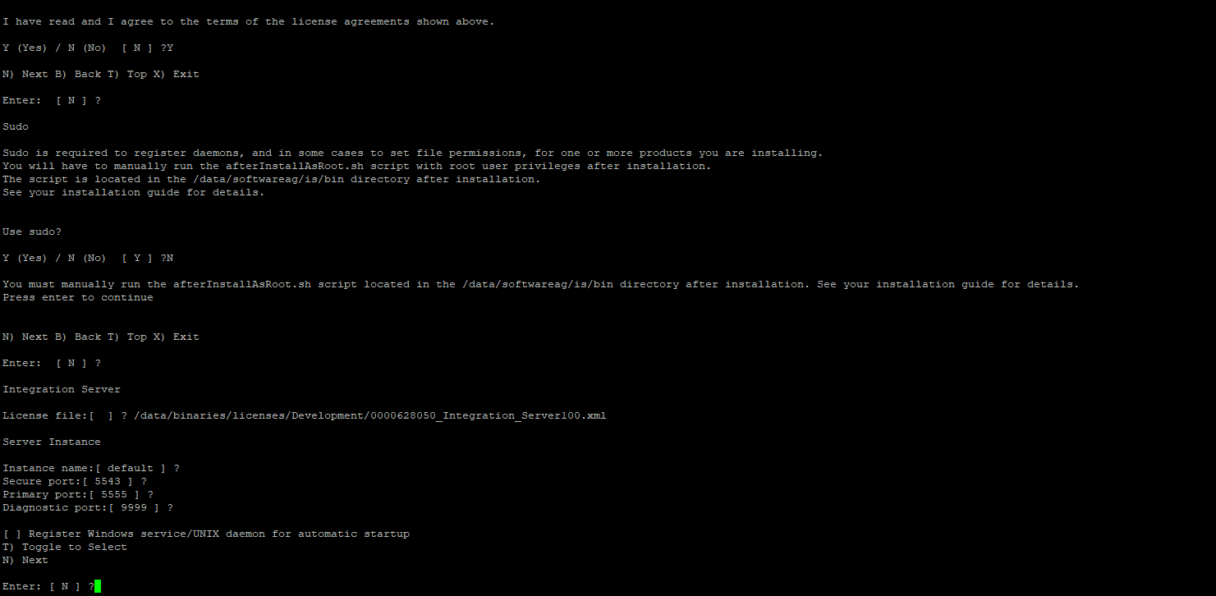

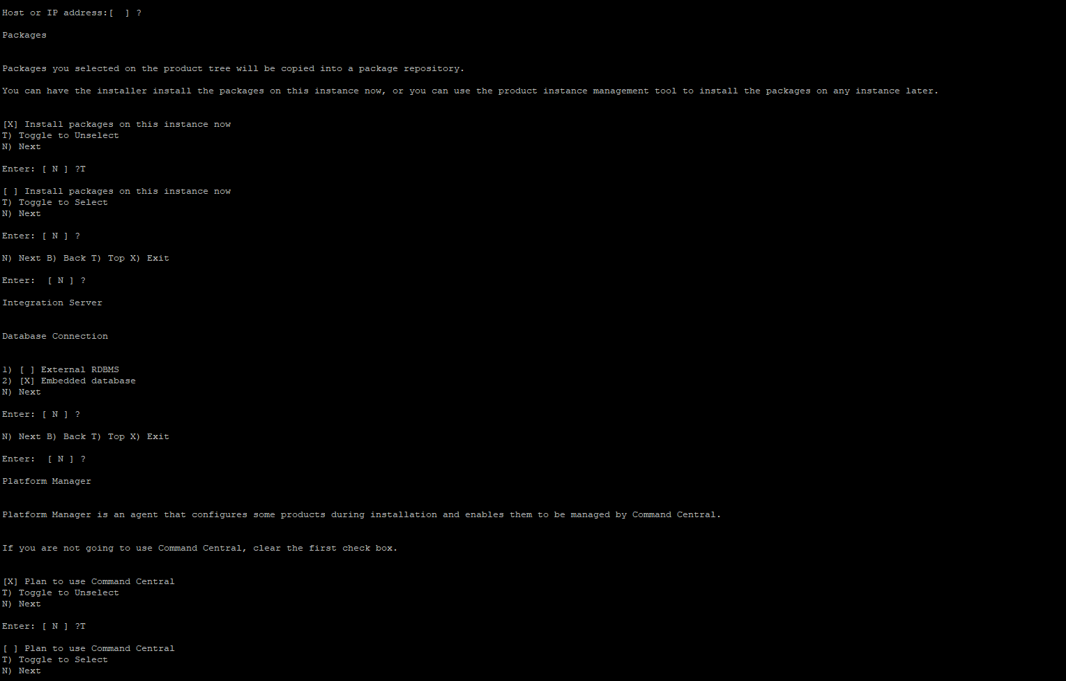
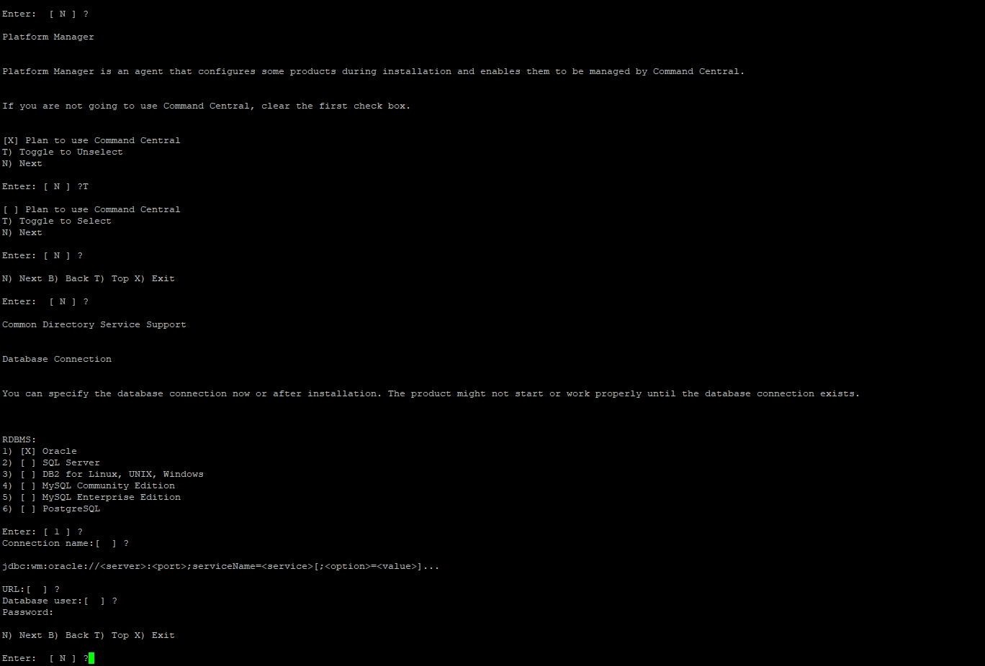

Once all the options are selected as above. The installer will list the products, dependencies and fixes that it will install for the Integration Server. Please wait for the installation to complete.

Installing DB Configurator (DBC)

Begin the installation as per the steps mentioned in the APIGW installation by runing the SAG installer.

Go to the directory /data/binaries and execute the below command.

./SoftwareAGInstaller20210826-Linux_x86_64.bin -readImage ./SAG_Linux_10.7_x64-9SEP.zip

Ensure that both the installer file SoftwareAGInstaller20210826-Linux_x86_64.bin and the image file SAG_Linux_10.7_x64-9SEP.zip are copied to the /data/binaries

Give the Installation directory as /data/softwareag/dbc and following the remaining instruction as per the screen shot below.

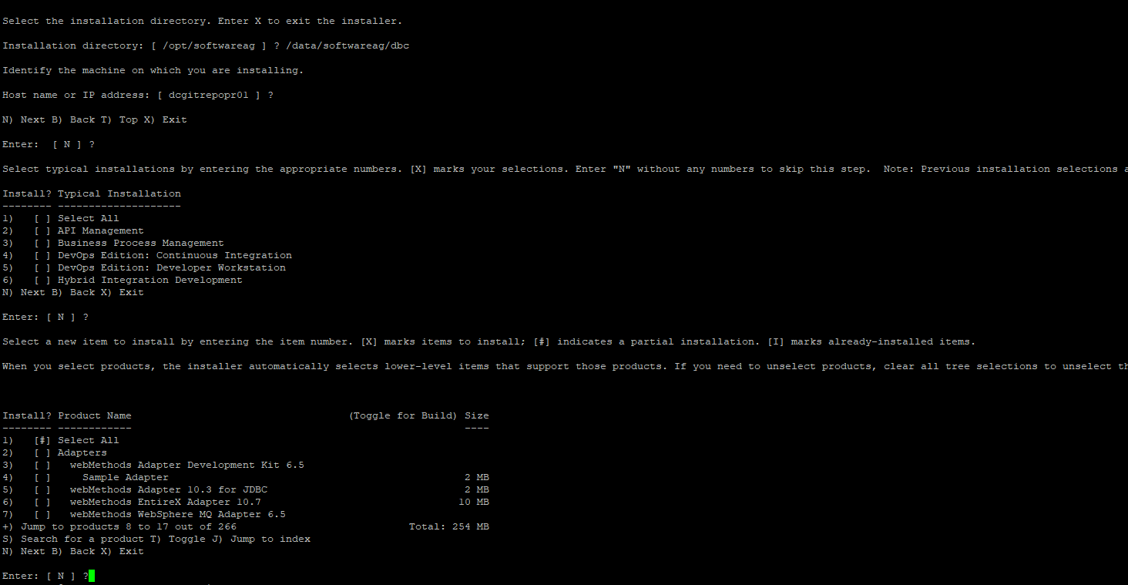
Give the + option and enter till you see the Product
- [ ] Database Configuration

Select the option 17 and press enter

It select all the other product dependencies. Select Y and continue

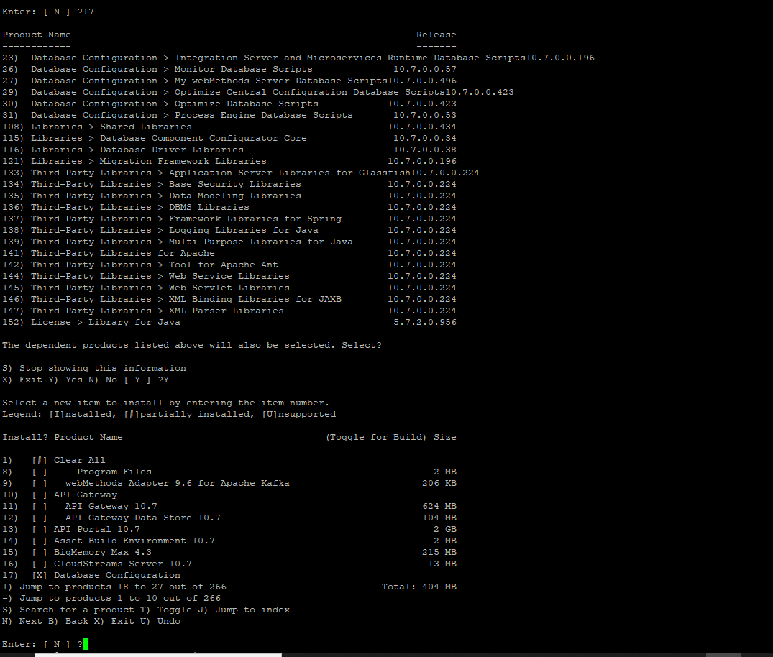
Now the Database Configuration product will be selected.

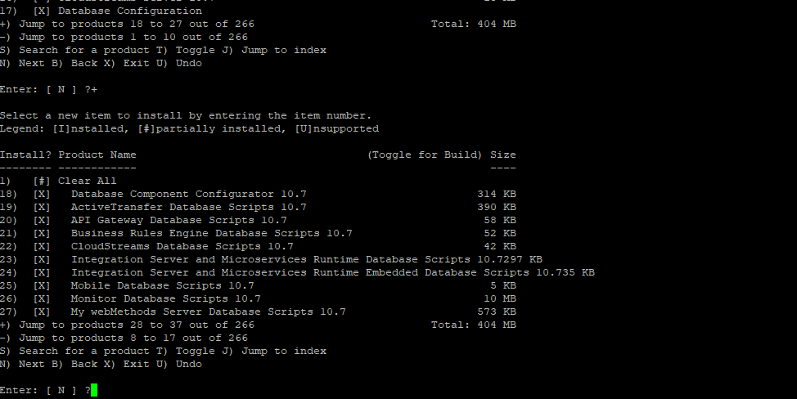
Follow the instruction and select Y to agree with the license agreement
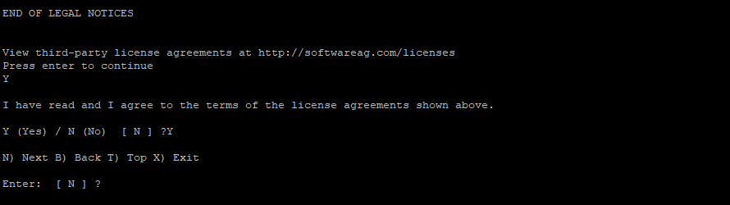
It will list all the products to be installed and followed by the fixes.

Press enter and the installation will begin.

Installing Microservices Runtime (MSR)

Begin the installation as per the steps mentioned in the APIGW installation by runing the SAG installer.

Go to the directory /data/binaries and execute the below command.

./SoftwareAGInstaller20210826-Linux_x86_64.bin -readImage ./SAG_Linux_10.7_x64-9SEP.zip

Ensure that both the installer file SoftwareAGInstaller20210826-Linux_x86_64.bin and the image file SAG_Linux_10.7_x64-9SEP.zip are copied to the /data/binaries

Give the Installation directory as /data/softwareag/msr2 and follow the remaining instruction as per the screen shot below.

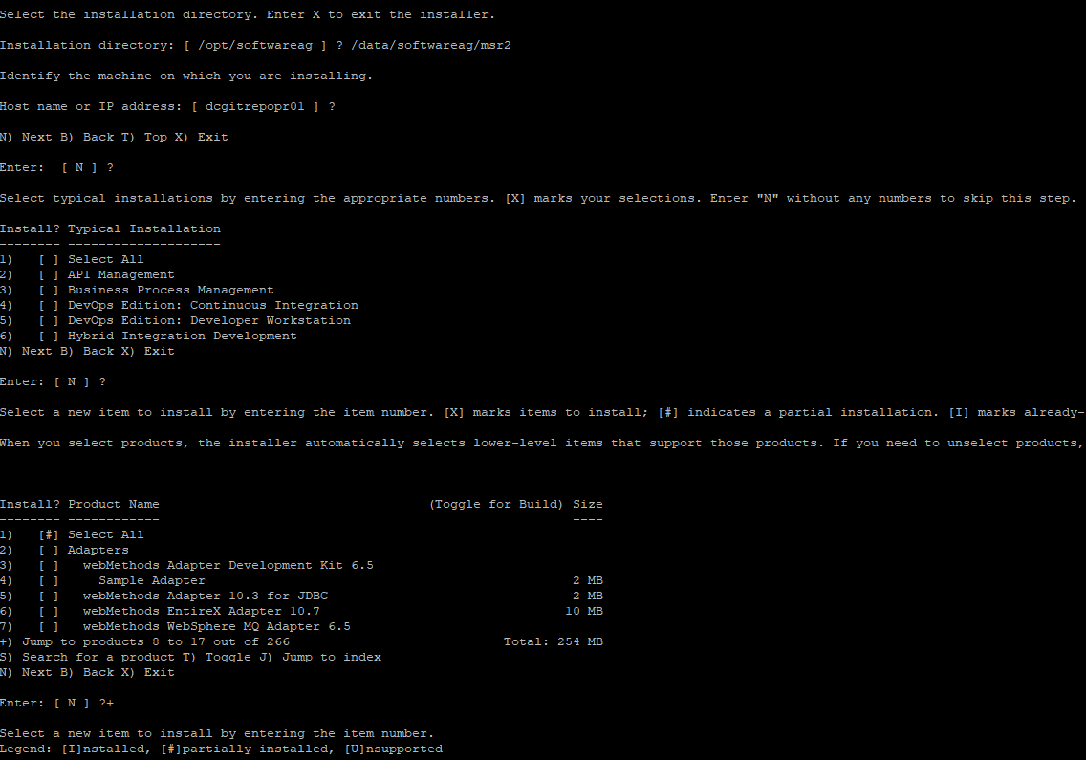

Navigate through the menu by entering + and press enter till you see the option

242) [ ] Microservices Runtime 10.7 1 MB

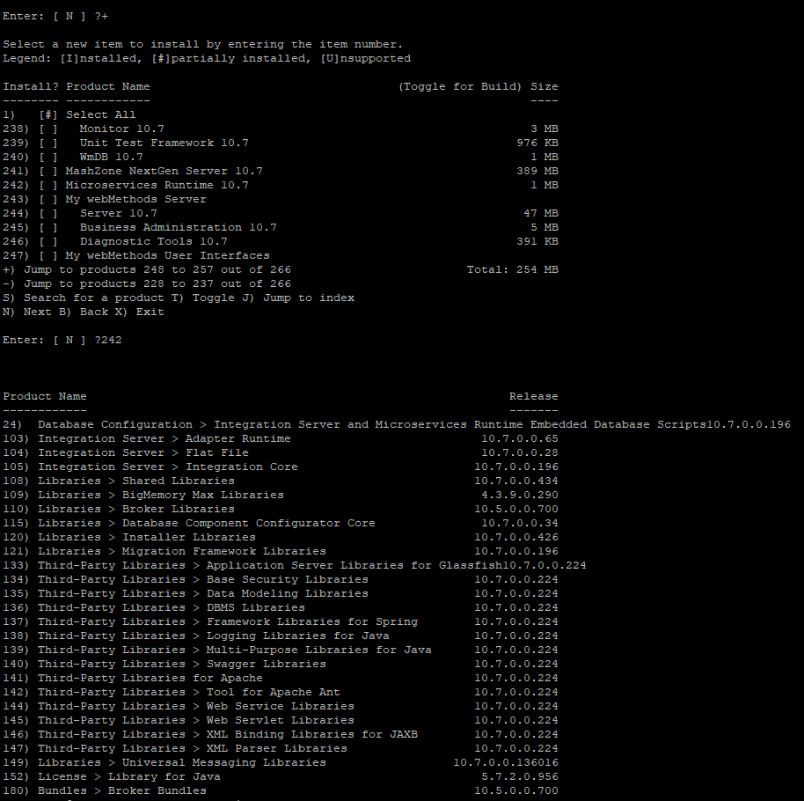
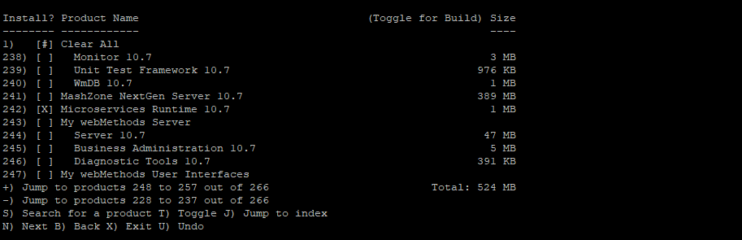
Now enter – and navigate back to the start of the menu to select the Adapters

- [ ] webMethods Adapter 10.3 for JDBC 2 MB
Enter # 5 and proceed.
Now select the below option to select the MQ Adapter.

- [ ] webMethods WebSphere MQ Adapter 6.5

In both the cases it will select the additional dependent product. Once both adapter are selected it will appear as below.

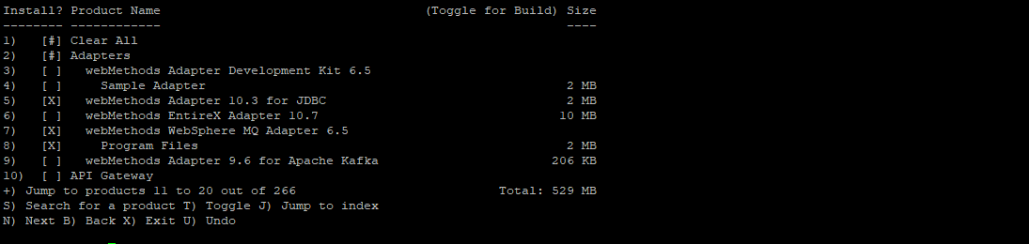

Press enter and proceed. The installer will select all the Fixes that needs to be installed along with the product

Follow rest of the instructions.

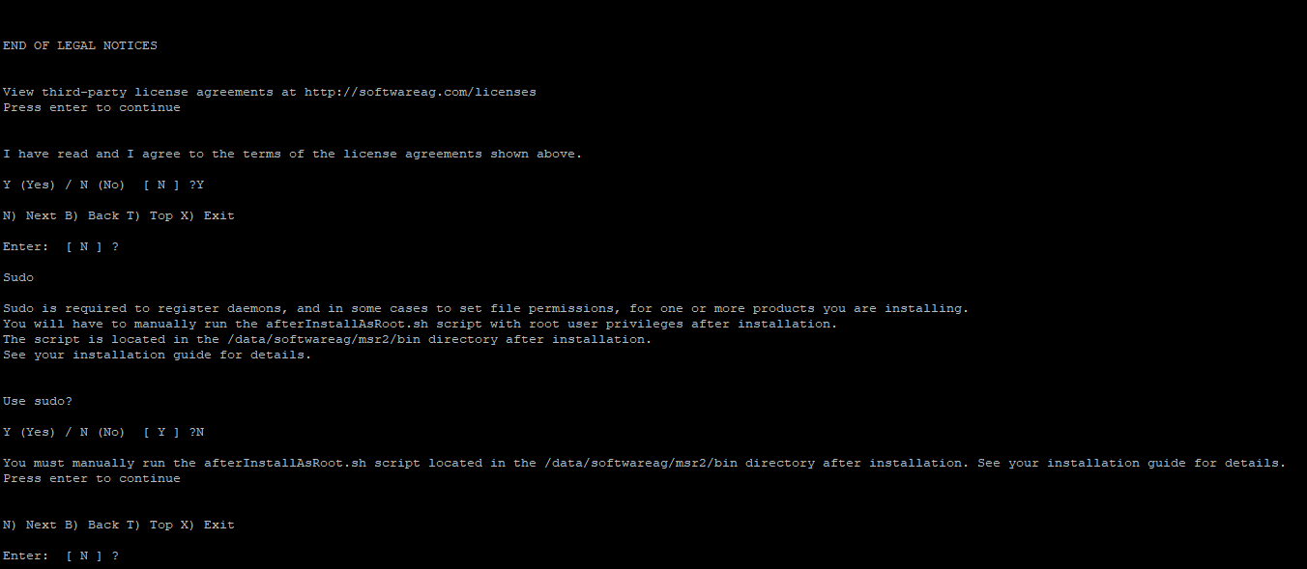
Select the License file /data/binaries/licenses/Development/0000628044_MicroservicesRuntime_100.xml
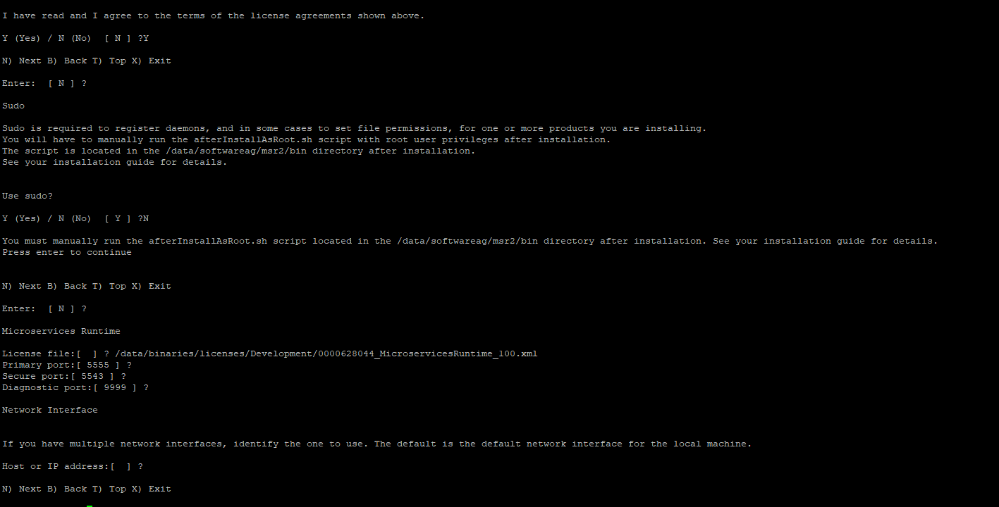
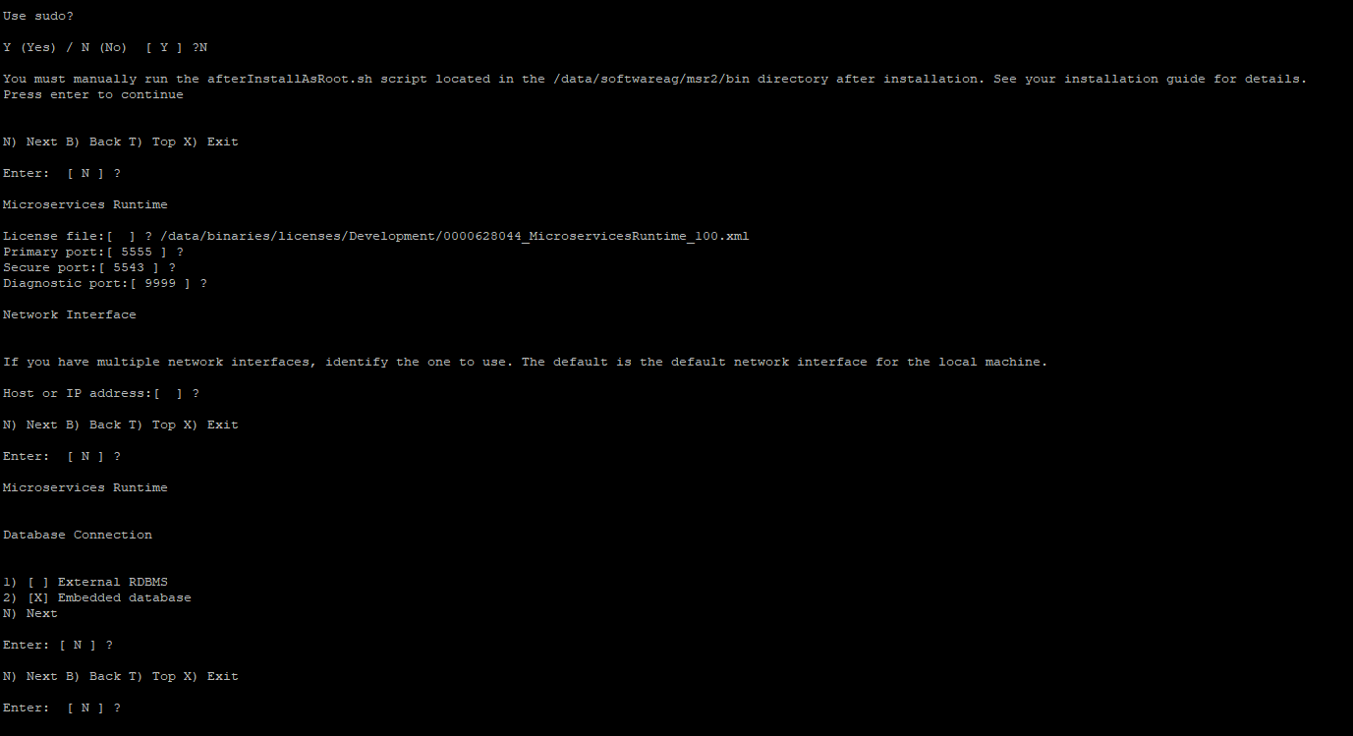
It will give the list of Products and Fixes to be installed.

Press enter and it will start the installation of the product.

Installing Terracotta (TSA)

Begin the installation as per the steps mentioned in the APIGW installation by runing the SAG installer.

Go to the directory /data/binaries and execute the below command.

./SoftwareAGInstaller20210826-Linux_x86_64.bin -readImage ./SAG_Linux_10.7_x64-9SEP.zip

Ensure that both the installer file SoftwareAGInstaller20210826-Linux_x86_64.bin and the image file SAG_Linux_10.7_x64-9SEP.zip are copied to the /data/binaries

Give the Installation directory as /data/softwareag/tsa and follow the remaining instruction as per the screen shot below.

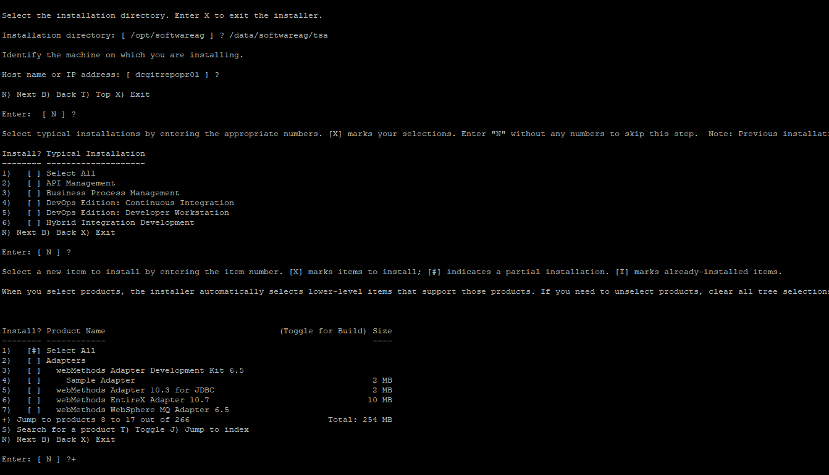
Navigate through the Menu by entering + and press enter till you see the below option.

- [ ] BigMemory Max 4.3 215 MB

Select 15 and press enter. Installer will select all the product dependencies. Follow the instruction and accept the license agreement and continue

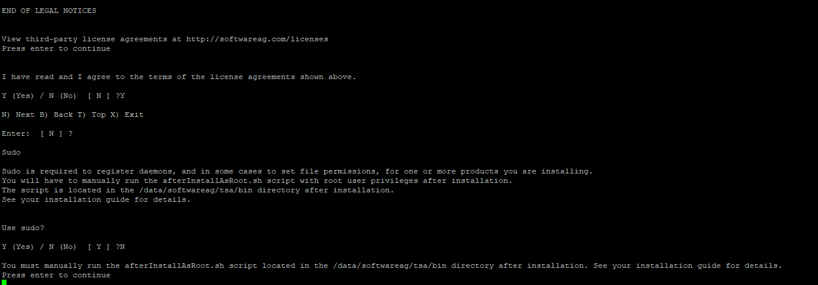
Toggle to unselect the Command Central installation

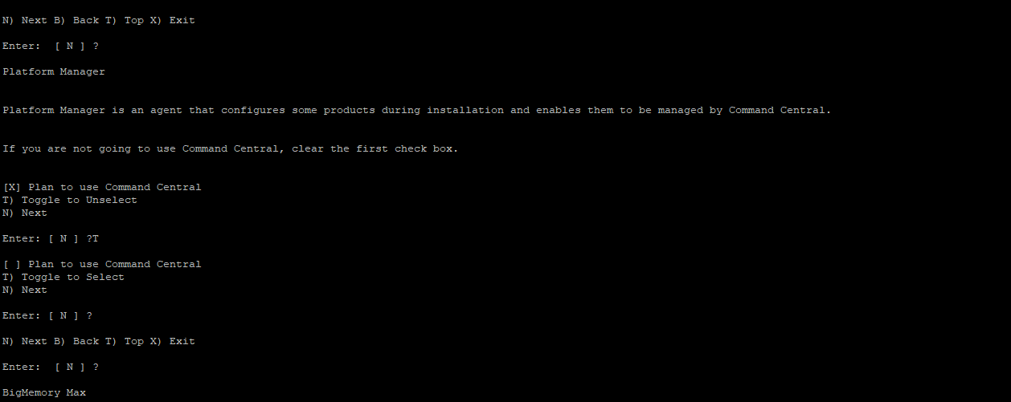
Give the terracotta license path.

/data/binaries/licenses/Development/terracotta-license.key

It will show the final list of products and fixes that will be installed.

Press enter and the installation would begin. Wait for installation to complete.

Installing Universal Messaging (UM)

Begin the installation as per the steps mentioned in the APIGW installation by runing the SAG installer.

Go to the directory /data/binaries and execute the below command.

./SoftwareAGInstaller20210826-Linux_x86_64.bin -readImage ./SAG_Linux_10.7_x64-9SEP.zip

Ensure that both the installer file SoftwareAGInstaller20210826-Linux_x86_64.bin and the image file SAG_Linux_10.7_x64-9SEP.zip are copied to the /data/binaries

Give the Installation directory as /data/softwareag/um and follow the remaining instruction as per the screen shot below.

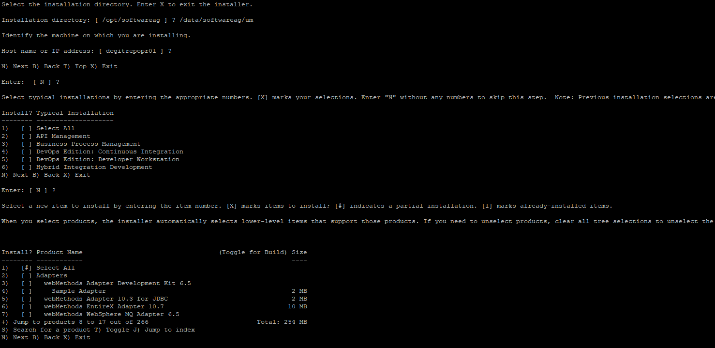
Navigate through the Menu by entering + and press enter untill you see the below option

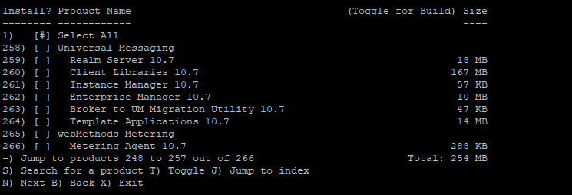
258) [ ] Universal Messaging

Select the #258 and press enter.

It will select all the product dependencies. Enter Y and press enter to continue.

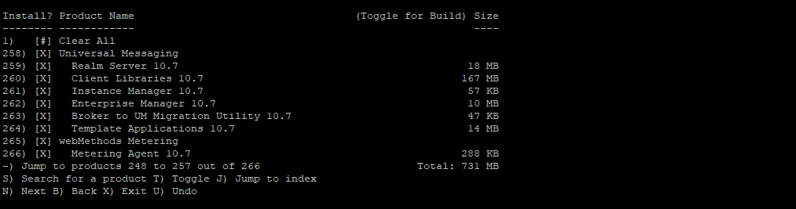

Press enter and it will list all the products the installer will install. Press enter to continue

Agree to the license agreement by selecting Y

Toggle to unselect the Command Central installation

Press enter. Select the Purpose as “ New installation” and press enter

Give the UM license file /data/binaries/licenses/Development/0000628052_UniversalMessaging_Integration105.xml

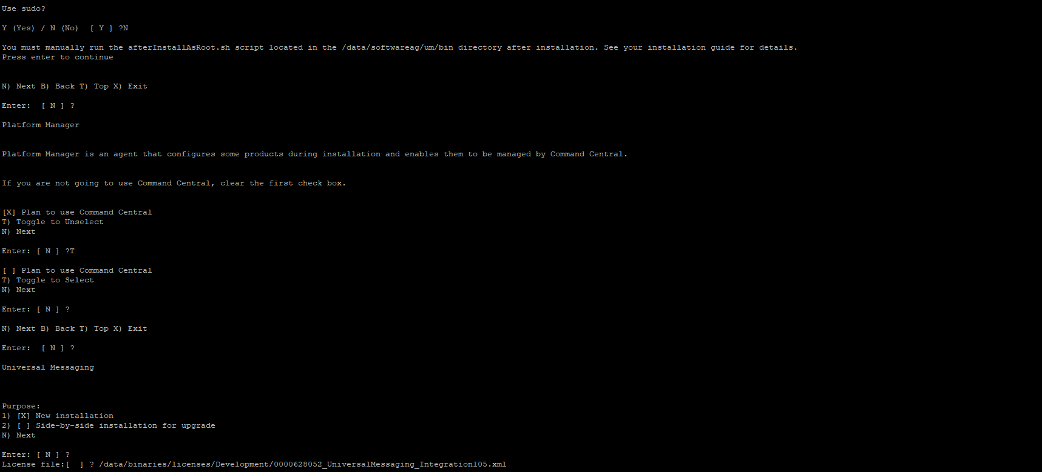
Follow the further instruction as per the screen shot below.

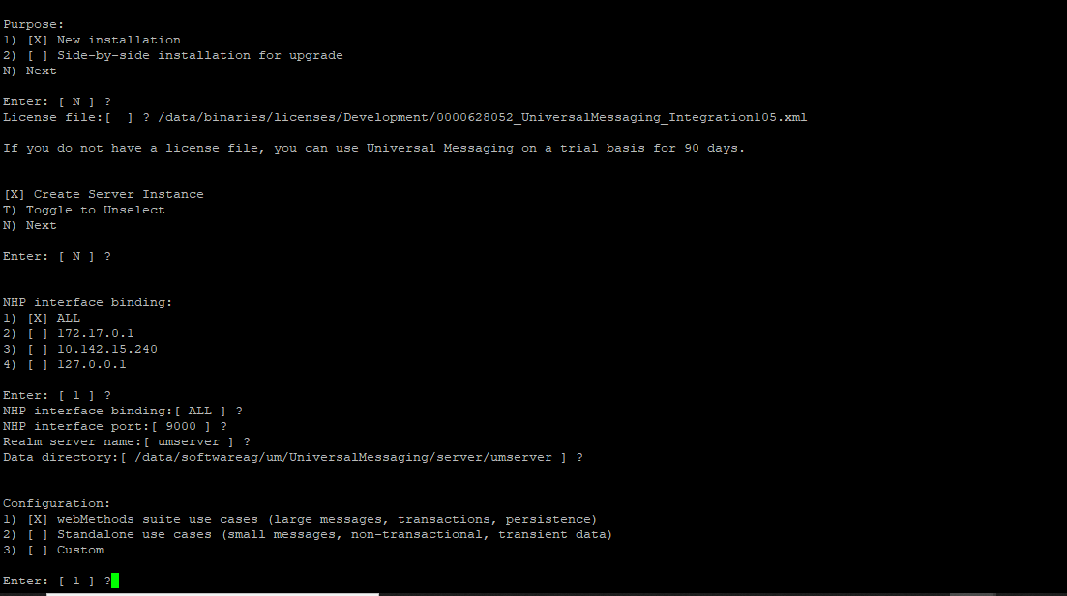
It gives the final list of products to be installed. Press enter to continue and the installation would begin. Wait for the installation to complete.

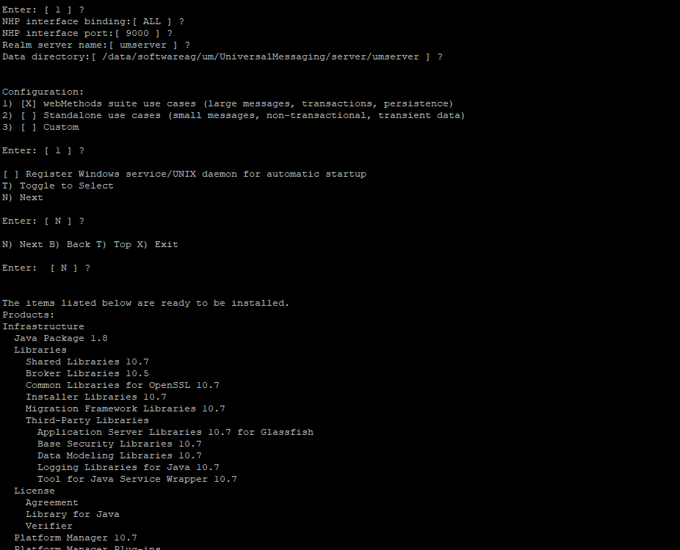

Installing My Webmethods Server (MWS)

Begin the installation as per the steps mentioned in the APIGW installation by runing the SAG installer.

Go to the directory /data/binaries and execute the below command.

./SoftwareAGInstaller20210826-Linux_x86_64.bin -readImage ./SAG_Linux_10.7_x64-9SEP.zip

Ensure that both the installer file SoftwareAGInstaller20210826-Linux_x86_64.bin and the image file SAG_Linux_10.7_x64-9SEP.zip are copied to the /data/binaries

Give the Installation directory as /data/softwareag/mws and follow the remaining instruction as per the screen shot below.

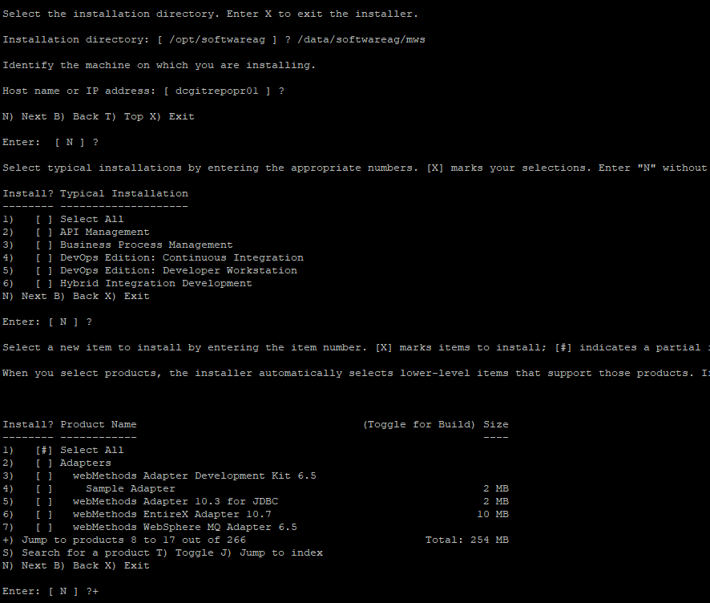
Navigate through the Menu by enterning + and press enter till you see the below product

243) [ ] My webMethods Server

Select the #243 and then select the dependencies by entering Y and press enter

then select the product

247) [ ] My webMethods User Interfaces

Below products should be finally selected

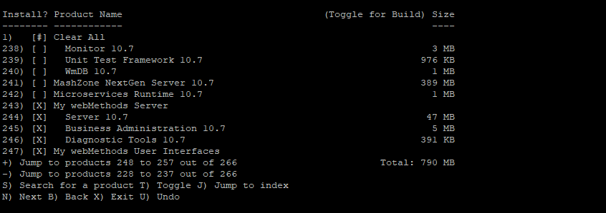
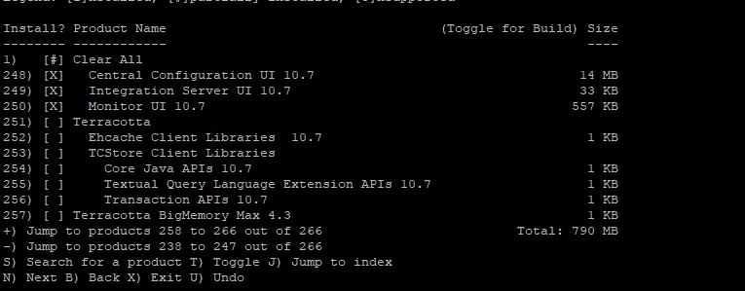
Press enter and proceed. It will list all the fixes that will be installed along with the product

Accept the license agreement and proceed

Follow the rest of the instructions as below.

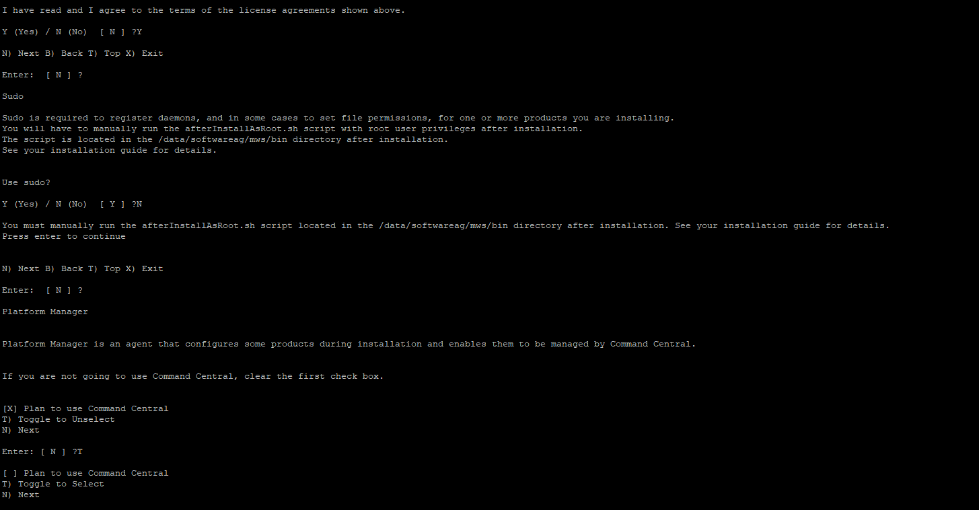
Toggle to unselect the Command Central installation

Follow rest of the instruction as per the screen shot below

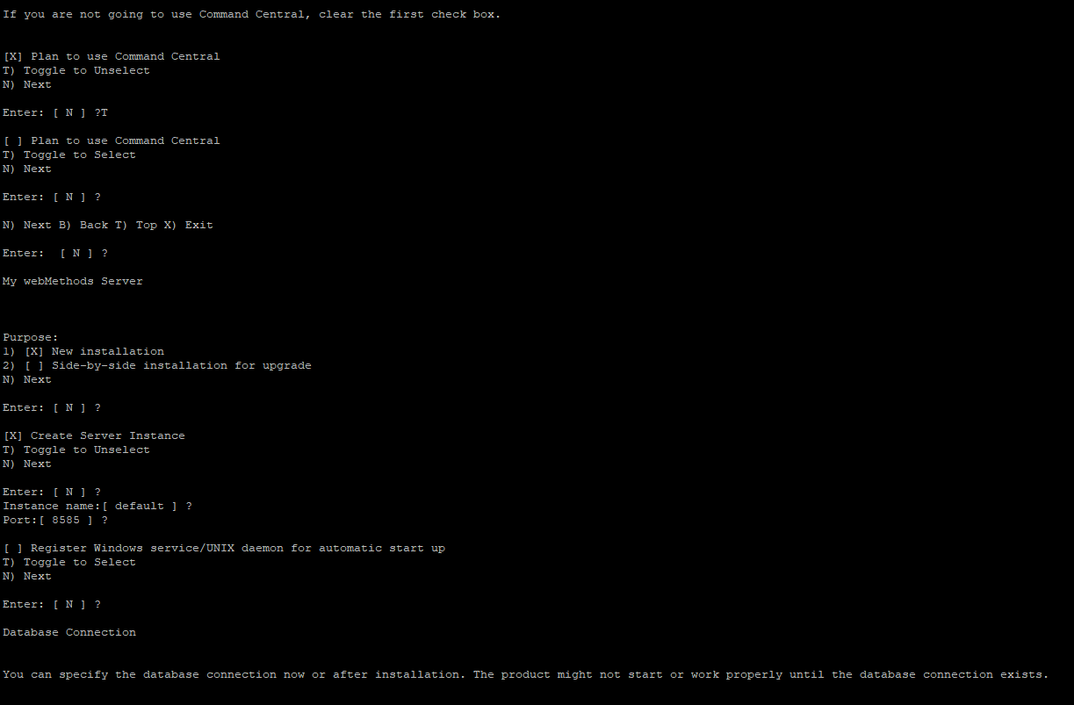
For MWS you need to provide the reference DB MWS schema during the setup so that the MWS can be initialized after the installation

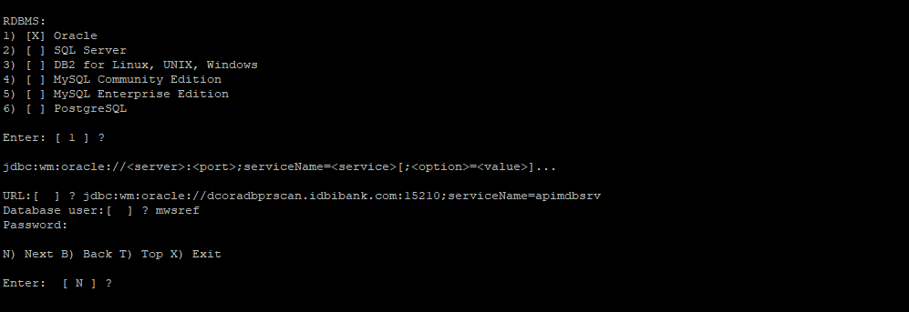
Press enter the installation for the MWS will begin. Wait for the installation to complete.

Once the installation is completed. You can bring up the IS and create the JDBC pool connection for MWSUser and ISInternal and then bring down the IS. Since IS, MSR and APIGW IS all uses the same port, for updating the JDBC pool connection for MSR and APIGW IS you will have do it one by one

Webmethods Docker Image Creation

Once the product installation is completed. We will then be able to create the Docker images for the installed product namely APIGW, IS, DBC, UM, MWS, TSA and MSR

There are two steps mainly involved here.

- Generating the Dockerfile
- Creating the Docker image from the generated Dockerfile

For APIGW, IS, MWS and MSR components the Dockerfile has to be generated using the out of box scripts.

For TSA the Dockerfile is installed as part of the Productinstallation

For DBC there are no scripts created as part of the installation and hence the Dockerfile is created manually. However, the Dockerfile placed in the reference server (10.142.15.240) in the DBC installation directory can be used to create the DBC Docker image.

Generating the APIGW Dockerfile and Docker image

Since, APIGW runs on the Integration Server you will have to first create the Dockerfile and docker image of the IS.

Use the IS base image created in the earlier step to generate the Dockerfile for APIGW and then create the APIGW docker image

Login to the GIT REPO server with the user “sagadmin”

Go to the APIGW base installation in the GIT REPO server.

cd /data/softwareag/apigw/IntegrationServer/docker
./is_container.sh createDockerfile -Dimage.name=centos:hardened
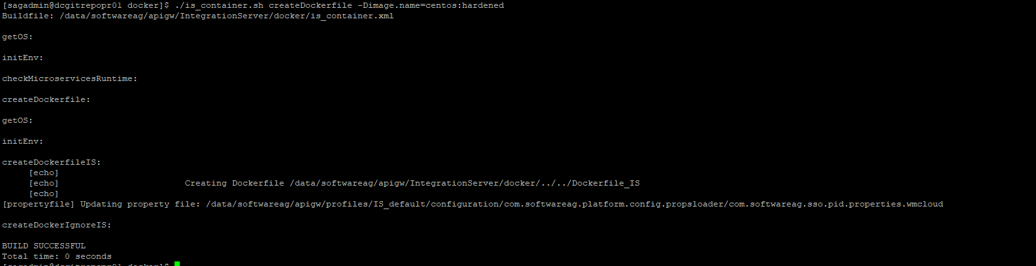
This generates the Dockerfile_IS in the root installation directory of APIGW under /data/softwareag/apigw

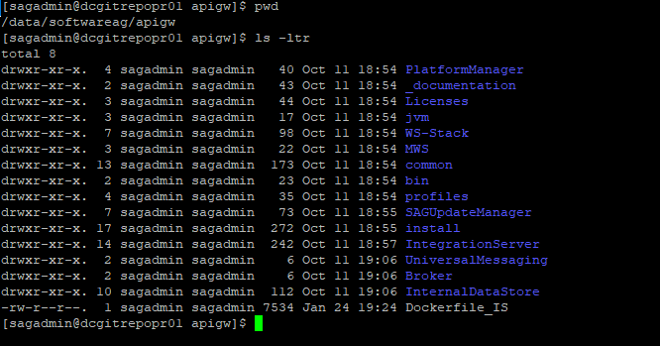
Now generate the APIGW_IS image using this docker file and using the below command

cd /data/softwareag/apigw/IntegrationServer/docker

./is_container.sh build -Dimage.name=apigw_is_image:v1.0

-Dimage.name – This is the property using which can create the base APIGW IS image. The name provided here is only for your reference and you can use the appropriate along with the tag. Never use the tag name as latest as part of the best practices

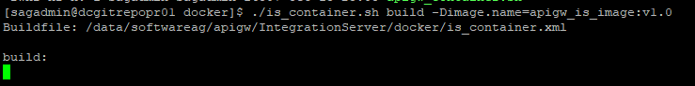
It starts building the APIGW IS docker image. Wait for the image creation to trigger. This would take few minitues to start building the image.

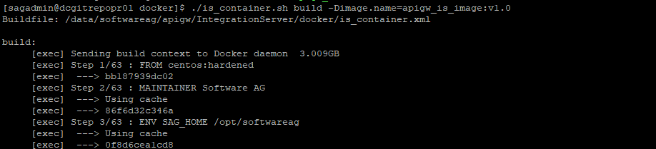

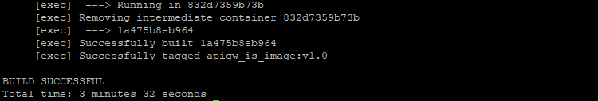
Now, execute the below to create the Dockerfile and Docker image for APIGW.

cd /data/softwareag/apigw/IntegrationServer/docker

./apigw_container.sh createDockerfile --base.image apigw_is_image:v1.0 --extern.ES

The base image name should the Docker image name that was created in the previous step

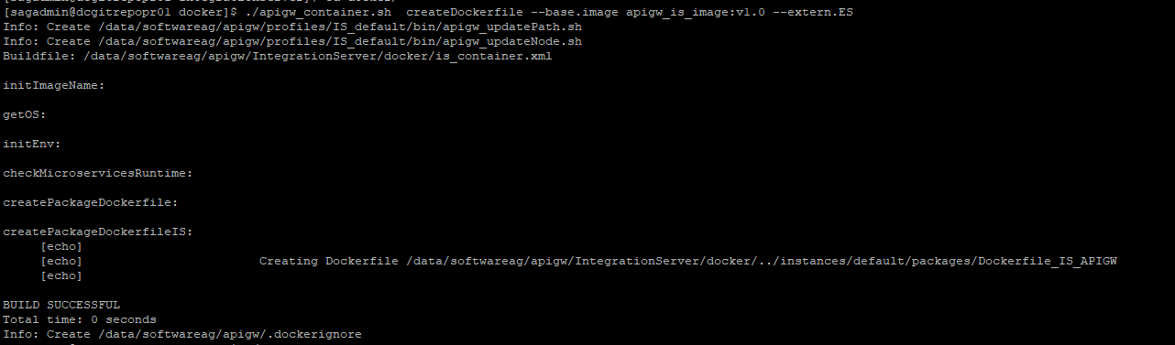

Since, we are using the external OSS version of Elastic Search and Kibana, the flag --extern.ES ensures that the bundled InternalDatastore (internal ES) and Kibana is ignored during the APIGW image creation.

This generates the APIGW Dockerfile Dockerfile_IS_APIGW in the location

/data/softwareag/apigw/IntegrationServer/instances/default/packages

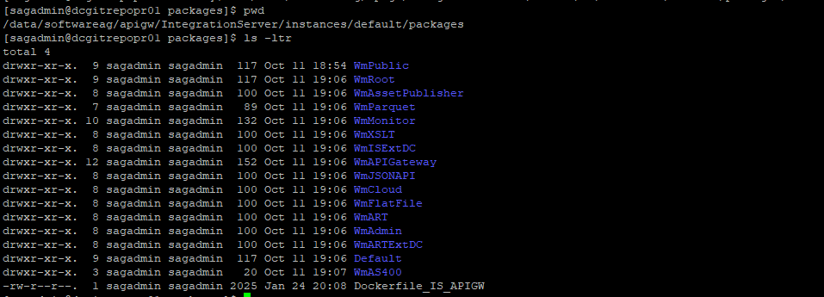
Execute the below command to create the final APIGW docker image

cd /data/softwareag/apigw/IntegrationServer/docker
./apigw_container.sh build --image.name apigw_image:v1.0

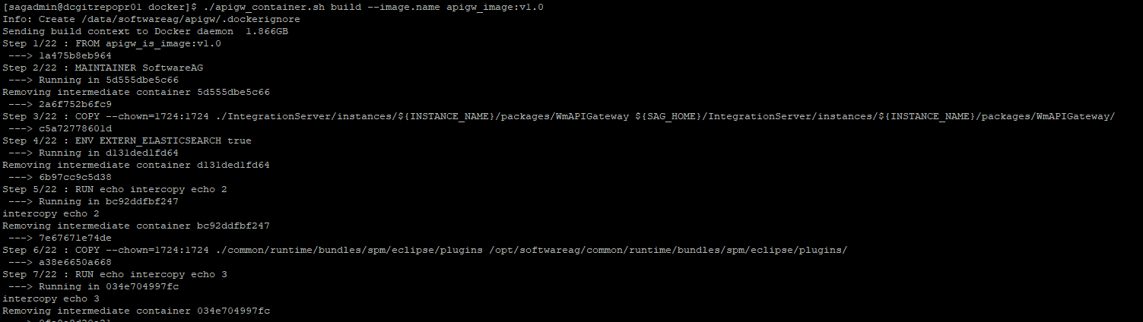
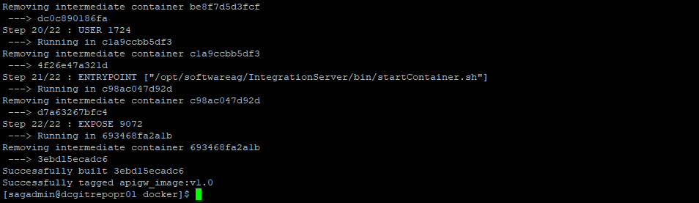
Note the docker image name is only for illustration purpose. You can create the docker image with the appropriate naming convention

Generating the IS Dockerfile and Docker image

Login to the GIT REPO server with the user “sagadmin”

Go to the IS base installation in the GIT REPO server.

Execute the below to generate the IS Dockerfile

cd /data/softwareag/is/IntegrationServer/docker
./is_container.sh createDockerfile -Dimage.name=ubi:hardened

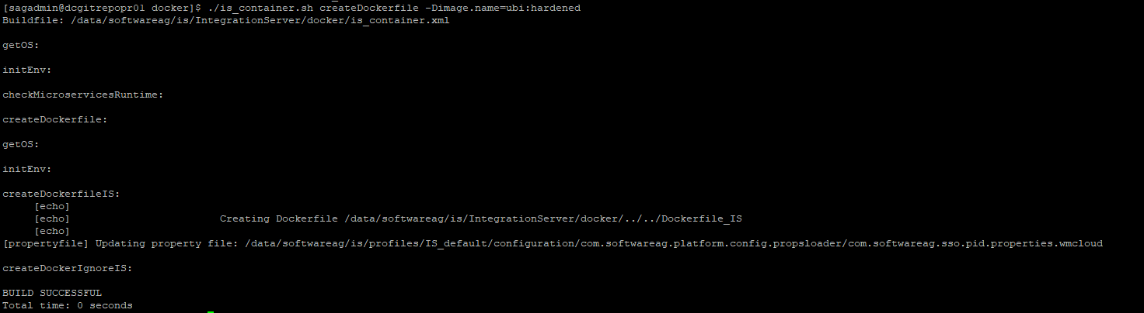
The IS Dockerfile will be generated in /data/softwareag/is

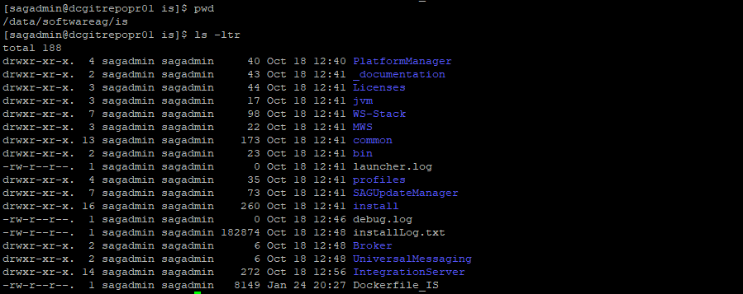
Execute the below command to create the IS Docker image.

Note the docker image name is only for illustration purpose. You can create the docker image with the appropriate naming convention

./is_container.sh build -Dimage.name=is_image:v1.0

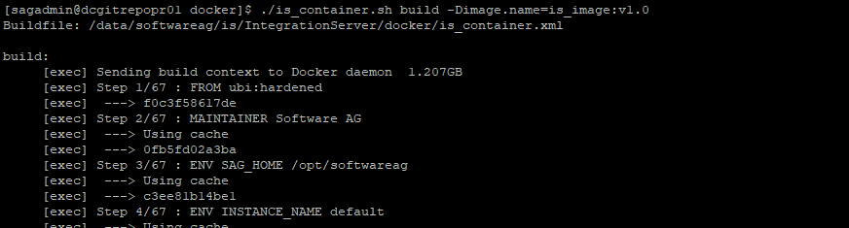

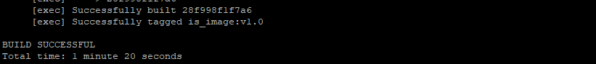

Generating the MSR Dockerfile and Docker image

Since, the MSR is the lighter version of the IS. The image creation procedure for MSR is same as that of IS. You only need to change the image name. Rest of the commands remain the same.

Login to the GIT REPO server with the user “sagadmin”

Go to the MSR base installation in the GIT REPO server.

Execute the below to generate the MSR Dockerfile

cd /data/softwareag/msr2/IntegrationServer/docker
./is_container.sh createDockerfile -Dimage.name=ubi:hardened

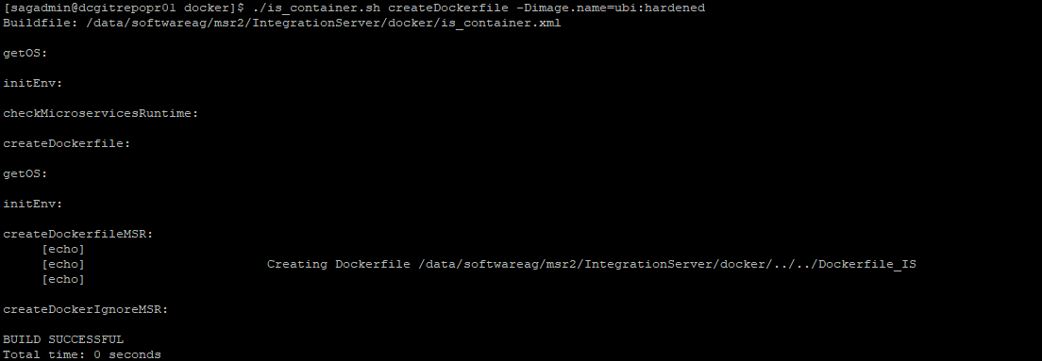
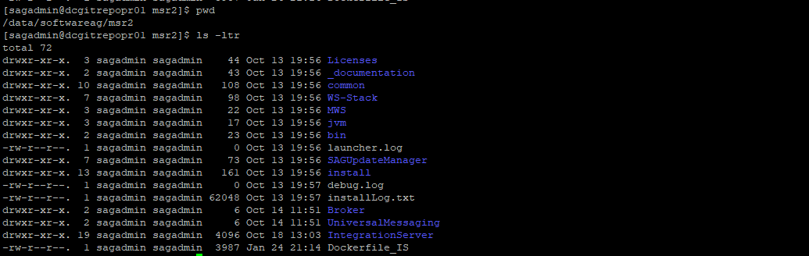
Execute the below command for creating the MSR docker image.

cd /data/softwareag/msr2/IntegrationServer/docker

./is_container.sh build -Dimage.name=msr_image:v1.0

Note the docker image name is only for illustration purpose. You can create the docker image with the appropriate naming convention.

Generating the MWS Dockerfile and Docker image
Login to the GIT REPO server with the user “sagadmin”

Go to the MWS base installation in the GIT REPO server.

Execute the below to generate the MWS Dockerfile

cd /data/softwareag/mws/MWS/tools/docker/bin

./mws-docker.sh createDockerfile -Dimage.name=centos:hardened

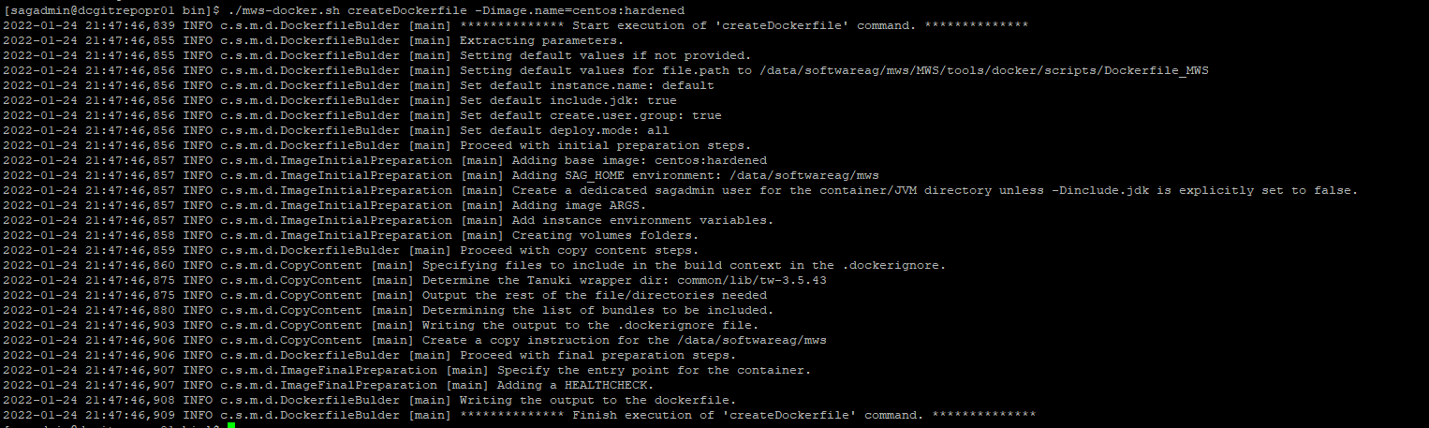
The MWS Dockerfile will be created in the location

/data/softwareag/mws/MWS/tools/docker/scripts

Once the Dockerfile_MWS file is created please add the below additional instruction in the file

RUN mkdir -p $CONFIGS_DIR/profile_cfg $CONFIGS_DIR/cluster_cfg $CONFIGS_DIR/assets_cfg $CONFIGS_DIR/instance_cfg $CONFIGS_DIR/jvm_cfg && chown -R 1724:1724 $CONFIGS_DIR
COPY --chown=1724:1724 ./MWS/server/default/config/deployMap.properties $VOLUMES_DIR/data

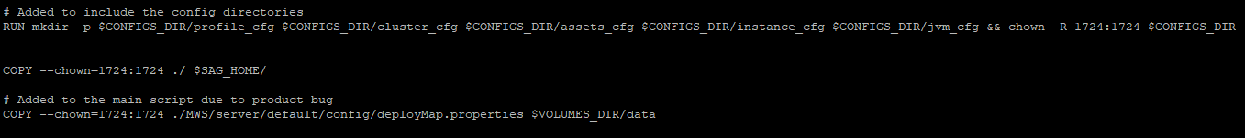
Execute the below command to create the MWS Docker image

Note the docker image name is only for illustration purpose. You can create the docker image with the appropriate naming convention.

cd /data/softwareag/mws/MWS/tools/docker/bin

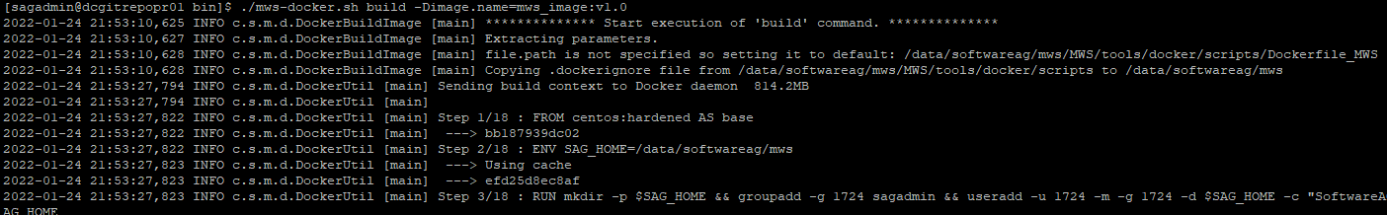
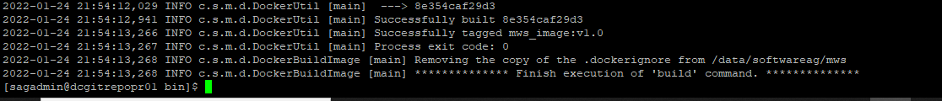

Generating the DBC Docker image

As mentioned before, DBC Dockerfile is not part of the Product installation. Hence, the below DBC Dockerfile script has to be used for the DBC docker image creation.

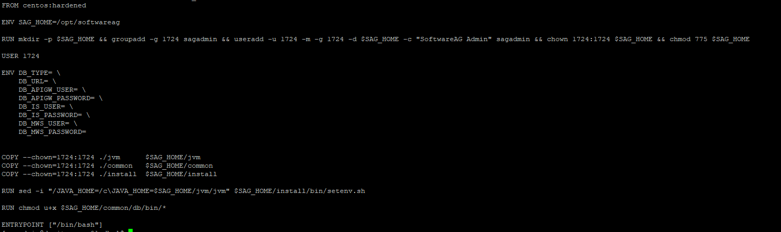

Login to the GIT REPO server with the user “sagadmin”

Go to the DBC base installation in the GIT REPO server.

cd /data/softwareag/dbc

The Dockerfile_DBC file is placed in this location.

Execute the standard docker build command to create the DBC Docker image.

docker build -f ./Dockerfile_DBC -t dbc_image:v1.0 .

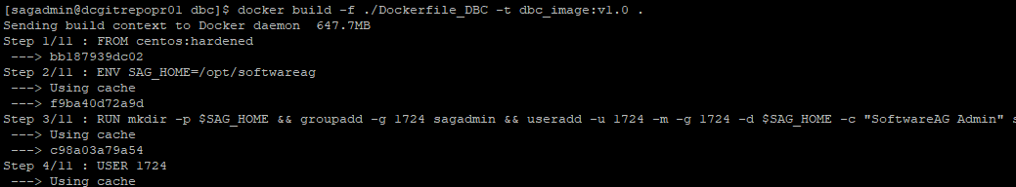
Note the docker image name is only for illustration purpose. You can create the docker image with the appropriate naming convention.

Generating the UM Docker image

For UM the assets for generating the Docker image is already downloaded from SoftwareAG GitHub and copied to the UM root installation in the reference server.

Following are the files required for the UM Docker image creation

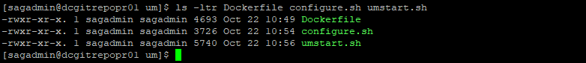
Login to the GIT REPO server with the user “sagadmin”

Go to the UM base installation in the GIT REPO server.

cd /data/softwareag/um

Execute the standard docker build command to create the UM Docker image.

docker build -f ./Dockerfile -t um_image:v1.0 .

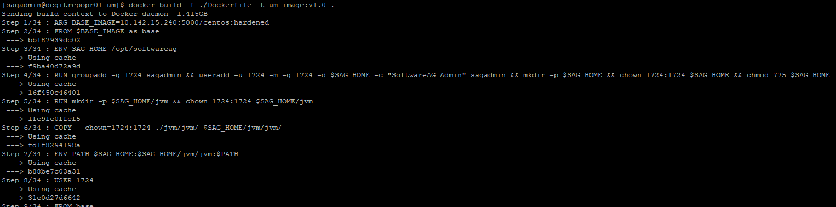
Note the docker image name is only for illustration purpose. You can create the docker image with the appropriate naming convention.

Generating the TSA Docker image

For TSA the scripts and the Dockerfile for the creation of the image gets installed with the Terracotta product.

Login to the GIT REPO server with the user “sagadmin”

Go to the TSA base installation in the GIT REPO server.
cd /data/softwareag/tsa/Terracotta/docker/images/server

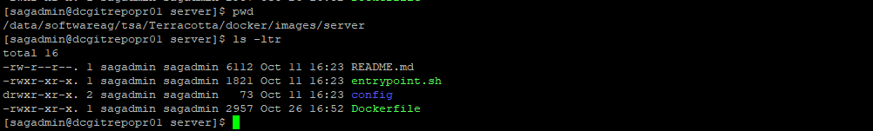
Execute the below command to create the TSA docker image

cd /data/softwareag/tsa

docker build -f ./Terracotta/docker/images/server/Dockerfile -t tsa_image:v1.0 .

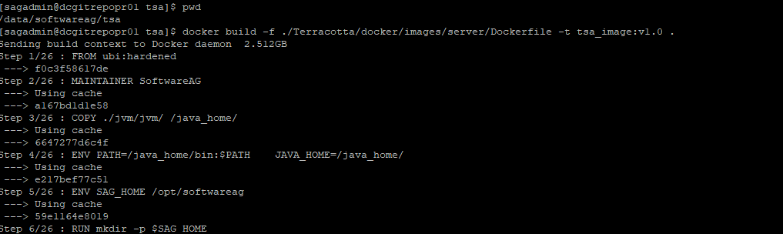
Note the docker image name is only for illustration purpose. You can create the docker image with the appropriate naming convention.

Once the images are created you will see the below list of images availabel in the docker local repository

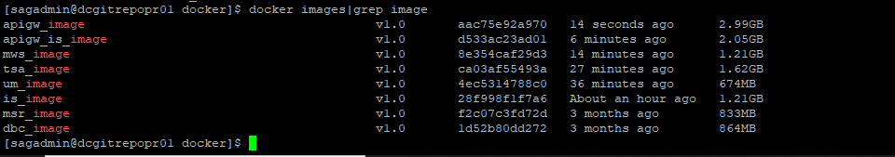
You can re-tag the images to add the docker repository name before pushing the image to the Docker registry.

For product we are using the Docker registry 10.142.15.240:5010

Hence, tag the images but executing the docker tag command. This is a pre-requisite to push the images to the central Docker registry.

docker tag apigw_image:v1.0 10.142.15.240:5010/apigw_image:v1.0
docker tag apigw_is_image:v1.0 10.142.15.240:5010/apigw_is_image:v1.0
docker tag mws_image:v1.0 10.142.15.240:5010/mws_image:v1.0
docker tag tsa_image:v1.0 10.142.15.240:5010/tsa_image:v1.0
docker tag um_image:v1.0 10.142.15.240:5010/um_image:v1.0
docker tag is_image:v1.0 10.142.15.240:5010/is_image:v1.0
docker tag msr_image:v1.0 10.142.15.240:5010/msr_image:v1.0
docker tag dbc_image:v1.0 10.142.15.240:5010/dbc_image:v1.0

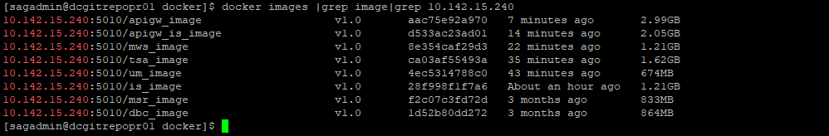
Now, you can push the images by executing the docker push command to the respective docker registry so that the images can be pulled by Kubernetes during the runtime.

Note: For APIGW, IS, MSR and MWS the Dockerfile generation utility comes out of the box along with the product installation, as describe earlier.

Next time any update is done to the base image you can directly run the build command and don't have to re-generate the Dockerfile

Understanding the Webmethods Kubernetes Templates

Once the images are created, using the Kubernetes scripts delivered for each of the component the products can be deployed as Pods in the Kubernetes cluster.

The following section decribes the webmethods properties that are defined at each of the components using the Kubernetes scripts. It is expected that the user has a good understanding of the Kubernetes concepts and its various objects such as Pods, Services, Deployment, Statefulsets, Namespace, Persistence Volume, Storage Class, ConfigMap, Secrets etc.

The kubernetes scripts delivered are for the webmethods core components APIGW, IS, MSR, UM, TSA, MWS and DBC. The PwC DevOps team has developed the kubernetes scritps for the non-webmethods product such as external Elastic Search and Kibana.

The base K8S scripts are available in the Kubernetes control plane node of Prod – 10.142.15.254, Non-Prod – 10.143.140.125 and DR – 10.172.19.254.

You can login to any of the server and go to the location

/data/K8S_Scripts

Further the base scripts can also be accessed in the shared drive

\\10.143.165.60\Pawan K Scan\PwC\SAG\K8S_Scripts

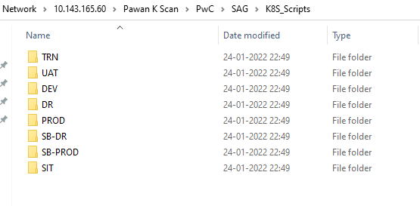

Its further grouped environment wise and each of the environment contains the scripts for deploying each of the webmethods components.

For example, Prod has the below list of component scripts

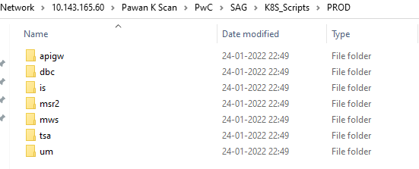

Where as the DEV has the scripts for the below set of components

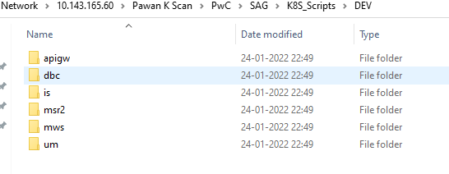
Note: PROD, DR, SANDBOX-PROD, SANDBOX-DR and UAT are the clustered environment and SIT, DEV and TRAINING are non-clustered environment. Additionally the TSA which is mainly used for the clustering of IS and APIGW-IS are created and shared only for the clustered environment. Non-clustered environments do not require the TSA deployment.

DBC Kubernetes Templates

There are mainly 3 set of scripts. Note change the namespace properties in these files accordingly while running the YAML templates

- dbc-configmap.yaml
- dbc-jobs.yaml
- dbc-secrets.yaml

dbc-configmap.yaml: This is for externalizing the DB connection details that would differ from environment to environment. This mainly has the DB_TYPE and DB_URL defined. This is further mounted on the dbc job template for using these as environment variable. This file is similar for all the environments.

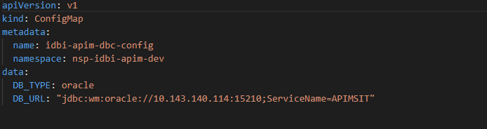

dbc-secrets.yaml: This file has the DB user and password in the base64 encoded format and this would be mounted as secret and used as environment variable in the dbc job template. This is similar for all the environments and you only have to encode the user and password using the unix base64 encode format and put it in the file as key value pair
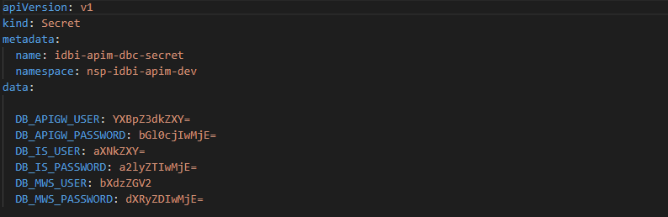
dbc-jobs.yaml: This file is a Kind: Job and the Pod deployed would run as job and complete once the product DB configuration is done.

The actual webmethods DB scripts is run in the command section of the template and all the parametes are passed as the environment variables

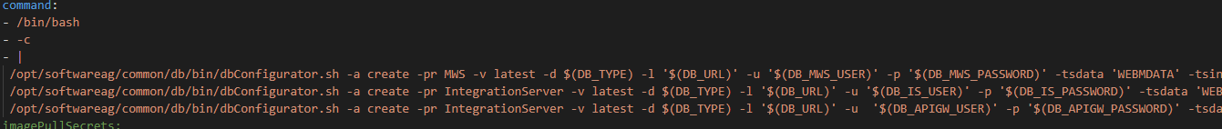
The create option creates the corresponding DB objects for the MWS, IS and APIGW schemas. You can replace create with drop option to delete these objects

TSA Kubernetes Templates

This mainly has the below set of scripts.

- tsa-configmap.yaml
- tsa-headless-svc.yaml
- tsa-service.yaml
- tsa-statefulsets.yaml
- tsa-storageclass.yaml

tsa-configmap.yaml: This file defines the externalized configuration of the TSA. The first file is tc-config.xml and it contains the important configuration for Terracotta server array. This sample configuration file is present in any TSA installation. You can refer to the one in the reference server installation at /data/softwareag/tsa/Terracotta/server/wrapper/conf

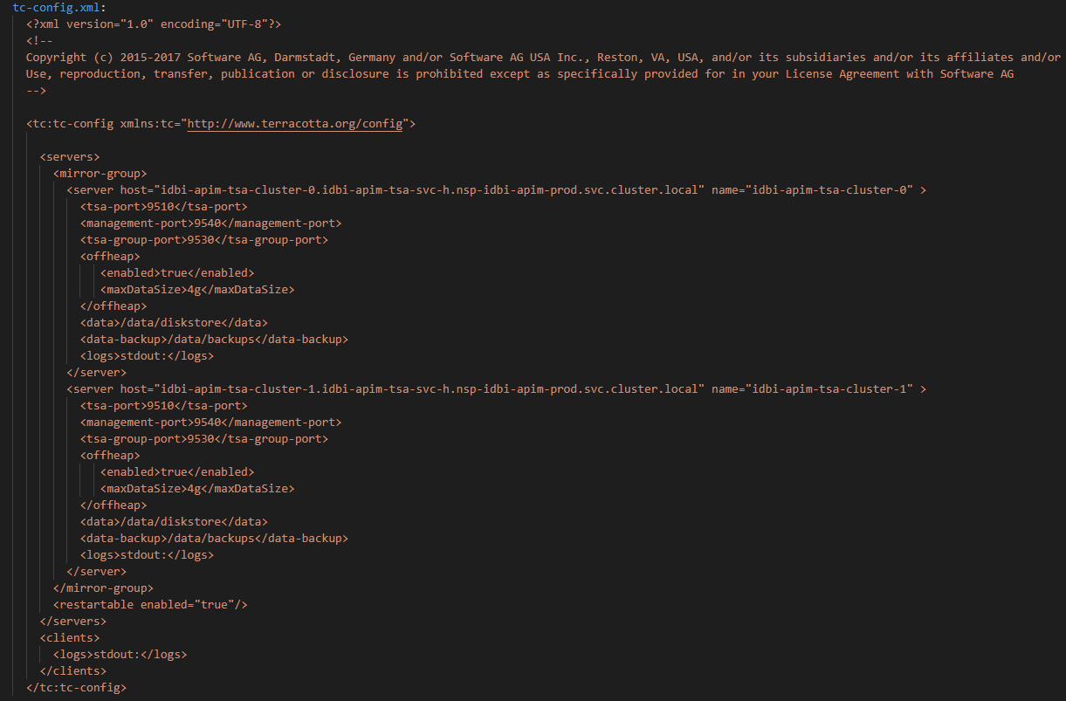

tsa-headless-svc.yaml: Since TSA need to be deployed as statefulset using this file we deploy the headless service

tsa-services.yaml: This template defines the nodeport service for the TSA.

tsa-statefulsets.yaml: Two replicas are deployed for TSA. Since there is requirement that the Pods are deployed in specific VM, this achieved through the Affinity and Toleration attributes based on the Labels and Taints applied by the DevOps team. Because the Taints and Labels are applied to the Kubernetes nodes for different environments differently. This needs to be updated accordingly for different environments based on the inputs from DevOps team.

For TSA 2 replicas are deployed as statefulsets.

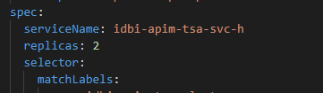
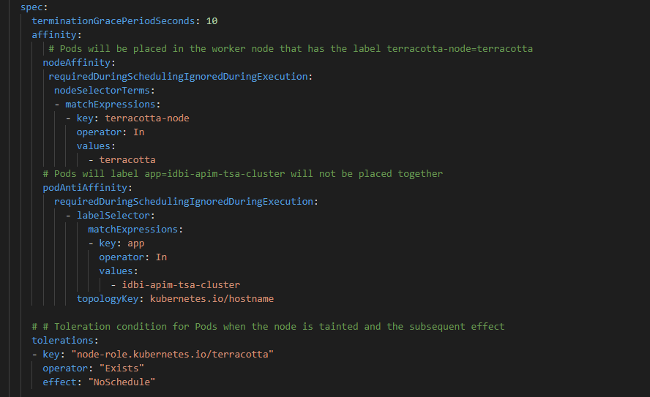
These are the attributes for the TSA container ports and volume mounts from ConfigMap and VolumeClaimTemplate.

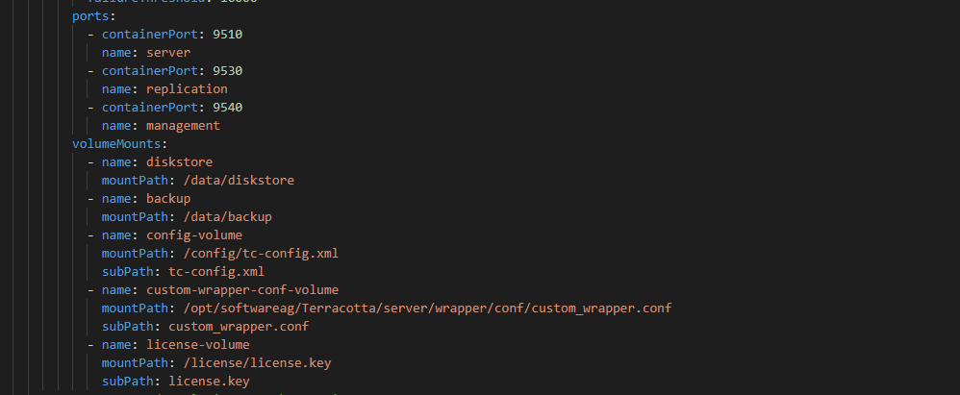

/data/diskstore - is used to store the TSA runtime data and the state information for maintaining the TSA cluster properly. If this folder gets corrupted and TSA is not running as expected. Then you will have to stop the Pods, clear the content of this directory from the NFS storage mount and then redploy the TSA Pods

/data/backup - is mounted from the container to the NFS storage created based on the Storageclass file. This stores the TSA backup, if it is generated.

/config/tc-config.xml – This is the location in the container where the tc-config.xml from the ConfigMap is mounted.

/opt/softwareag/Terracotta/server/wrapper/conf/custom_wrapper.conf - This is the location where the custom_wrapper.conf file is mounted in the container. This file is mainly used to define the TSA JVM parameter.
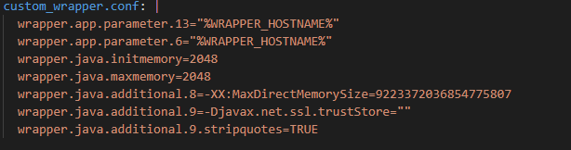
/license/license.key – This is the TSA License file mounted in the container from the ConfigMap

Below is the section where the persistent volumes of the TSA is created for each of the Pods in the replicaset and mounted on the NFS mount created by the Storage class
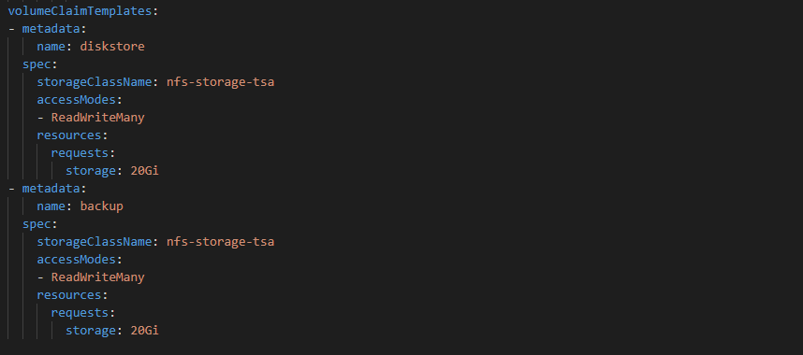

tsa-storageclass.yaml: This is the teamplate using which the Storage class for the TSA is created.

UM Kubernetes Templates

Following are the YAML templates created for UM
- um-configmap-license.yaml
- um-configmap.yaml
- um-deployment.yaml
- um-services.yaml
- um-pvclaim.yaml
- um-storageclass.yaml

um-configmap-license.yaml: This is the config map that contains the UM license file details mounted on to the container

um-configmap.yaml: The Server_Common.conf file is used to define the configuration for UM. The same is mounted in the UM container in the um-deployment.yaml file

This config file is mainly used to define the JVM init and max memory settings and the Keystore and Truststore of the UM

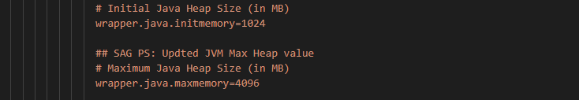

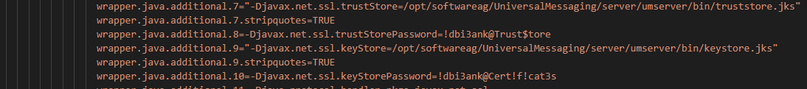
um-services.yaml: Both the Clusterip and Nodeport services are defined in this template file

um-pvclaim.yaml: Used for defining the Persistent volume claim. This is important to persist the UM Data on to the file system. The Volume is then mounted in the running container. The PV is claimed from the volume created using the Storage class.

um-storageclass.yaml: Used for defining the Kubernetes storage class file for Persistent volume to be used for persisting the UM data storage.

um-deployment.yaml: This section of the template defines the UM deployment specification. These are the Kubernetes defined attributes. For UM the replica count is set to 1

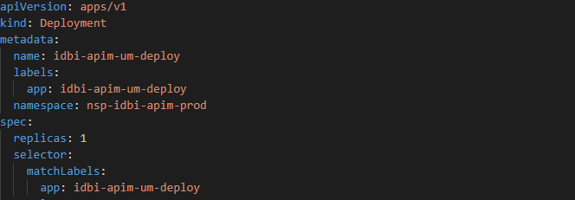
Below snapshot defines the Pod Affinity and Toleration depending on the Node label and Taints set for the UM specific node. For more details please check the taints file updated by the DevOps team. There would specific labels and taints applied for different environment.

The volume mounts are mounted from the configMap that are UM specific configurations and licenses. For example,
For License - /opt/softwareag/UniversalMessaging/server/umserver/licence.xml
For UM Specific Config - /opt/softwareag/UniversalMessaging/server/umserver/bin/Server_Common.conf
Below for mounting the Keystore and Truststore from configMap

/opt/softwareag/UniversalMessaging/server/umserver/bin/keystore.jks
/opt/softwareag/UniversalMessaging/server/umserver/bin/truststore.jks

For UM Data created through the Storage Class PV /opt/softwareag/UniversalMessaging/server/umserver/data

All these are mounted on to the running instance of the Pod

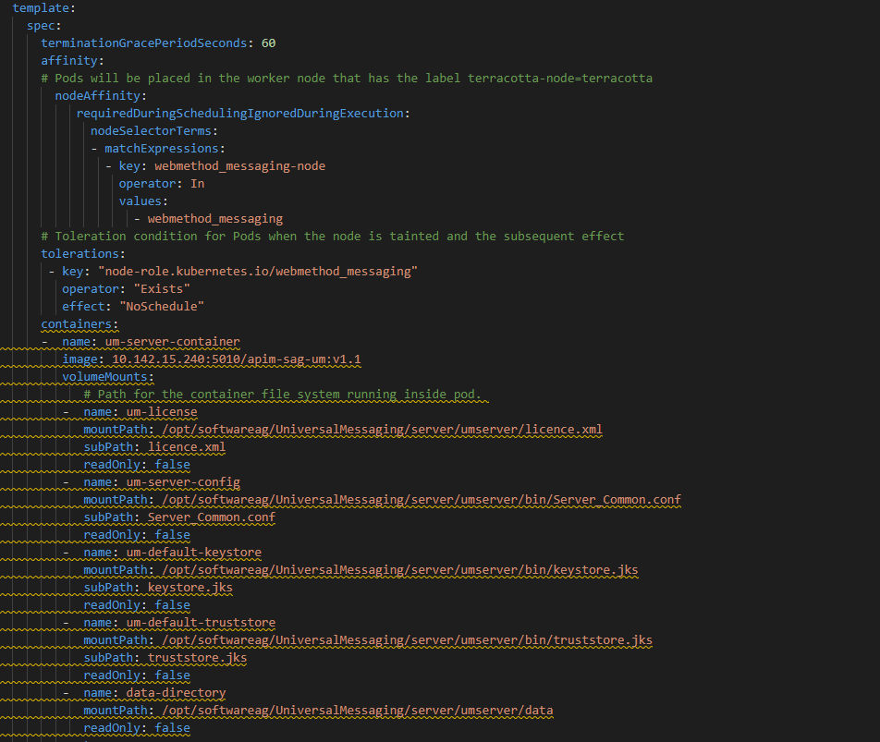

IS Kubernetes Templates

Following are the YAML templates created for IS

- is-configmap.yaml
- is-license-configmap.yaml
- is-services.yaml
- is-statefulsets.yaml
- is-storageclass.yaml

is-configmap.yaml: This is a configMap template used for externalizing the IS configuration. Currently 5 configuration files are added to this template. In future if you want to add any further configuration for the IS, you can use this configMap.

- application.properties: Through this file you can define various configuration such as JDBC connection pools, DB schemas username and password, extended settings for TSA, Truststore and Keystore file location, SAML url. For comprehensive list of properties please check the MSR documentation. This template is applicable when you use the MSR feature and hence for installing the IS we use the MSR license. Snapshot as below
You can see that the passwords are AES encrytpted password being used. You can generate all the AES encrypted password by login in to any running instance of MSR.

Once you login to the MSR go to Configuration Variables > Generate Encrypted Configuration Variable.

Enter the Value and click on the Encrypt button to generate the encrypted password. You can see the AES ecypted password is generated. Now Copy and paste it in the relevant field.

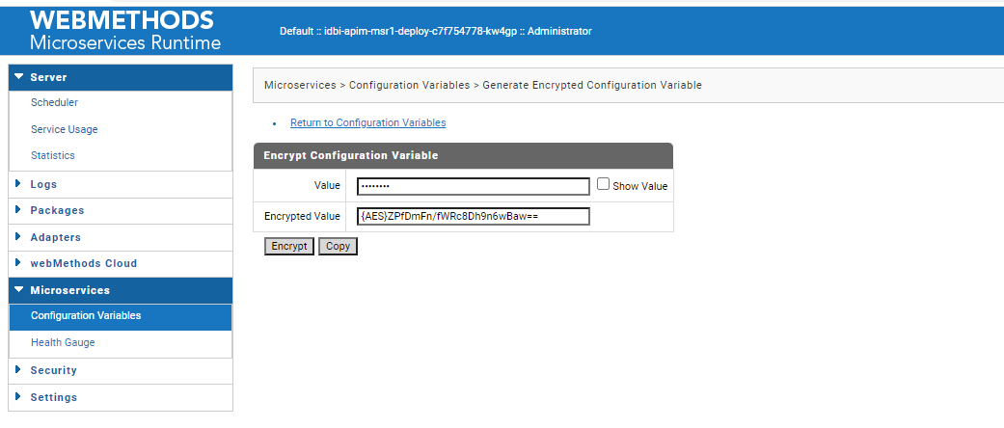

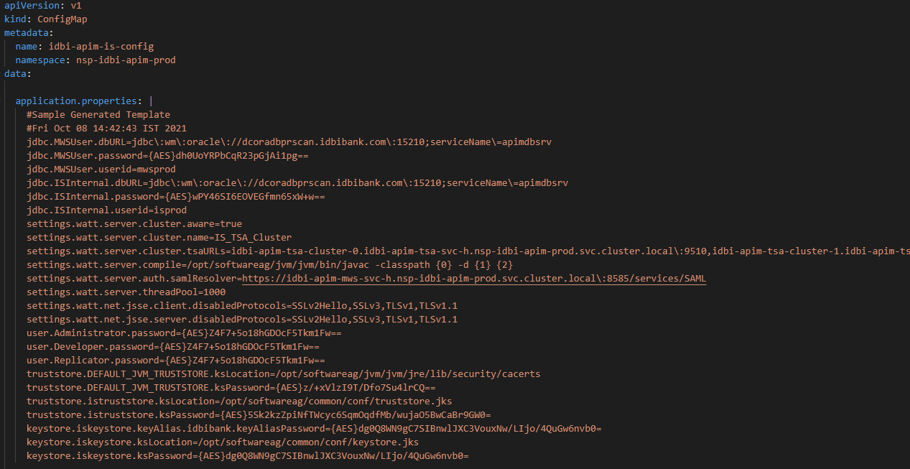
- custom_wrapper.conf: Using this file you can update the JVM properties of the IS, including the JVM init and max memory.
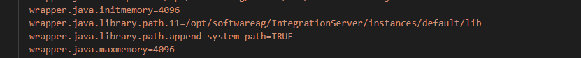

- jndi_DEFAULT_IS_JNDI_PROVIDER.properties: This configuration file describes the JNDI properties for the UM. Through the property java.naming.provider.url=nsps\://idbi-um-svc.nsp-idbi-apim-prod.svc.cluster.local\:9002, you can define the UM connection string. Since this depends on the namespace. For different environment this will be set differently and hence required to be externalized

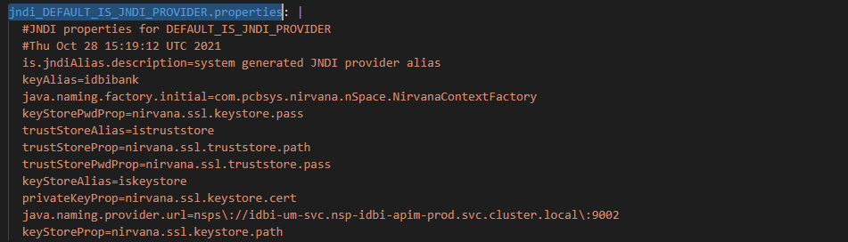

- messaging.cnf: This is an XML configuration file used by the IS to connect to the UM. This basically has all the properties that is specific to UM connection such as UM RNAME, Truststore and Keystore used for UM connection, client pre-fix, UM Alias name etc.
- jms.cnf: This configuration file defines the JMS connection details .

All these properties file can be mounted to IS runtime container through the Deployment templates

is-license-configmap.yaml: This file is used to define the TSA and the IS (MSR) licenses.

is-services.yaml: For defining the headless and nodeport services for the IS Pods and the container default ports such as 5555, 5543 and 9999 are mapped to the nodeport

is-storageclass.yaml: Since IS has the CSQ defined for outbound message publish to UM. It will a good idea to persist the volume, so that in case the UM is down the messages are not lost. For that we define the Persistent volume using teh storage class and NFS mount.

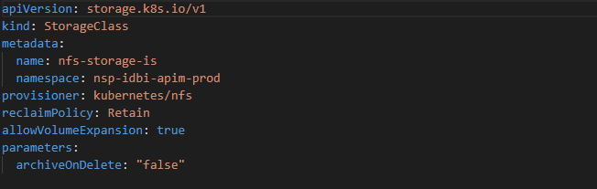
is-statefulsets.yaml:

Since IS needs to maintain the state of the CSQ, we deploy the IS Pods as statefulsets. The below snap shot defines the specification of the Statefulsets and the headless service. In case of cluster environment we deploy 2 sets of replicas.

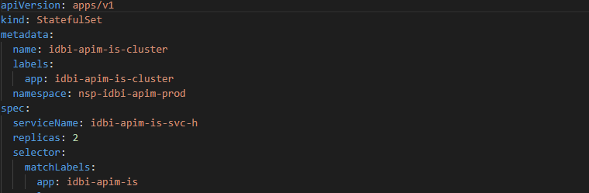
Below snapshot defines the Pod affinity and toleration rules depending on the Taints and Labels applied by the DevOps team on the Kubernetes nodes. Since, these are specific to the environments, please check the document created by the DevOps team before applying them to the template.

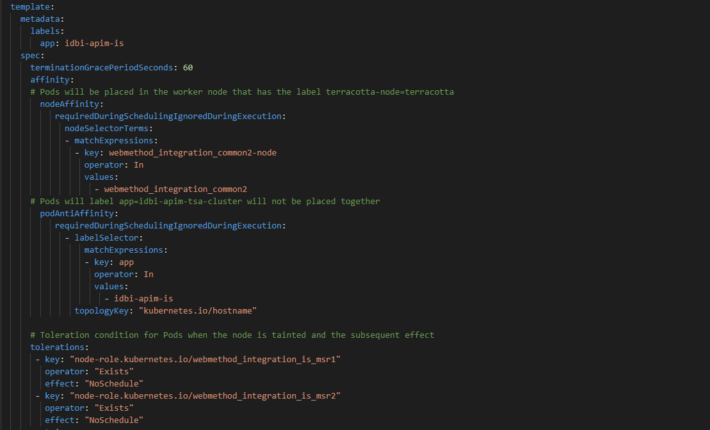
Below are the container specification properties. Ports defined are the default IS ports for admin – 5555, Diagnostic Port – 9999 and Transaction port – 5543. The Pod resource limits are set as per the project and environment requirement.

Readiness and liveness probes are to monitor the state of the Pods that applies certain delays before the Pod are in the running state and requests can be accepted because of the time take to initialize the container startup. /invoke/wm.server/ping is the IS defined API that can be pinged for checking the status.

Below is the snapshot of the volume Mount. The volumes are mounted from the license and product configMap. The below are the volume mounts directly mounted to the container config location.

/opt/softwareag/IntegrationServer/instances/default/licenseKey.xml
/opt/softwareag/common/conf/terracotta-license.key
/opt/softwareag/profiles/IS_default/configuration/custom_wrapper.conf
/opt/softwareag/IntegrationServer/application.properties

and below are the ones mounted to the /tmp

/tmp/jndi_DEFAULT_IS_JNDI_PROVIDER.properties
/tmp/messaging.cnf
/tmp/jms.cnf
/tmp/keystore.jks
/tmp/truststore.jks

and then copied to the IS config directory in the command section of the template. The reason is that when the files are mounted to the container from configMap, they are created as root user. Even if they are given 777 permission, these files will not be writable by the sagadmin user, using which the container process is started. Hence, due to this it will throw error as the files will not have the necessary permission to edit them, as the container starts up. IS tend to update these files based on the latest state of the process.

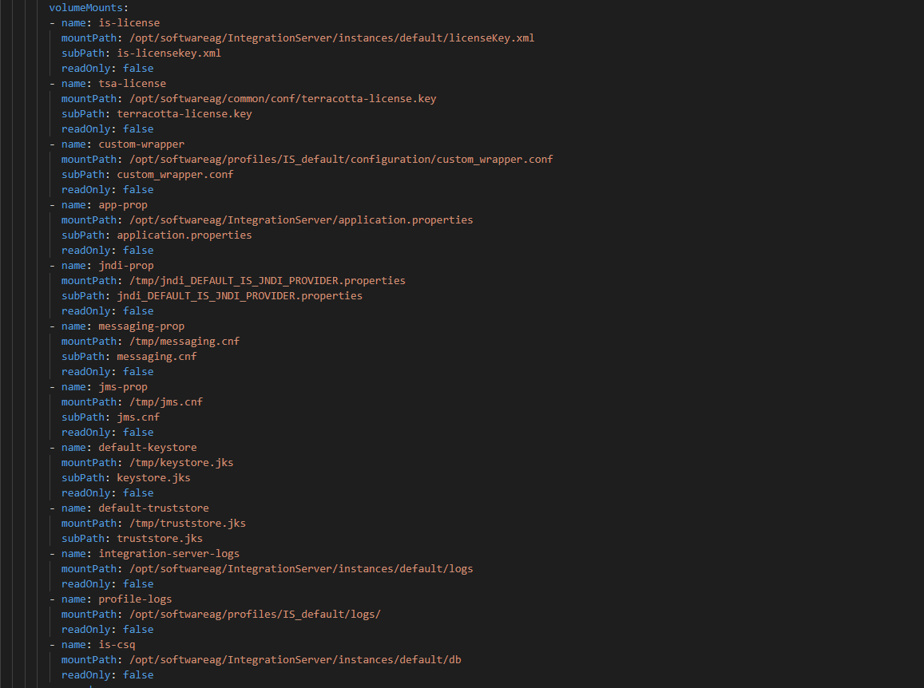

Below ones are the container log directory which are mapped to the local host path for mainting the logs. The logs are persisted to local hostPath, so that old logs can be accessed for any application issues

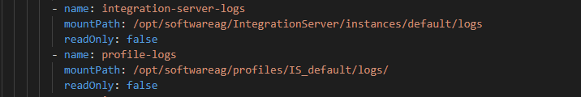
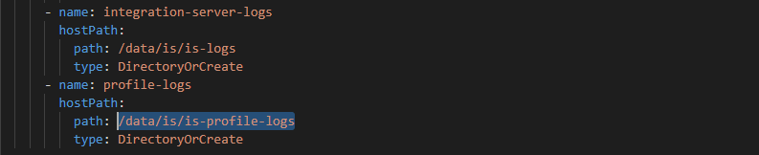

The volumes for the hostPath are defined in the volume section and then mounted on to the container directory.

The CSQ volume mount is defined in this section of the volume Mount

This is mounted from the NFS mounted defined using the volumeCliamTemplate and created using the Storage class template.

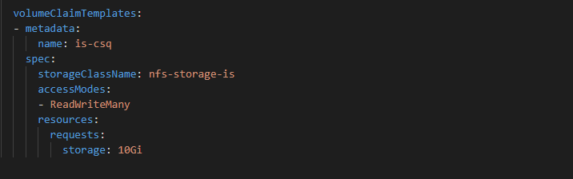

Finally, below is the snapshot of the command section of the Pod template that is used to execute the Unix command inside the container.

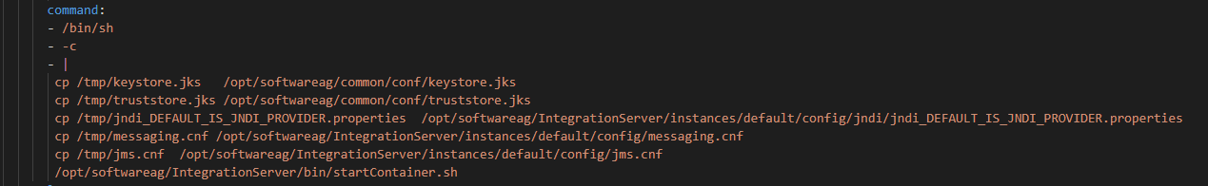
Once the command section is added it replaces the Docker image entrypoint and hence the container startup script has to be executed additionally.

MSR Kubernetes Templates

Following are the YAML templates created for MSR

- msr2-configmap.yaml
- msr2-license-config.yaml
- msr2-services.yaml
- msr2-deployment.yaml

msr2-configmap.yaml: This is a configMap template used for externalizing the MSR configuration. Currently 5 configuration files are added to this template. In future if you want to add any further configuration for the MSR, you can use this configMap.

- application.properties
- jndi_DEFAULT_IS_JNDI_PROVIDER.properties
- messaging.cnf
- jms.cnf
- setenv.sh

The description for each of these files is similar to what has been covered in the IS section. MSR is the lighter version of IS. Please refer to the above section for more details. The following section will cover the difference in the properties for MSR.

MSR is not deployed as clustered component unlike IS and hence does not require the connectivity to TSA. Therefore, that part in MSR is not available in the application.properties. Similarly, the MSR is not configured for JDBC Pools, as there is not DB auditing enabled. Rest of the properties remains same as the IS.

For rest of the config files the defined properties for MSR and IS remains the same.

The only difference in MSR is that it does not uses the Tanuki wrapper and hence there is no custom_wrapper.conf file instead the JVM related properties are updated in the properties file called setenv.sh.

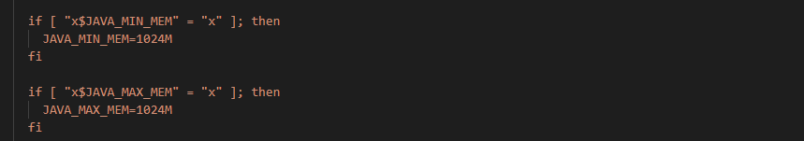
msr2-license-config.yaml: Defines the MSR license that will be mounted in the container.

msr2-services.yaml: Defines the clusterip and nodeport services

msr2-deployment.yaml: One of the difference between MSR and IS Pods is that in MSR the Pod deployment is of Kind: Deployment. Since in MSR deployment we going to persist any state or the container data.

In case of clustered deployment, we are deploying 2 Pods of MSR whereas in case of non-clusterd environment we are deploying 1 Pod.

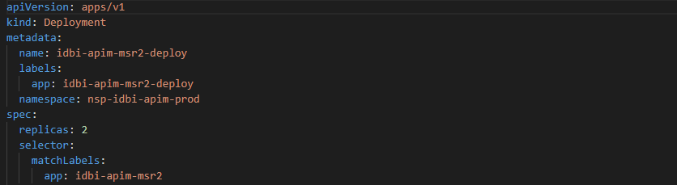

The affinity and toleration section of the Pod template is similar to what has been configured for IS. However, they are configured differently for different environment based on the taints and labels details shared by PwC DevOps team. Hence, refer to the details while configuring the Affinity and Toleration rules in the MSR template.

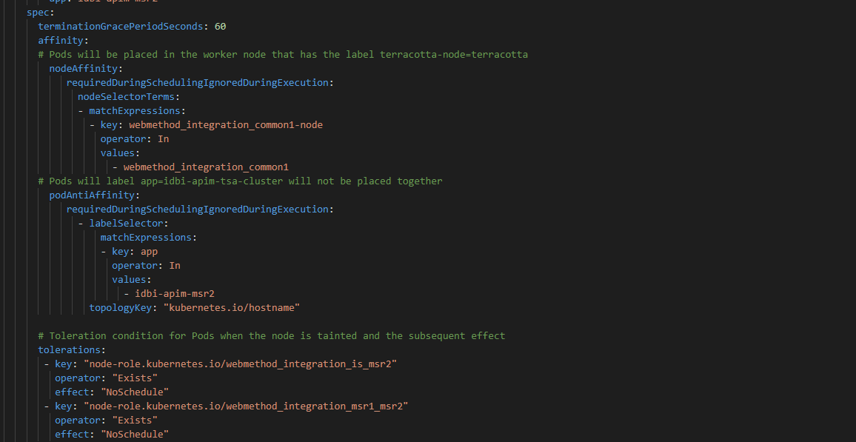
Container section of the MSR remains similar to the one described for IS. Please refer to the IS section.

One point to highlight is the Log directory, which is again mounted on the MSR dedicated worker node and below table shows the hostPath

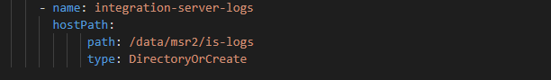
The rest of the volume mount details are similar to IS
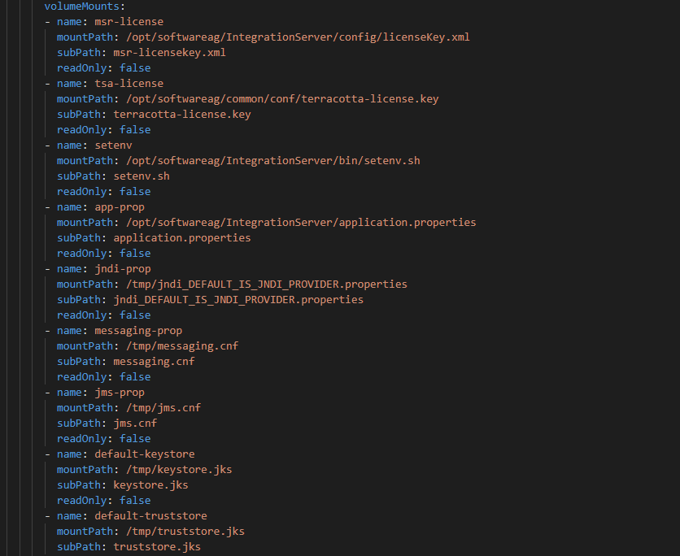
Below configurations are directly mounted to the container directory path theough configMap

/opt/softwareag/IntegrationServer/config/licenseKey.xml
/opt/softwareag/common/conf/terracotta-license.key
/opt/softwareag/IntegrationServer/bin/setenv.sh
/opt/softwareag/IntegrationServer/application.properties

and below are the ones that are mounted to /tmp and then copied using the copy command in the command section of the template, so that the files are created with the “sagadmin” user instead of “root” user.

/tmp/jndi_DEFAULT_IS_JNDI_PROVIDER.properties
/tmp/messaging.cnf
/tmp/jms.cnf
/tmp/keystore.jks
/tmp/truststore.jks

Finally, the command section executing the Unix command for copying the MSR properties to the config directory and executing the container startup script

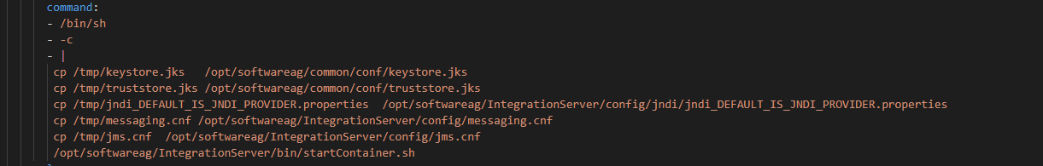

APIGW Kubernetes Templates

Following are the YAML templates created for APIGW

- apigw-configmap.yaml
- apigw-license-configmap.yaml
- apigw-services.yaml
- apigw-deployment.yaml

apigw-configmap.yaml: This is the template using which the configurations for the APIGW is externalized and can be modified for different environments. There are mainly 4 properties file that are updated in this configMap.

- application.properties: Similar to the ones that has been described for IS and MSR before. Main properties to note here are the JDBC pool connection details, DB schemas username and password, TSA details for the clustered APIGW nodes, user name and AES encrypted password generated using the MSR feature, SAML url, TLS propoerties, SSL Keystore and Truststore path and password. For complete list of properties please refer to the MSR documentation on application.properties.
Below is the snapshot for this file from Prod
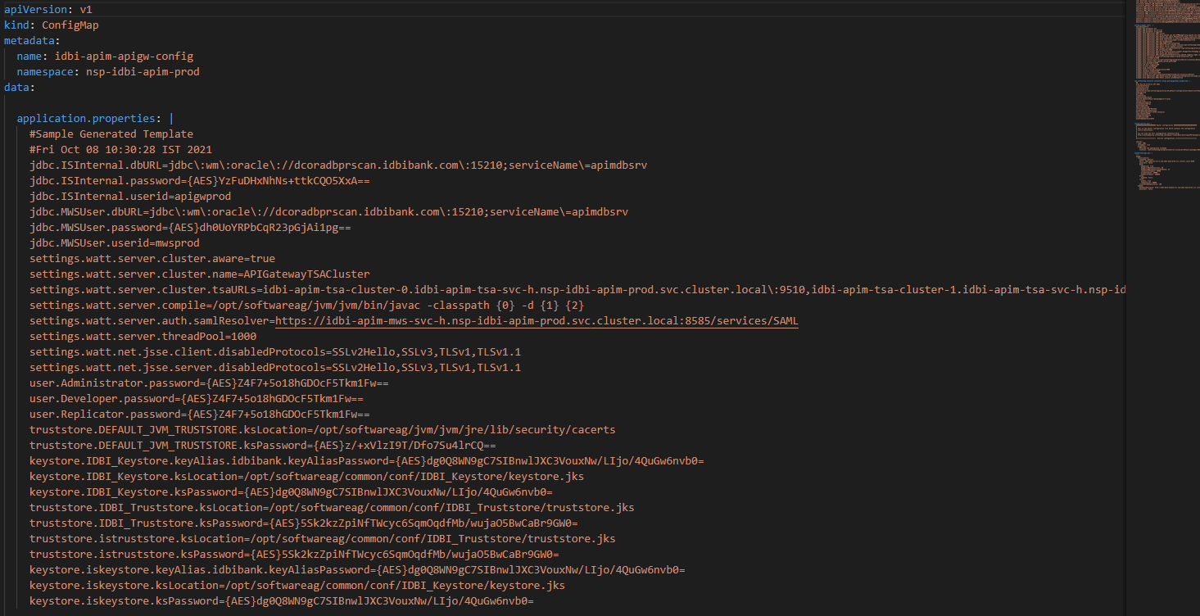
- custom_wrapper.conf: Similar to IS this is where you can define the JVM properties and other properties for the APIGW IS instance.
- com.softwareag.catalina.connector.https.pid-apigateway.properties: This is the property file used for updating the APIGW port to SSL. It has the details of the path for the Keystore and the port. The Keystore password is also updated in the same file.
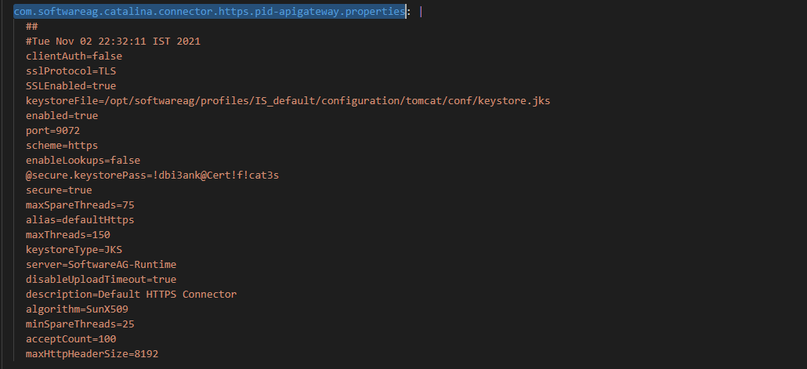
- config-sources.yml: This is the YAML template used to define the system configuration of the APIGW for connectivity to the external Elastic Search and Kibana component. This property file in turn refers to the system-settings.yml that is used when the extral ES and Kibana are used.

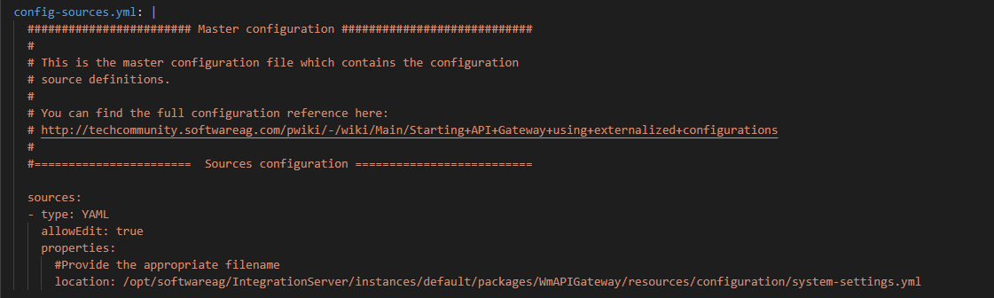

- system-settings.yml: This is the file where all the ES and Kibana external connectivity configurations are defined. It contains the details of the ES Pod fqdn and the autostart=false flag refers that the APIGW uses the external ES. Rest are the http and https properties. For more details refer to the APIGW administration guide. Similarly the next session contains the detail of the external Kibana.
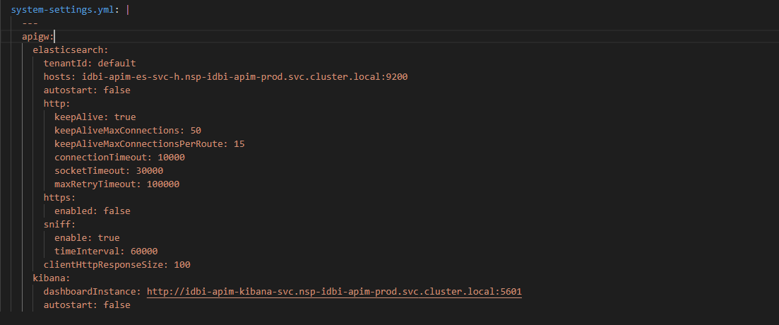
apigw-license-configmap.yaml: This file defines the licenses for the APIGW and the TSA licenses.

apigw-services.yaml: This file defines the clusterip and nodeport services used for connecting to the APIGW pods

apigw-deployment.yaml: The APIGW Pods are deployed using the kubernetes Kind: Deployment. There are 2 replicas of Pods deployed for clustered environment and 1 replica for non-clustered environment. Below is the snapshot for the Deployment specification of the APIGW.
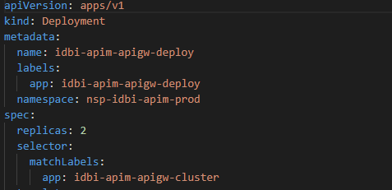
The below section defines the Pod Affinity and the Toleration depending on the Node level Lables and Taints set. Note that since each of the APIGW Pods are to be deployed to specific worker node of the kubernetes cluster, we need to use the Affinity and the Toleration rules.

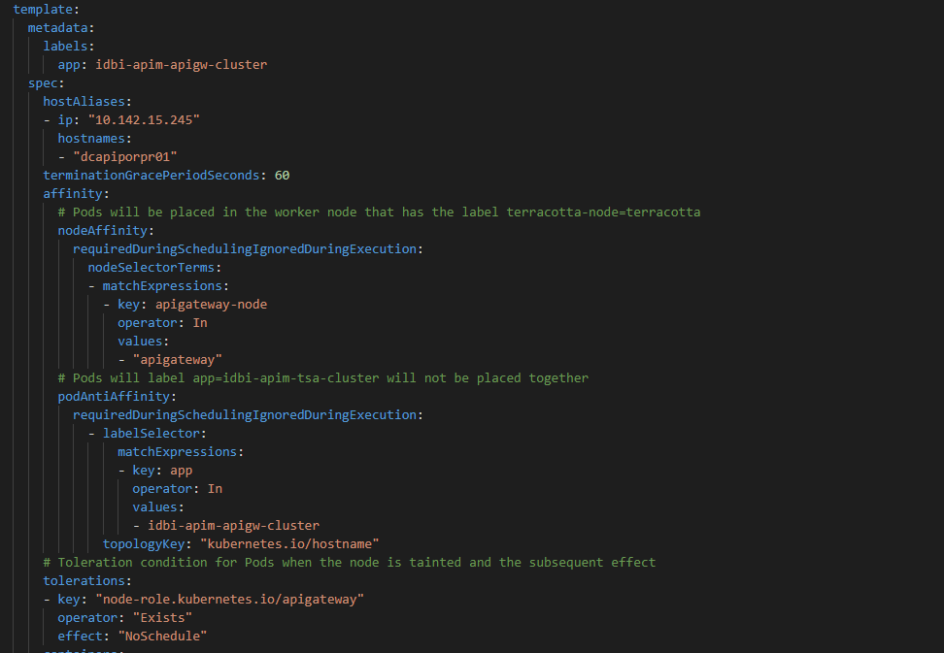
The hostalias is used for resolving the API Portal host for the Pods to be able to connect to the API Portal. These lines can be commented for the environments where the APIGW is not connecting to the API Portal.

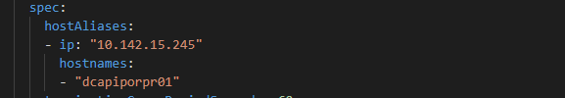

Below are the container specifications that are set similar to IS and MSR Pods. Please refer to the earlier section for the details. One difference is the APIGW UI port, which in this case is configured to 9072.

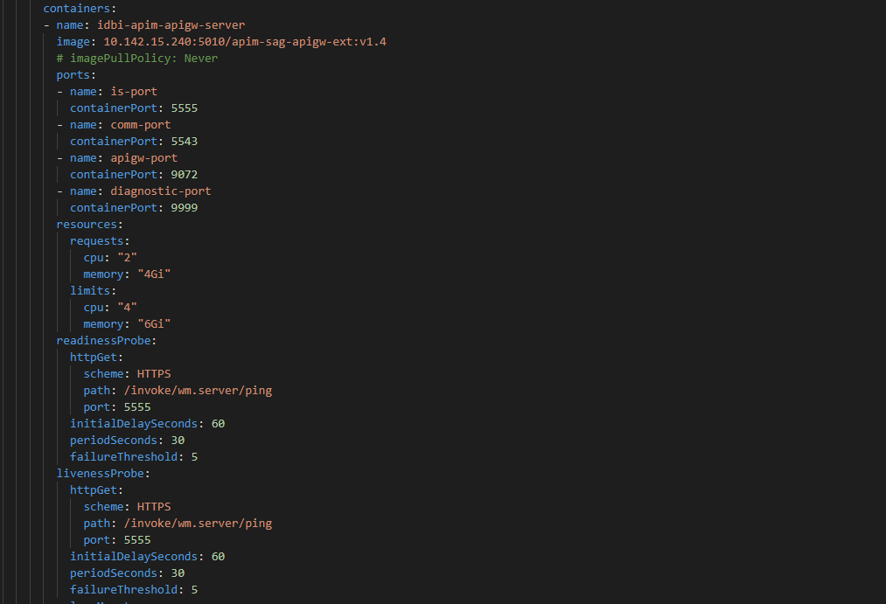

Below section defines the various volume mounts for the APIGW. These volumes are mounted from the container through the configMap. These properties are directly mounted from the configmap to the container config location

/opt/softwareag/IntegrationServer/instances/default/config/licenseKey.xml
/opt/softwareag/common/conf/terracotta-license.key
/opt/softwareag/profiles/IS_default/configuration/custom_wrapper.conf
/opt/softwareag/IntegrationServer/application.properties

These properties are mounted first to the /tmp

/tmp/com.softwareag.catalina.connector.https.pid-apigateway.properties
/tmp/config-sources.yml
/tmp/system-settings.yml
/tmp/keystore.jks
/tmp/truststore.jks

and in the command section of the template they are copied to the respective config location in the container.

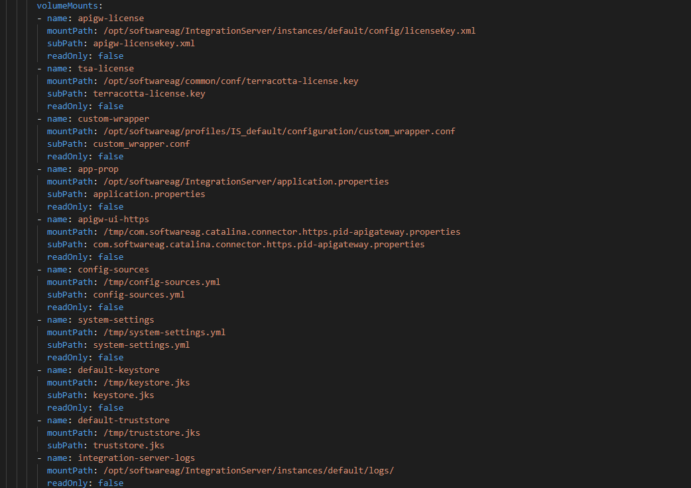
Like other Pods the APIGW also uses the specific hostPath for mounting the Logs and below in the details where the log directory is created before deploying the Pod.

MWS Kubernetes Templates

Following are the YAML templates created for MWS

- mws-configmap.yaml
- mws-secret.yaml
- mws-services.yaml
- mws-statefulsets.yaml

mws-configmap.yaml: The MWS configurations are externalized using these configuration files, which are then mounted to the runtime container. Since, these paramters are different for different environment, they need to be modified accordingly for each of the environments.

- mws.db.xml: This file is used to define the MWS database configuration. The DB password is AES format and hence can be encrypted using the MSR feature as explained in the IS section of the document.

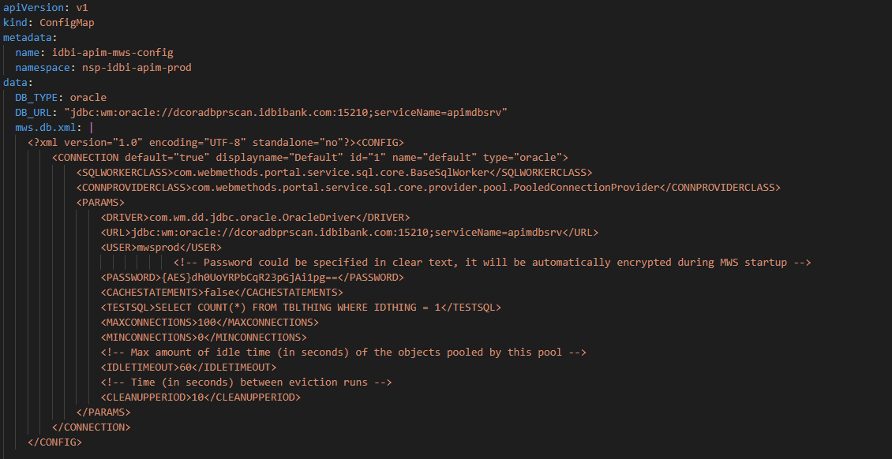
- jetty.xml: This property is used to define the SSL configurations for the MWS server.
- cluster.xml: This is the property which is used to define the cluster configuration for the MWS. This file the MWS port 8585 is defined and the MWS host name or the FQDN of the MWS Pod and the frontend URL.

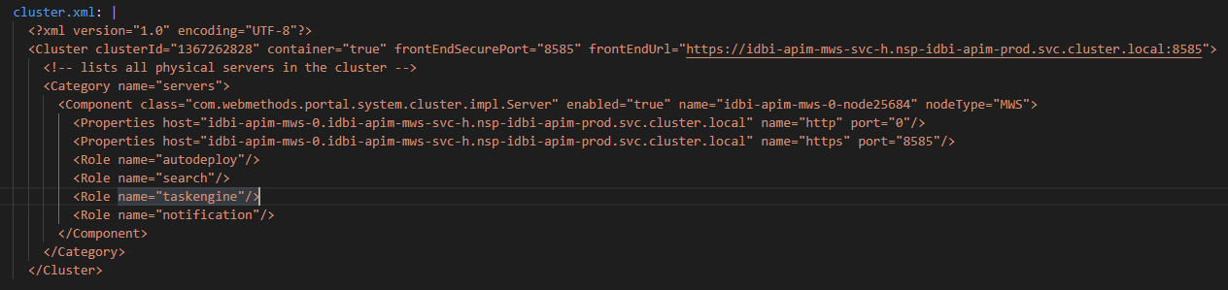
- custom_wrapper.conf:In this file the JVM parameters for the MWS pod is defined also the Truststore and Keystore file location for the container is also defined. Since the Truststore and Keystore files uses the password, the password can be generated using the AES format of MSR and copied to this file for these key value pair.
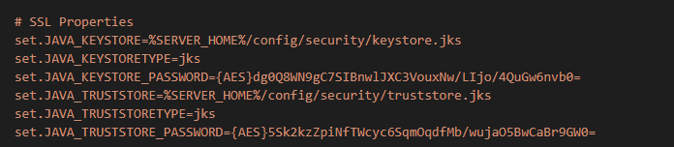
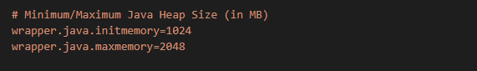
mws-secret.yaml: This file defines the MWS DB username and password in the base64 encoded. These are then set as environment variables for the deployment of the MWS.

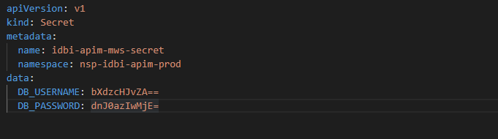
mws-services.yaml: The clusterip and nodeport services are defined for MWS in this file

mws-statefulsets.yaml: MWS pods are deployed as Statefulsets with replica count as 1. Below section defines the Statefulsets specification for the file.

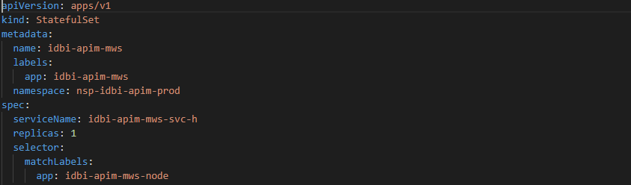
Below section contains the specification of the Pod template. The DB type and DB Connection values are set as environment variables from the configMap. Since the Pod has to be deployed to a specific Worker node, this is achieved through the Affinity and Toleration rules based on the Labels and Taints set on the worker node by the DevOps team. Since, these rules are different for different environment, please check before applying them.

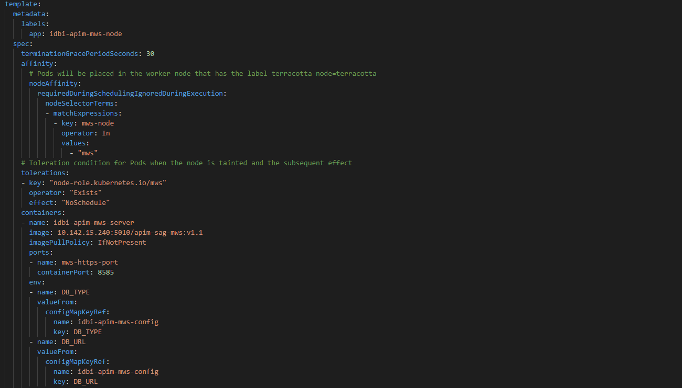
Below section of the template contains the details on the DB username and password mounted from the Secret file. The rest of the section contains detail on the resource request and limit and the probes for monitoring the Pods status.

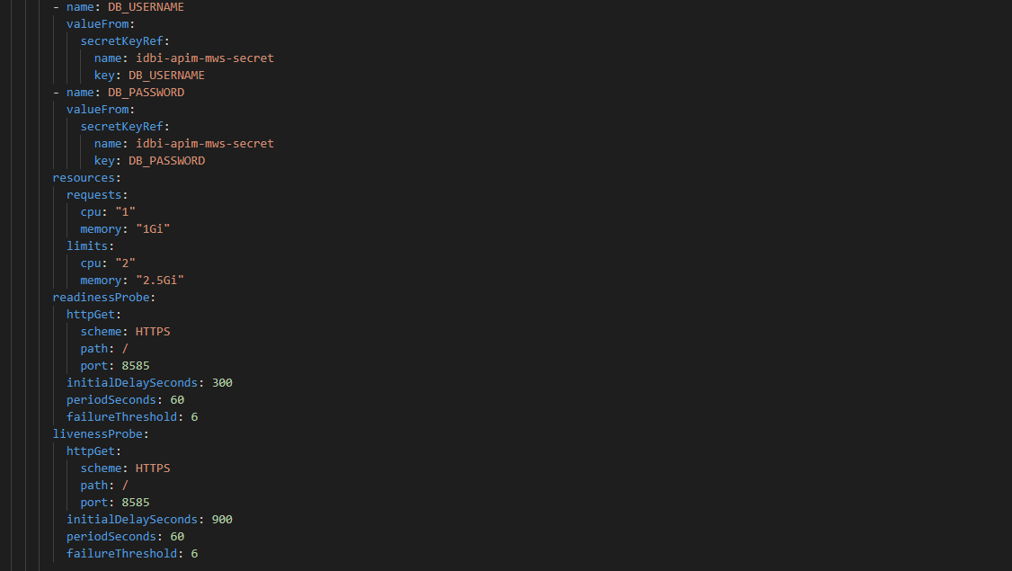
Below section describes the volumeMount. These are the externalized MWS configurations and properties files mounted through the configMap and the details for the configuration are described in the configMap section earlier.

The custom_wrapper.conf is directly mounted to the container config location

/data/softwareag/mws/MWS/volumes/configs/profile_cfg/custom_wrapper.conf

The below configuration are mounted to /tmp in the container and then in the command section they are copied to the respective container location.

/tmp/cluster.xml
/tmp/jetty.xml
/tmp/mws.db.xml
/tmp/keystore.jks
/tmp/truststore.jks

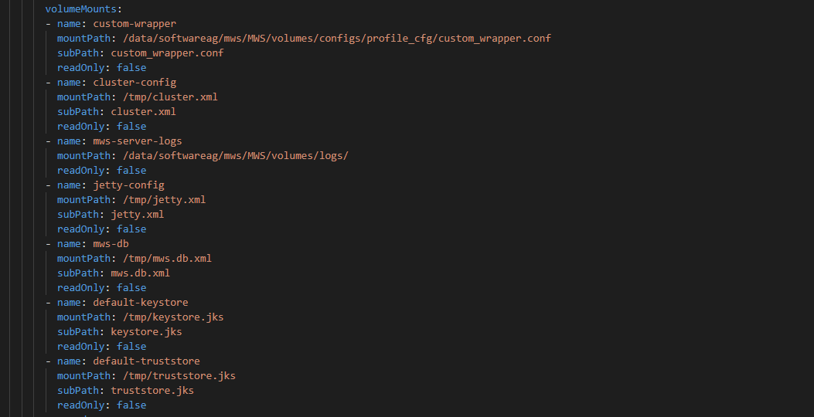
Apart from the copy command there are additional command executed to copy the cluster.xml and jetty.xml file to the DB. These are the MWS properties file that resides in the DB and hence the below execution of the command does the needful and then removes the filesystem files from the container.

cd /data/softwareag/mws/MWS/bin
./mws.sh -s default putconfig cluster.xml
sleep 5
./mws.sh -s default putconfig jetty.xml
sleep 5
rm -f /data/softwareag/mws/MWS/server/default/config/cluster.xml
rm -f /data/softwareag/mws/MWS/server/default/config/jetty.xml

Since we are introducing the command section the Docker image Entrypoint will be replaced and therefore we need to specifically call the container startup script.

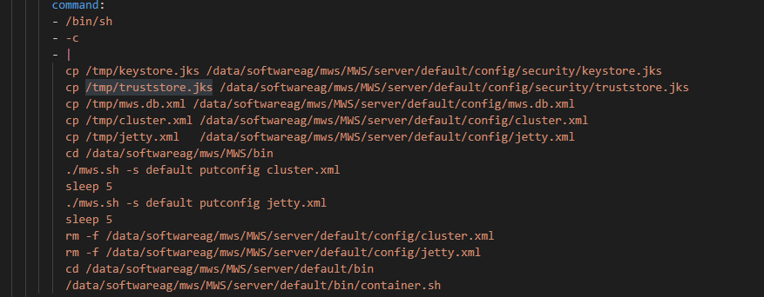
The MWS log directory is mounted to the hostpath of the worker node. Below in the details where the log directory is created before deploying the Pod.

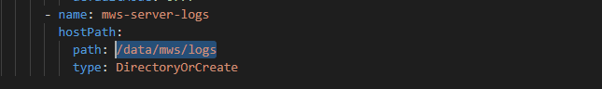

Deployment of Webmethods Containers on Kubernetes

In the IDBI environment there are 3 Kubernetes cluster and 3 docker registry. One kubernetes cluster is setup for Prod (Prod and SB-Prod), one for Non-Prod (UAT, SIT, DEV and TRN) and one for DR (DR and SB-DR). Since the Kubernetes cluster is used by multiple environment, the webmethods products are deployed in different namespace for different environment.

Below are the namespace for the Prod Kubernetes cluster.

- nsp-idbi-apim-prod
- nsp-idbi-apim-snd

Below are the namespace for the DR Kubernetes cluster.

- nsp-idbi-apim-prod
- nsp-idbi-apim-snd

Below are the namespace for the Non-Prod Kubernetes cluster.

- nsp-idbi-apim-dev
- nsp-idbi-apim-sit
- nsp-idbi-apim-trn
- nsp-idbi-apim-uat

Before we start the deployment we have to ensure that the above namespaces are created in the specific environment.

We have clustered and non-clustered environment.

PROD, DR, SB-PROD, SB-DR and UAT are deployed as clustered environment whereas SIT, DEV and TRAINING are deployed as non-clustered environment. Moreover, the TSA is deployed only in the clustered environment for IS and APIGW IS clustering.

All the clustered environment have 2 replicas of APIGW, IS, MSR2 and TSA and 1 replica of MWS and UM whereas the non-clustered environment has 1 replica of each of the component and no TSA.

Since the deployment is using Kubernetes platform, the approach for the webmethods product deployment and the configuration remains the same for all the other environment.

We have created the self-signed certificate for each of the environment. The steps for generating the self-signed certificates is captured in the document “GeneratingCertificates”. Please refer to this document for the detailed steps and commands. Once the self-signed certificates are generated, we then create the Keystore and Truststore.

Since, the Keystore and Truststore files are directly mounted as configMap through the Deployment or Statefulsets templates of the Pod, we need to import them as the configMap. The name for the Keystore and Trusstore configMap will remain the same in all the environment, so that the same name can be used in the deployment template.

Copy the Keystore and Truststore to the Kubernetes Control plane server and execute the below command to create the configMap for the Keystore and Truststore

kubectl -n nsp-idbi-apim-snd create cm idbi-apim-default-truststore-config –from-file=/data/K8S_Scripts/SB-DR/certs/truststore.jks

kubectl -n nsp-idbi-apim-snd create cm idbi-apim-default-keystore-config --from-file=/data/K8S_Scripts/SB-DR/certs/keystore.jks

Change the namespace accordingly for different environment.

Since, there are dependencies of multiple product components. For example, the clustering of IS and APIGW IS has dependencies on TSA and the IS and MSR connect to the UM

The product deployment should be done in the below order

- DBC
- UM
- TSA
- IS
- MSR
- MWS
- Elastic Search
- APIGW
- Kibana

Note: For non-clustered environment, TSA deployment is not needed. Elastic Search and Kibana are deployed by the DevOps team and hence make sure the Elastic Search is deployed before APIGW and then followed by Kibana

For the Pod deployment. Copy the K8S_Scripts directory to the Kubernetes control plane.

You need to go the respective component directory. For example, um and execute the command

kubectl apply -f .

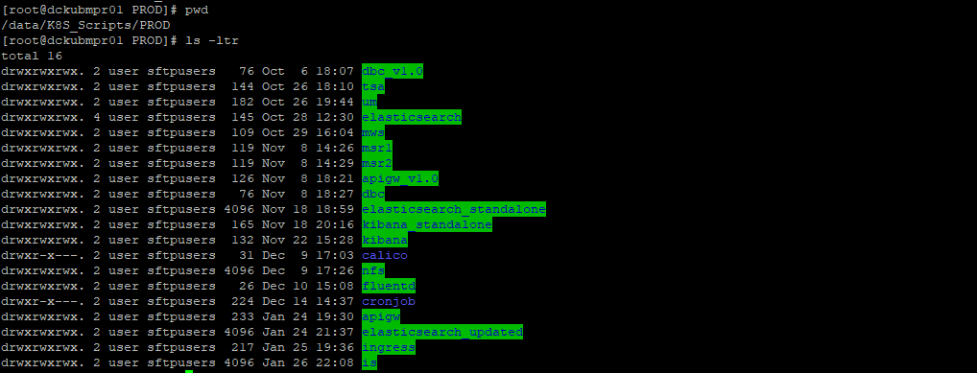
You need to repeat the same for each of the component one by one before all the products are deployed.

Once the products are deployed this is how the state of all the running Pods will look like

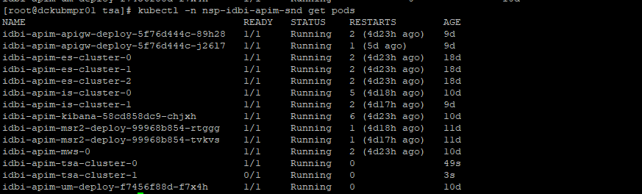

Environment Details
Below are the list of environment details

Prod Environment Details:

Prod DB Details

SandBox Prod Environment Details:

SandBox Prod DB Details

UAT Environment Details:

UAT DB Details

DEV Environment Details:

DEV DB Details

SIT Environment Details:

SIT and DEV will share the same APIGW Standard Edition. The only difference is that the APIGW registration port will be configured different ports for DEV and SIT.

SIT DB Details

TRN Environment Details:

TRN DB Details

SandBox DR Environment Details:

SandBox DR DB Details:

DR Environment Details:

DR DB Details:

For the Administrator password please refer to the “Environment Detail.xls” sheet in the Credential tab.

Post Deployment Configuration:
Once the deployment is completed you need to do the below configuration for the APIGW and MWS server.

If you want to access the Admin console of APIGW IS and APIGW UI for clustered environment, you will need to enable the Kubernetes Port forwarding.

Execute the below command once in the APIGW Node 1 and then in Node 2

Note: Please change the port forwarding port depending on the available port that is accessible and the firewall is opened for VDI browser access.

nohup kubectl -n nsp-idbi-apim-prod port-forward --address 0.0.0.0 pod/<apigw-pod-name-node1> 30001:5555 &
nohup kubectl -n nsp-idbi-apim-prod port-forward --address 0.0.0.0 pod/<apigw-pod-name-node1> 30002:9072 &

nohup kubectl -n nsp-idbi-apim-prod port-forward --address 0.0.0.0 pod/<apigw-pod-name-node2> 30001:5555 &
nohup kubectl -n nsp-idbi-apim-prod port-forward --address 0.0.0.0 pod/<apigw-pod-name-node2> 30002:9072 &

Before you run the port forwarding command, you should export the KUBECONFIG

export KUBECONFIG=/home/user/admin.conf

Login to the APIGW node and do the following

Go to Administration > Keystore/Truststore and ensure that the custom keystore and truststore are set as per the below screen shot

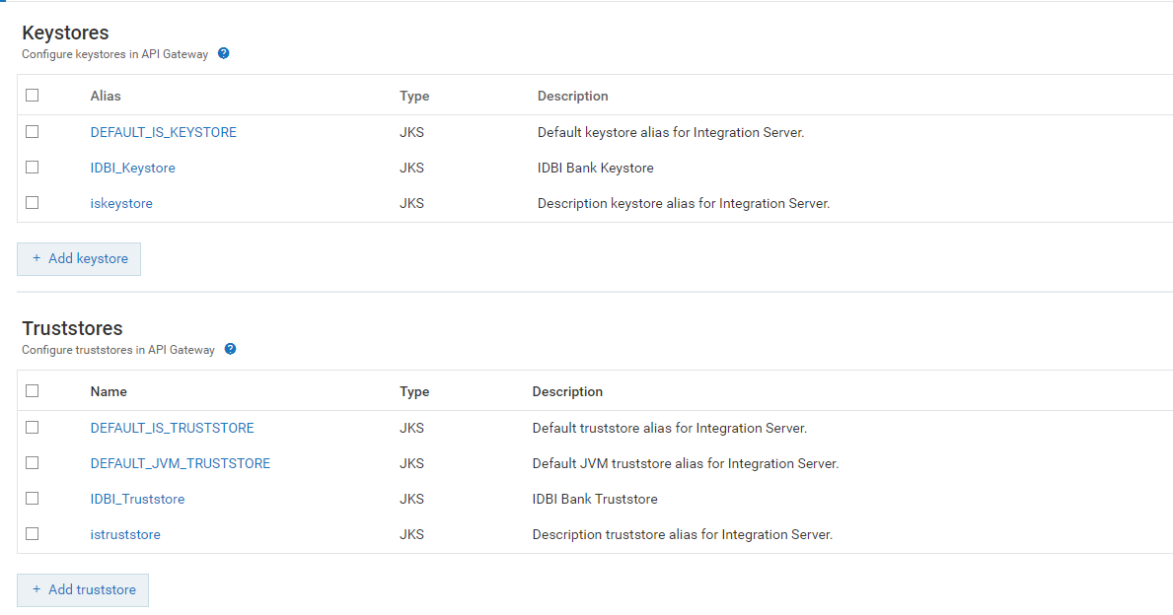
For inbound messages the below keystore and truststore should be set.

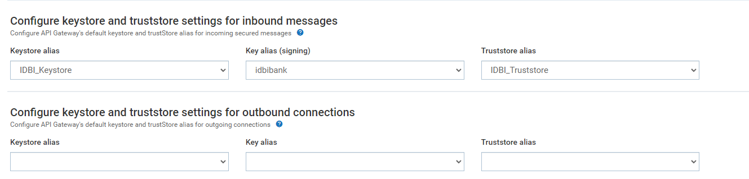
Now Go to Security > Ports and add the API Gateway Internal Port as below to enable the communication with the API Gateway external node. In this case the Port configured is 6643.

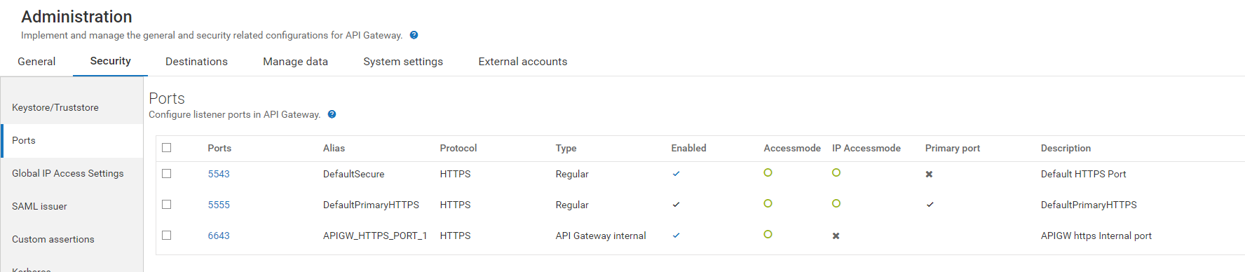
Click on Add Port and Select type API Gateway Internal.

Give the rest of the details as below.

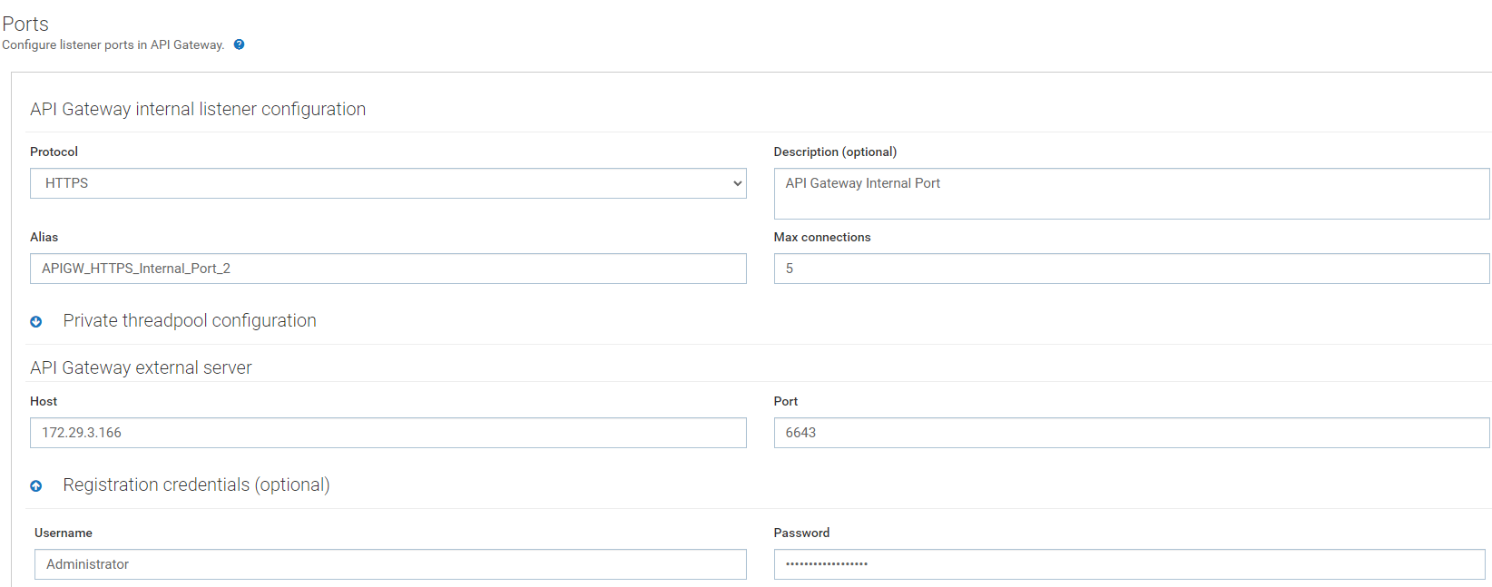
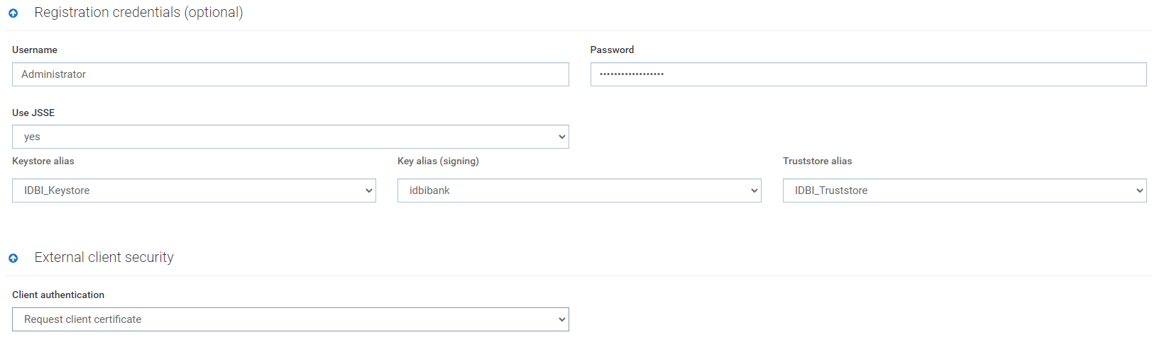
Click on Add button.

Then you will see that the new port 6643 has been added.

Then enable the Port.

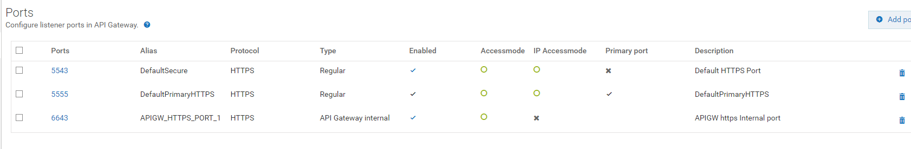
Updating the Administrator Password for APIGW

Login to the APIGW UI and click on the user icon on top right.

And the click on “profile”.

Then enter the current password and then the new password and save it.

Since, the APIGW uses the external Elastic Search for datastore, doing these changes in one of the APIGW node is enough. The changes will automatically get reflected in the other node.

Updating the Administrator Password for MWS

Login to the MWS Admin page.

Click on My Profile

Enter the new password and Confirm new password.

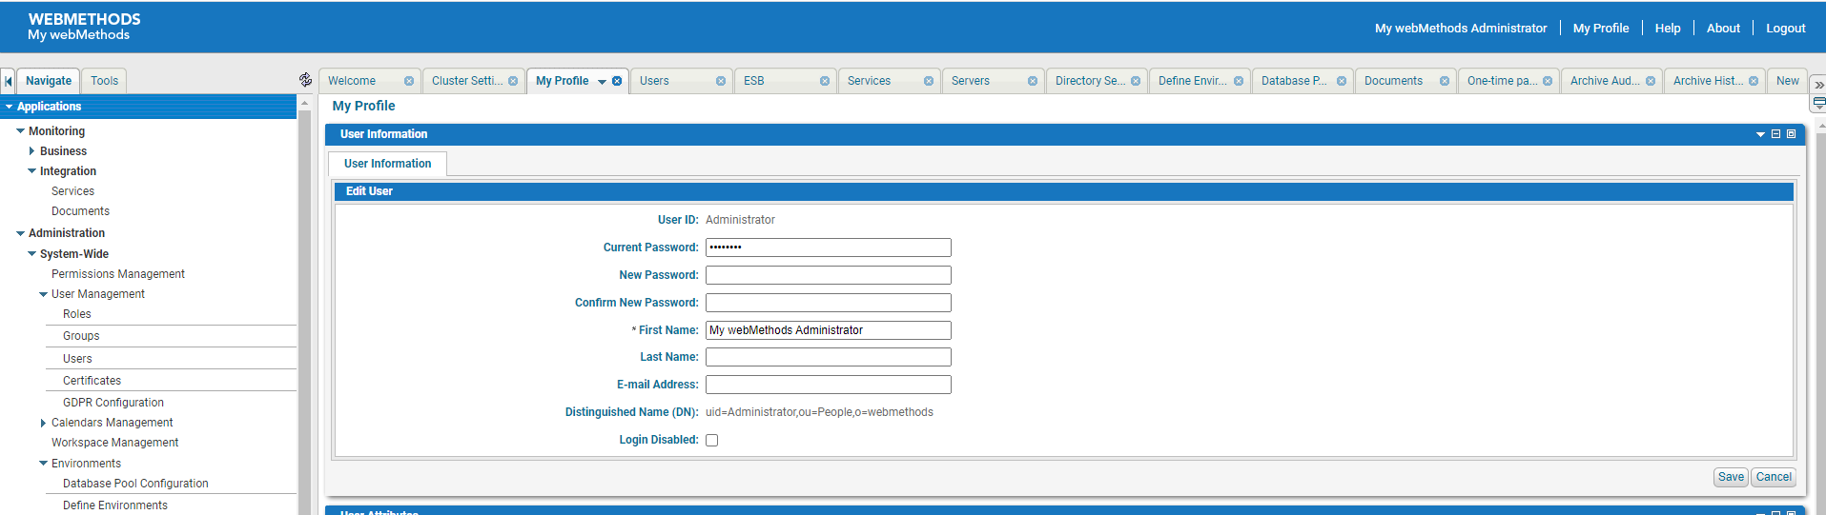

Environment Validation

DEV:

Below screenshots shows the validation for the environment

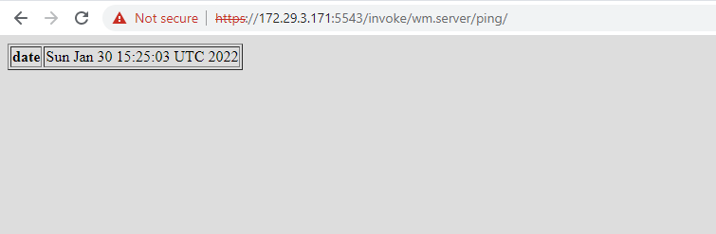

APIGW IS
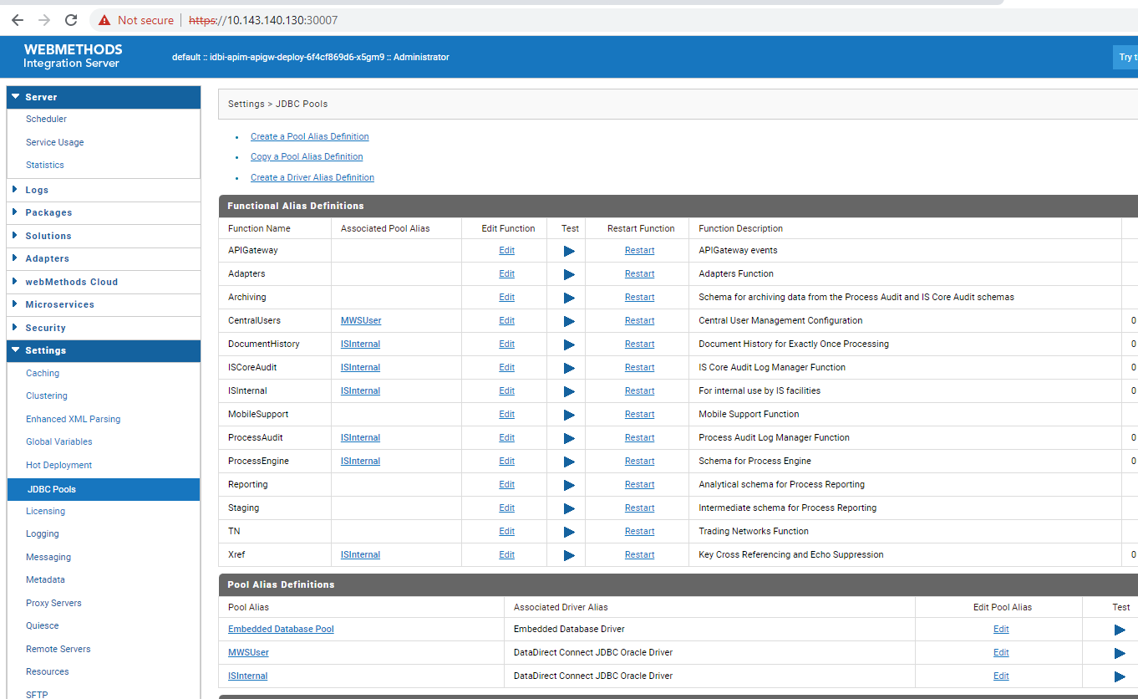

APIGW UI

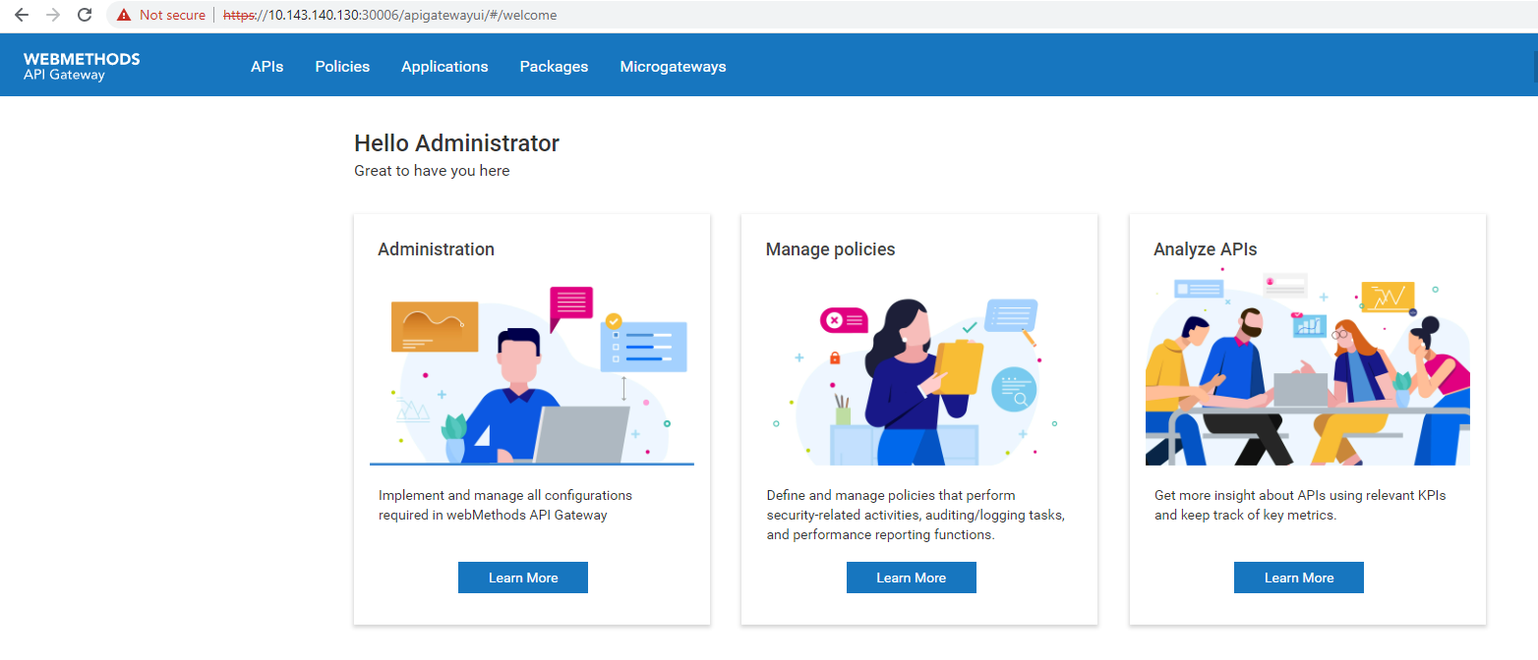

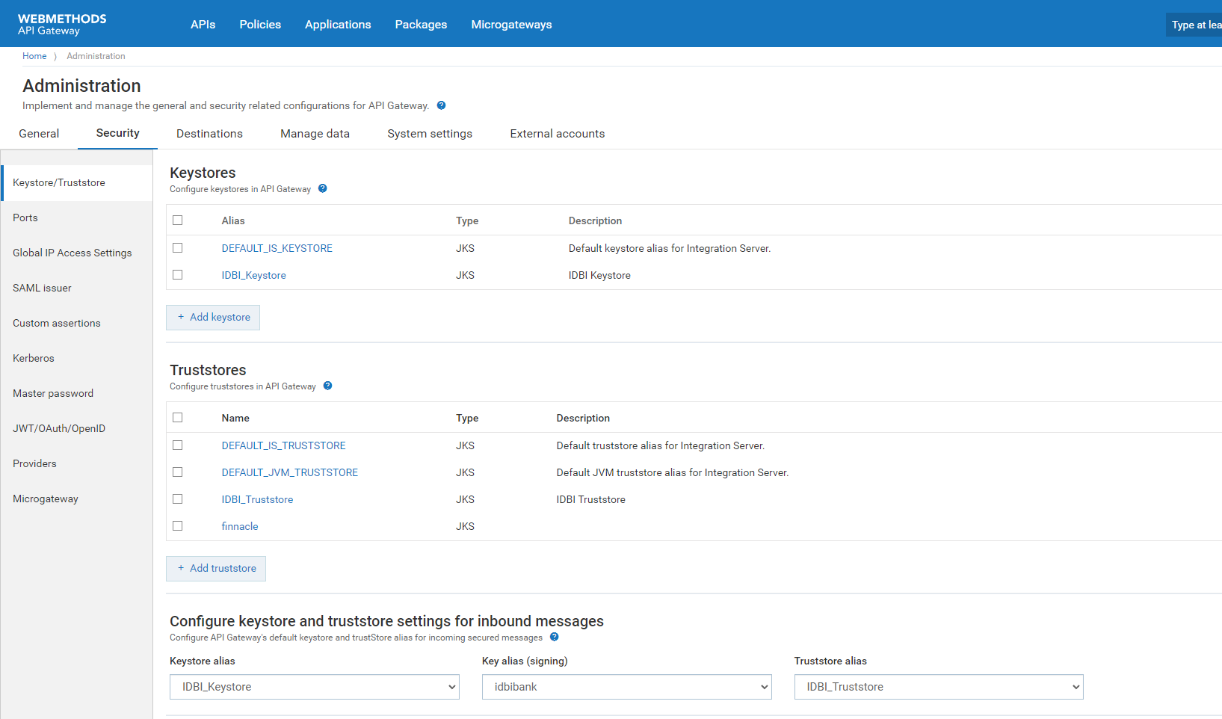

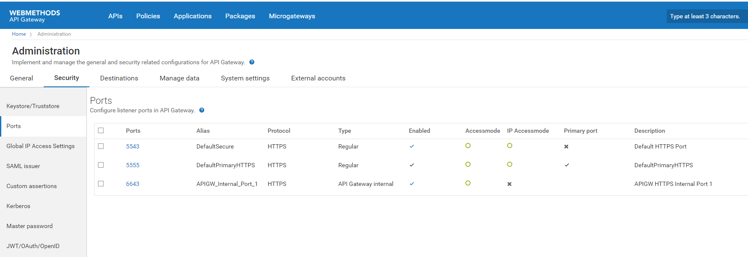

IS:

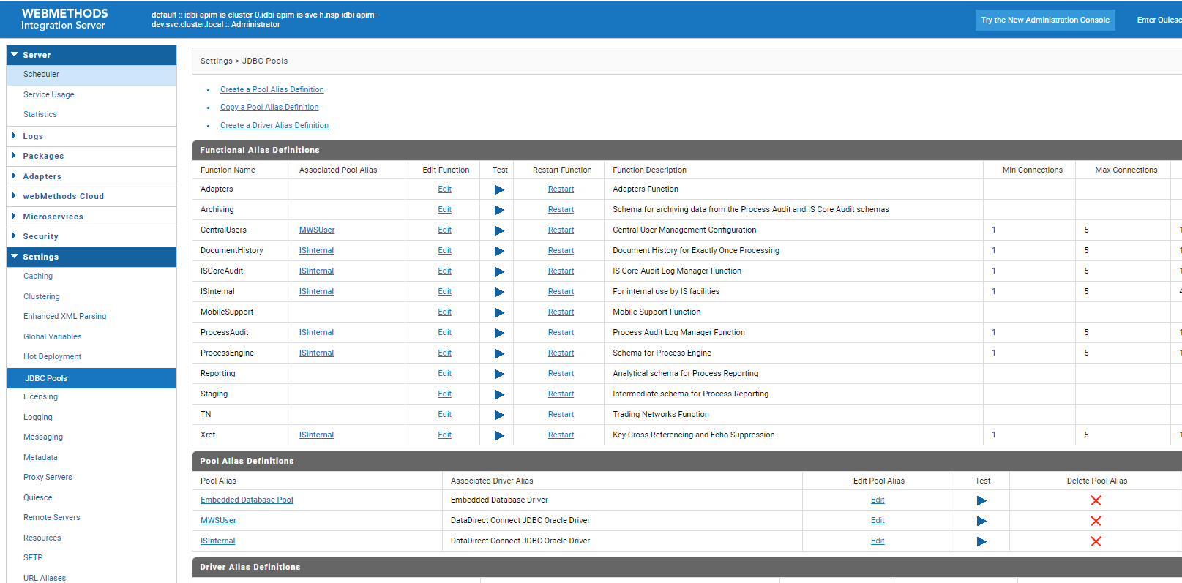

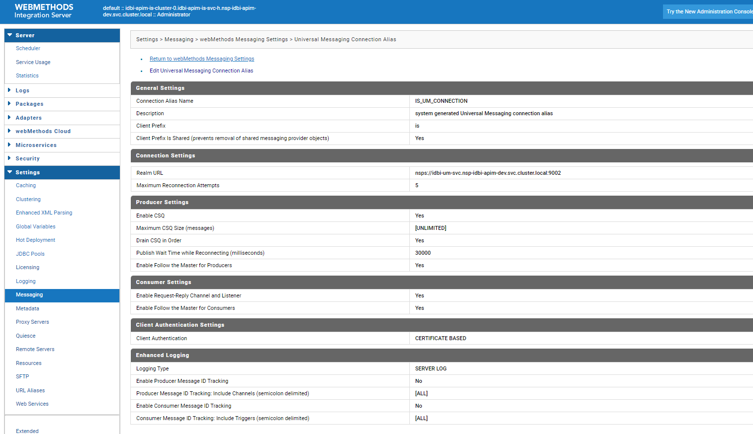

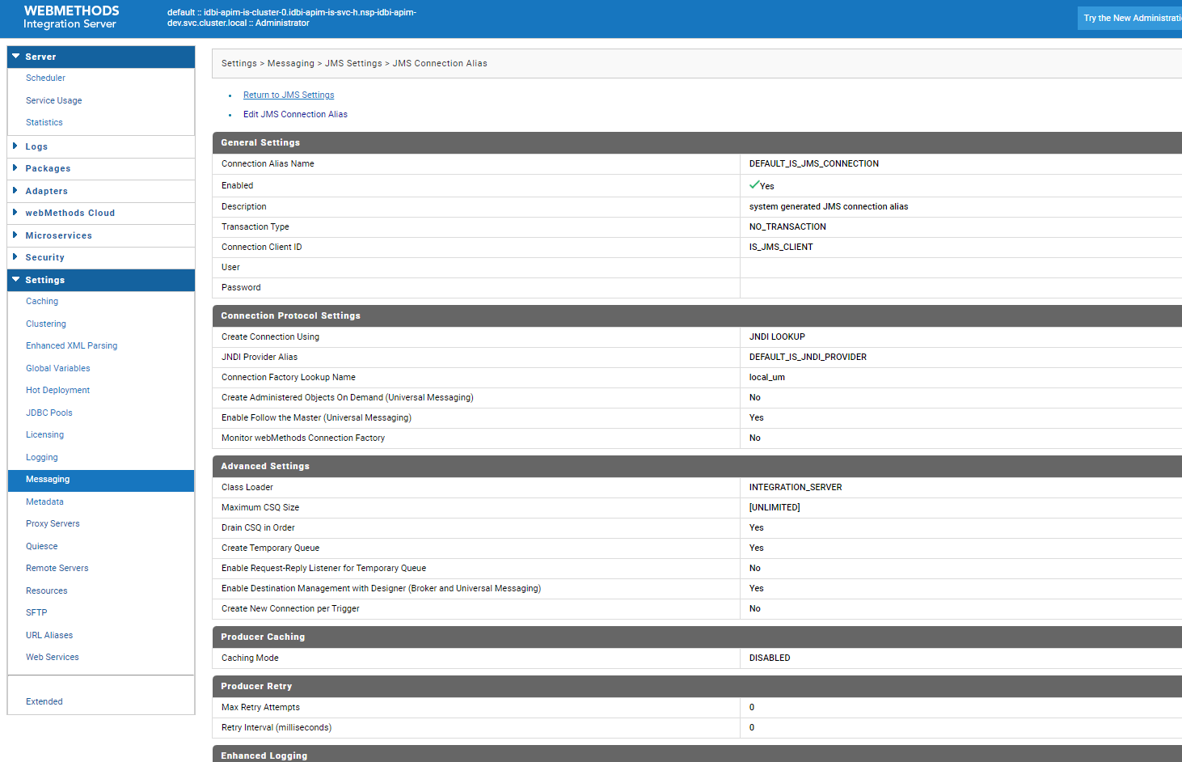
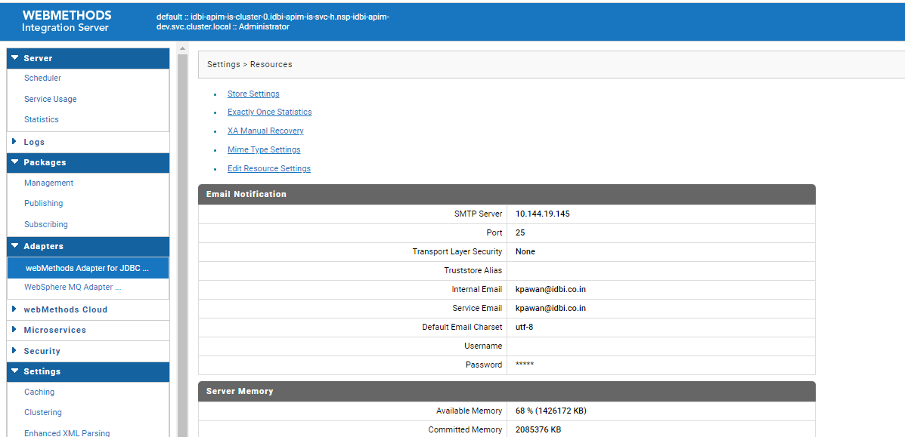

MSR:

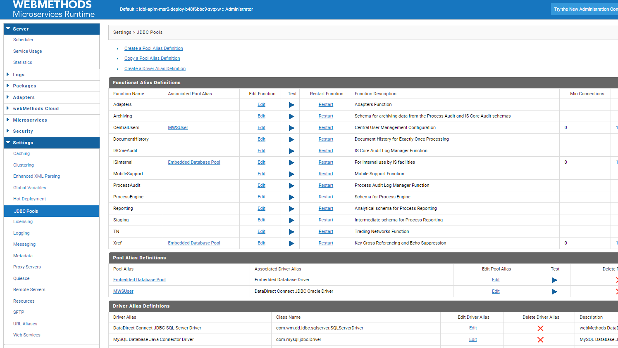
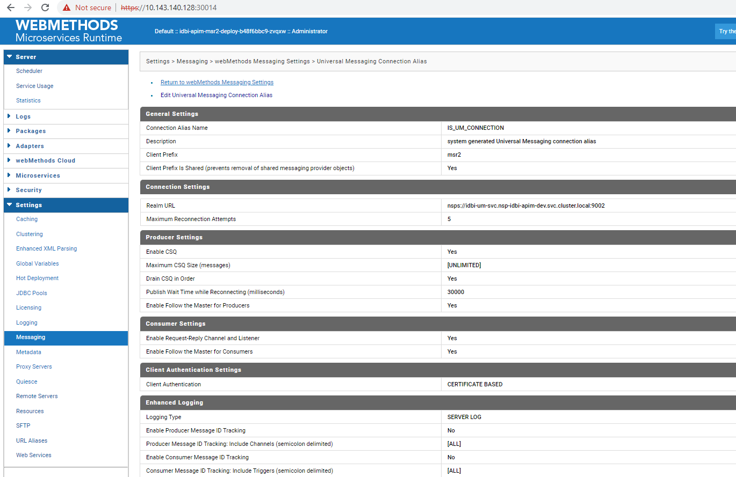

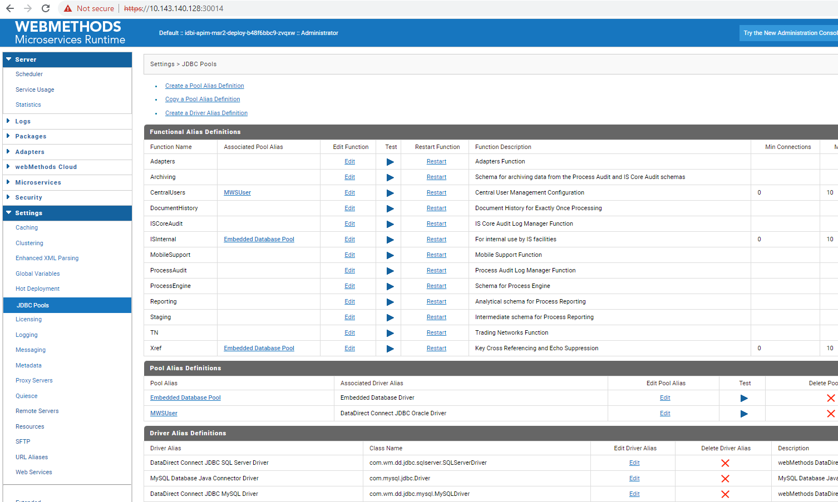

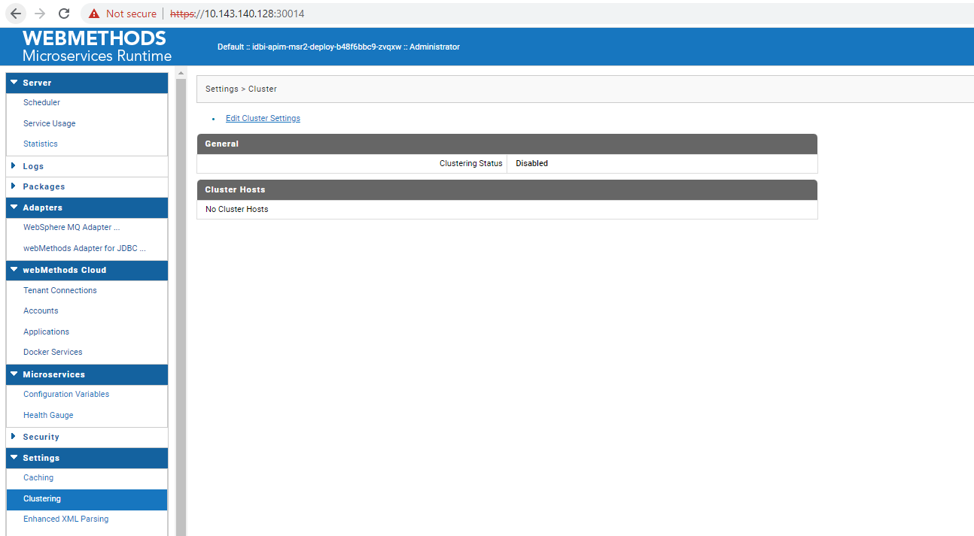

MWS:
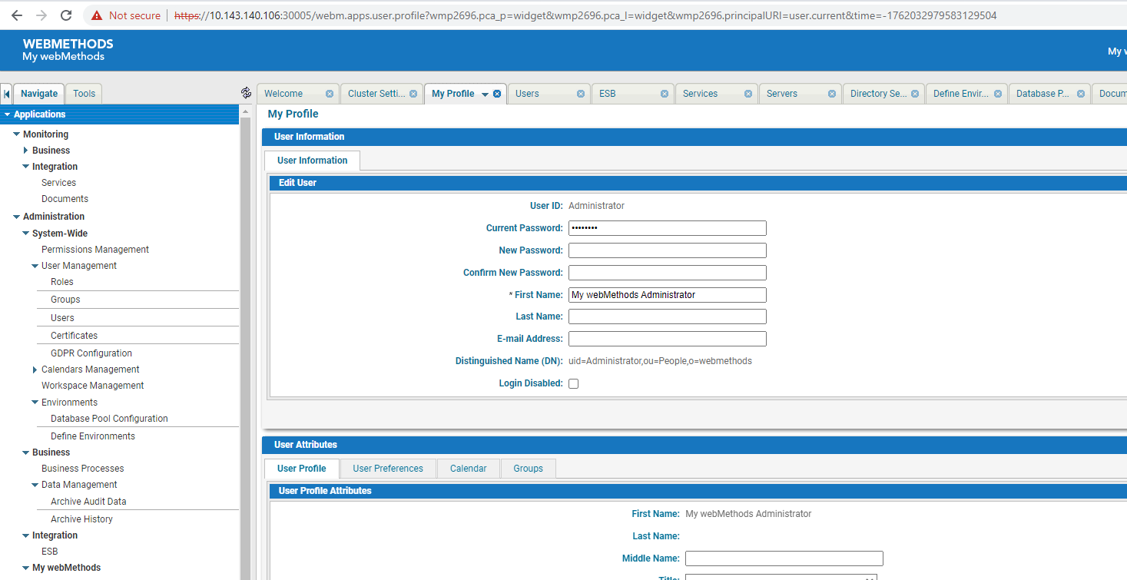

SIT:

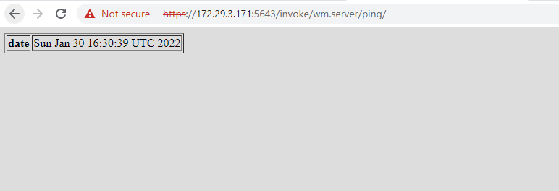

API GW IS:

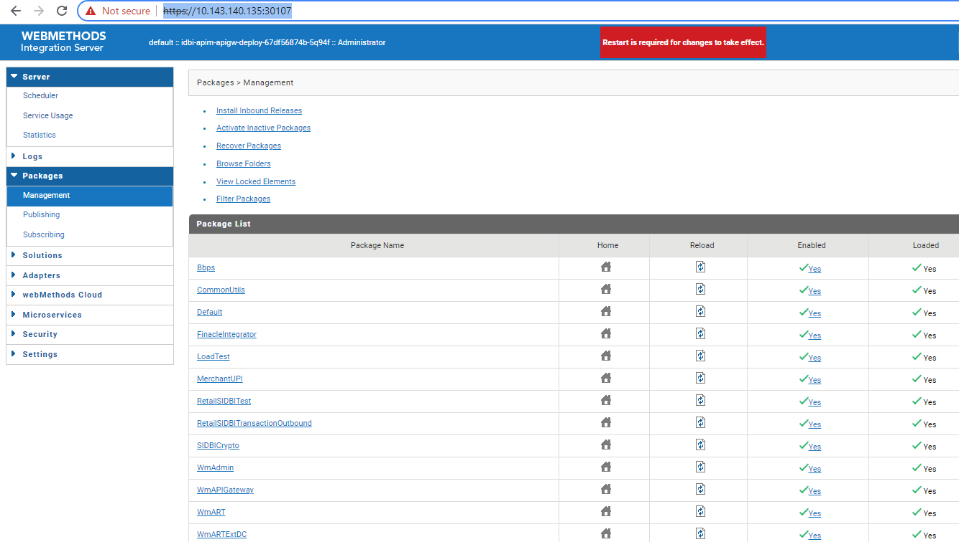

APIGW UI:

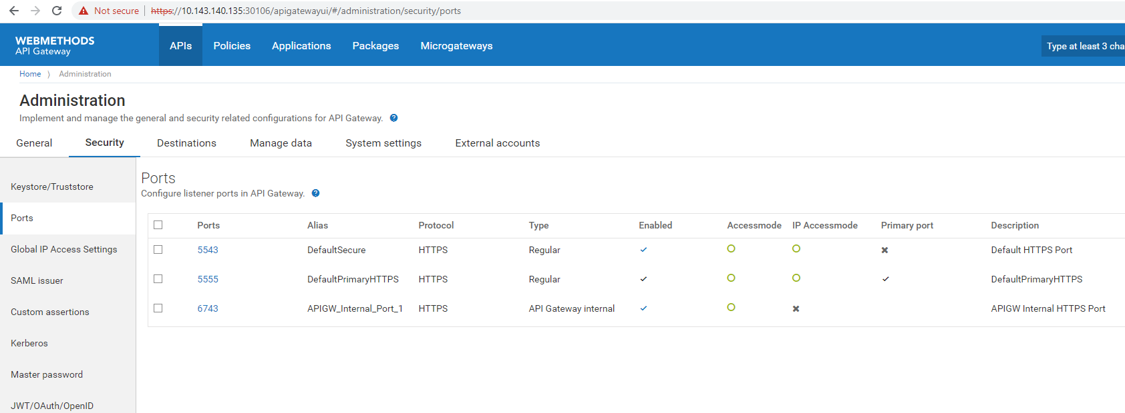

IS:

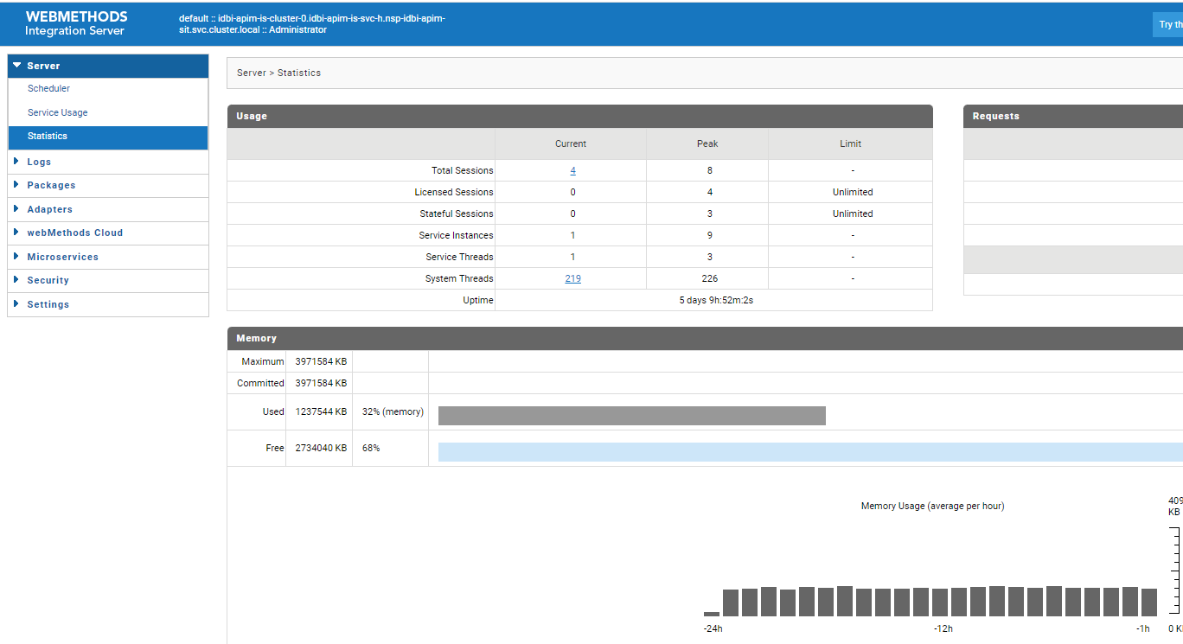

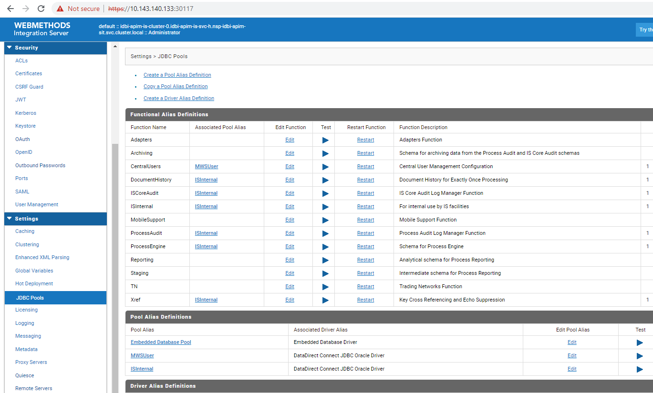

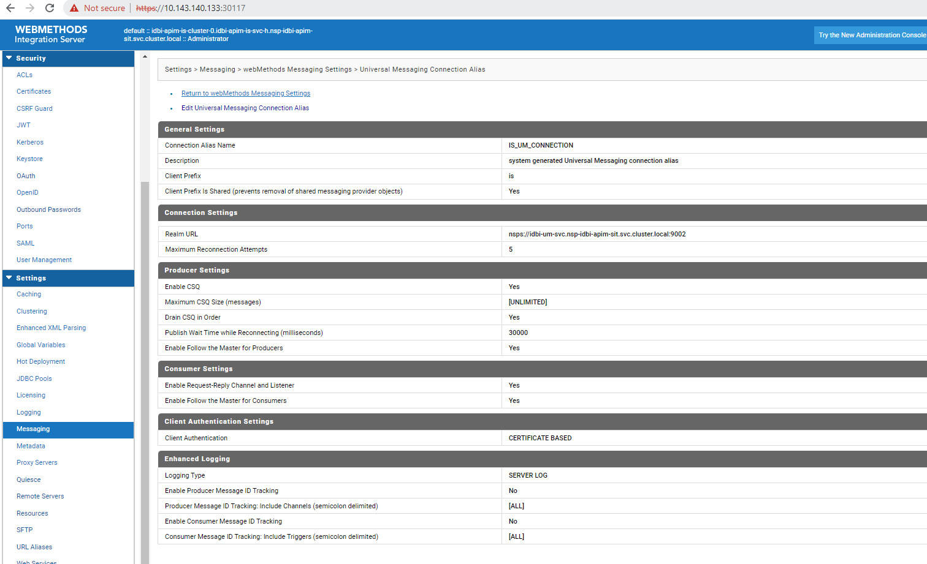

MSR:

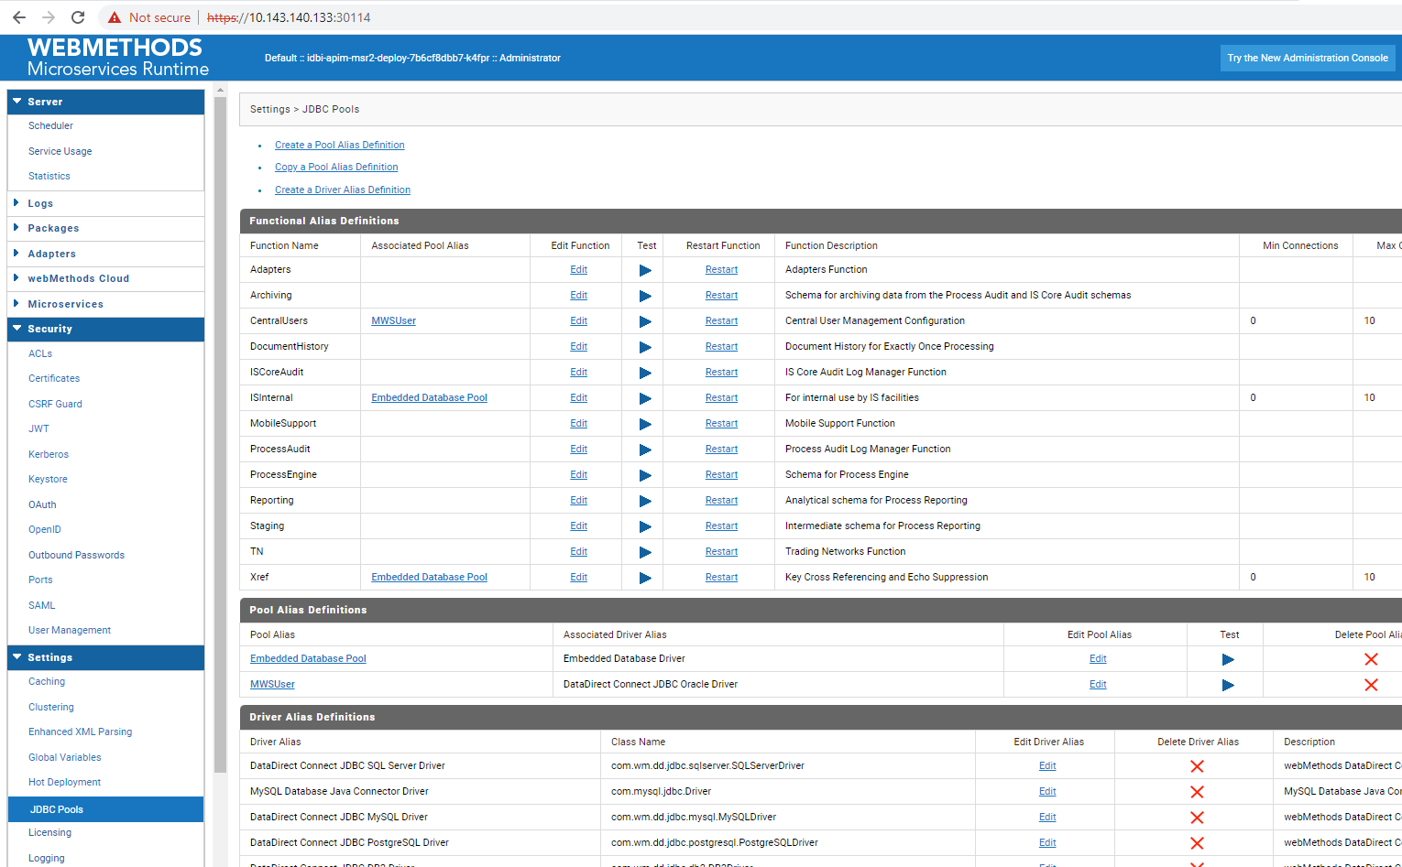

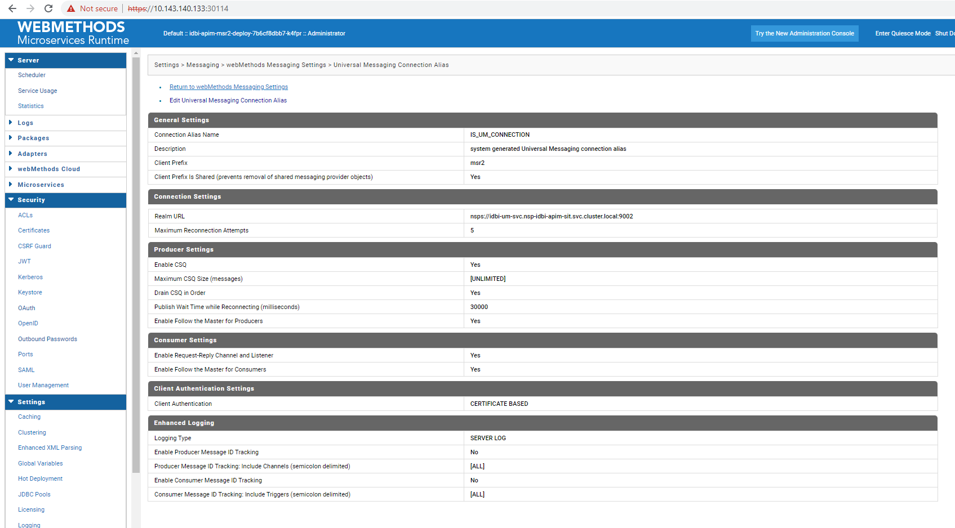

MWS:

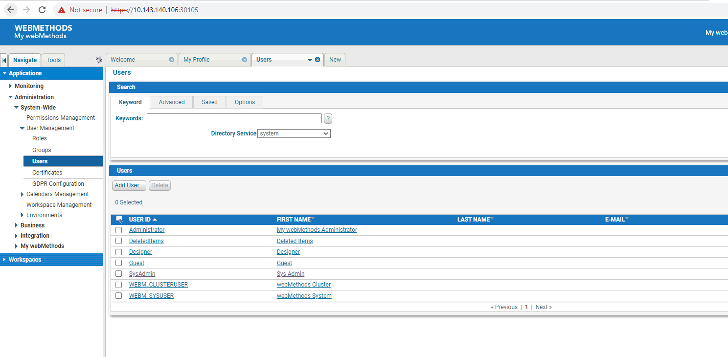

TRN:

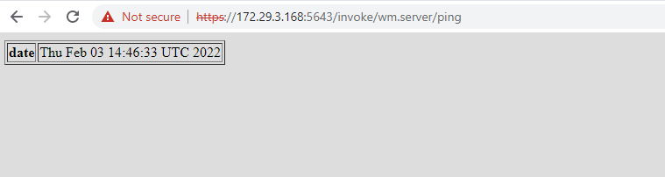
APIGW IS

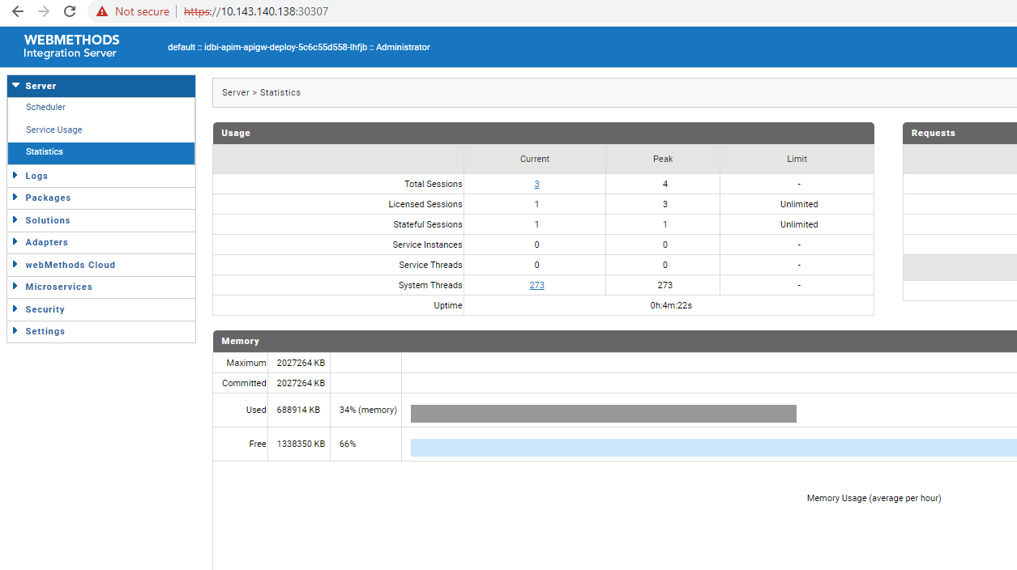

APIGW UI
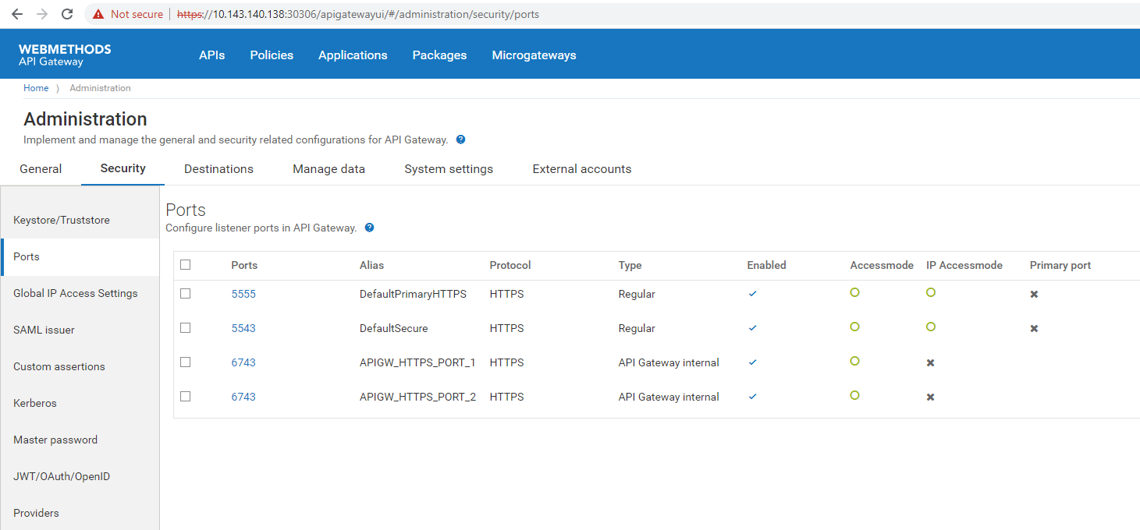

MSR
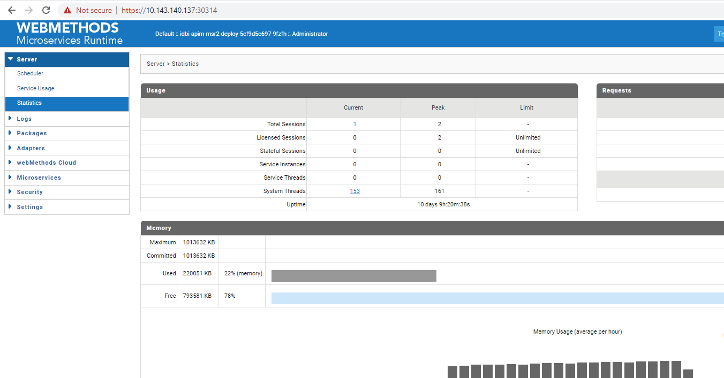

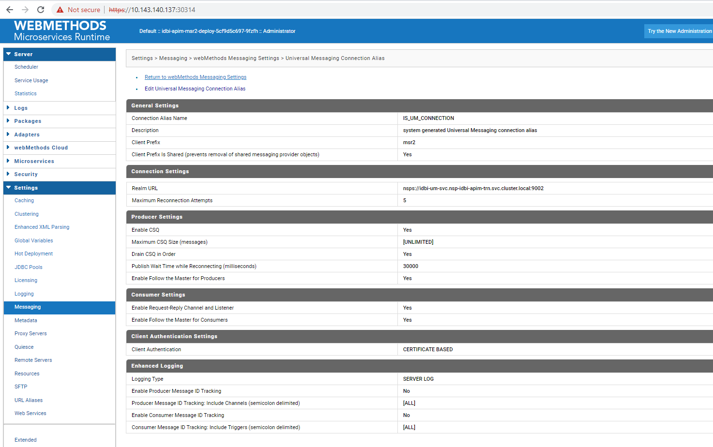

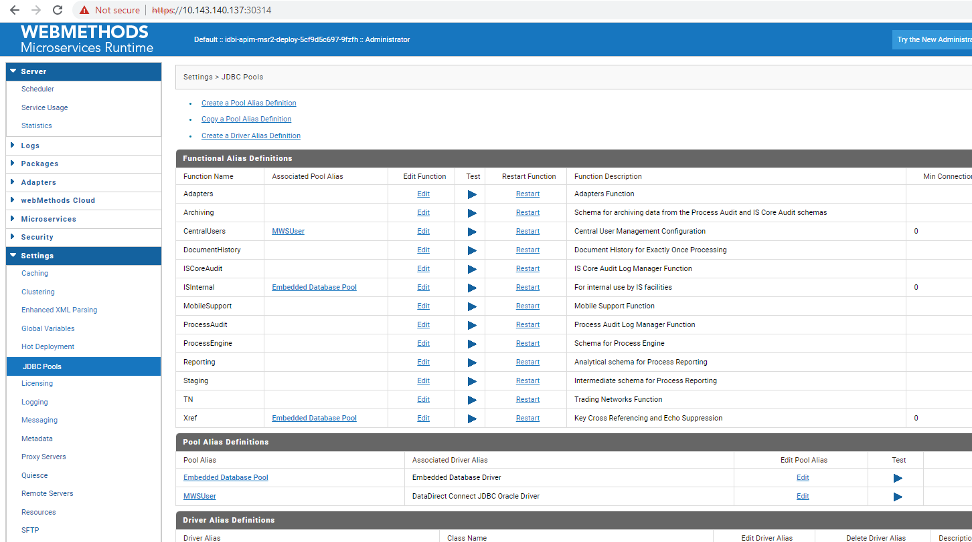

IS
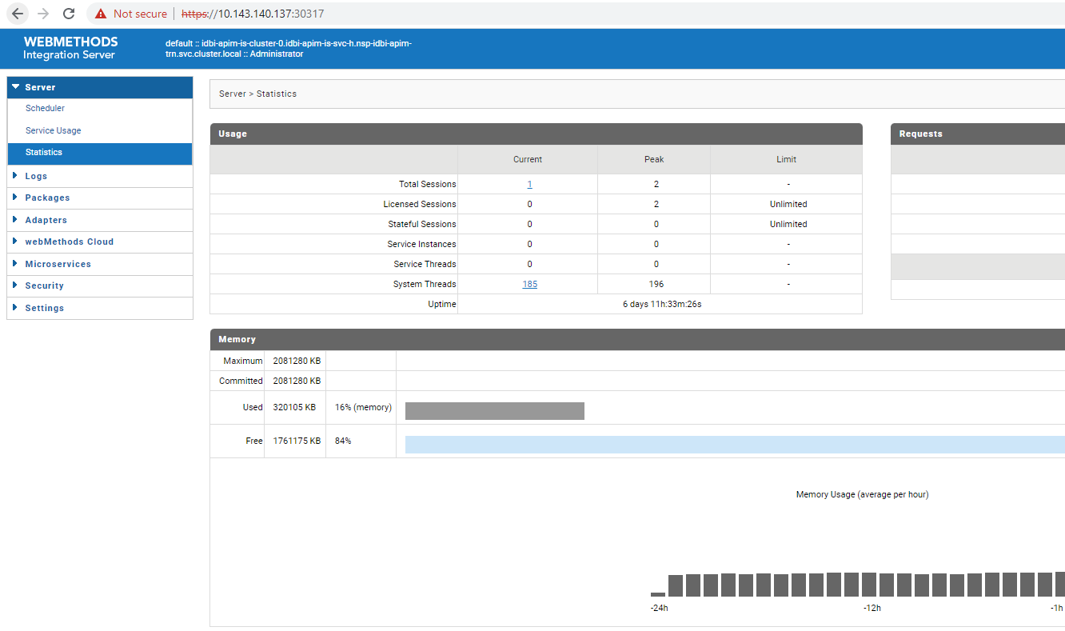
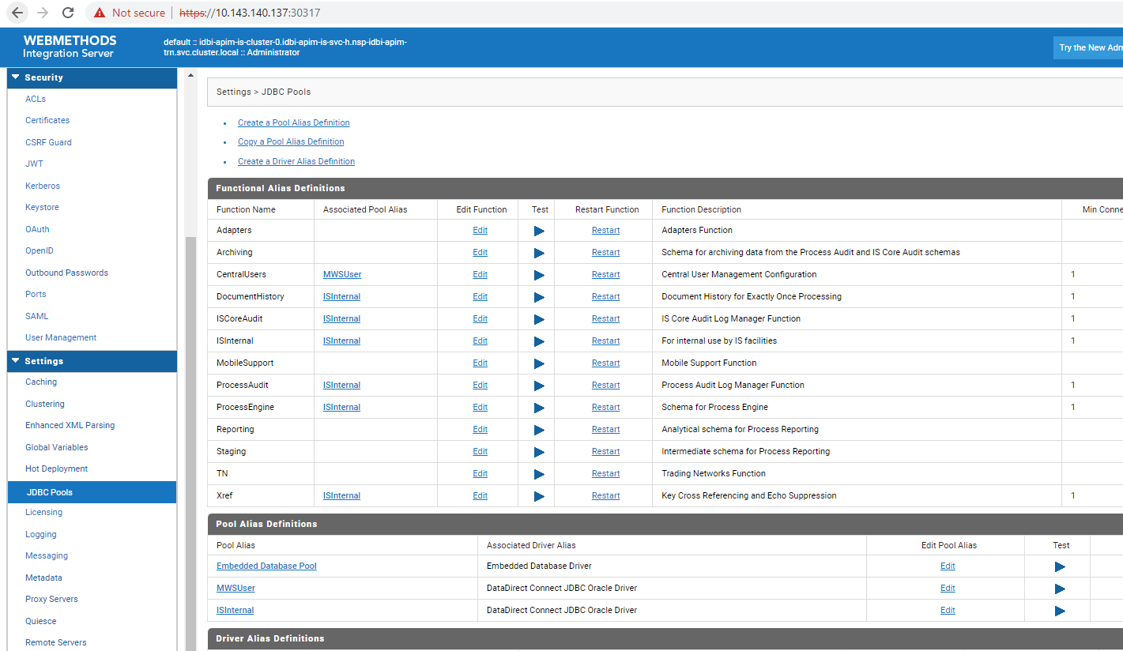
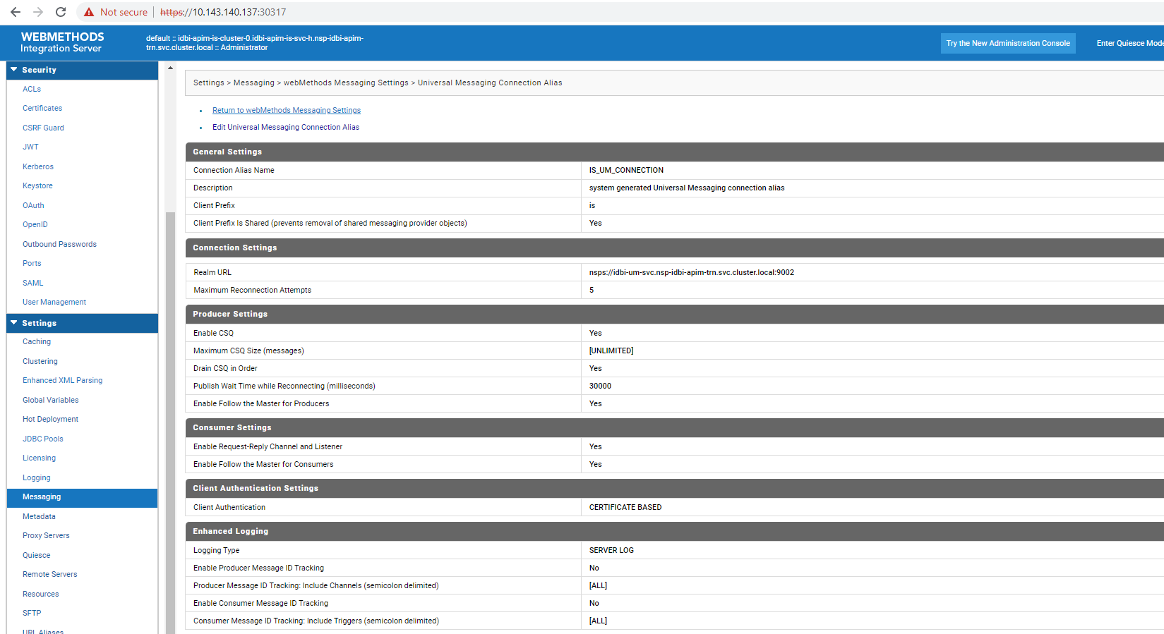

MWS
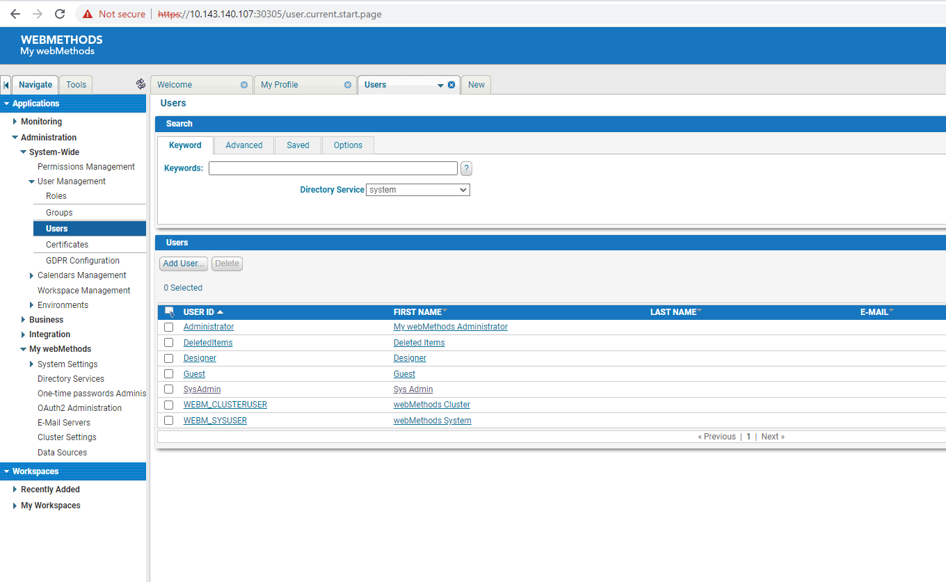

UAT
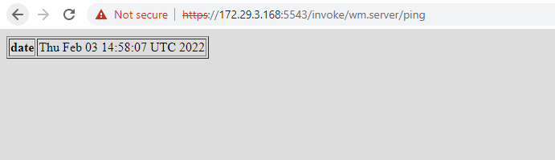

APIGW IS
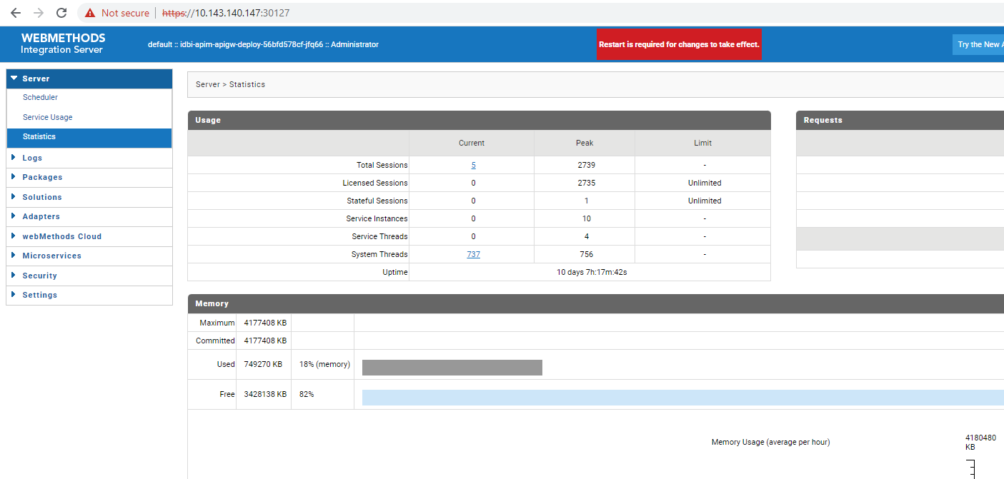
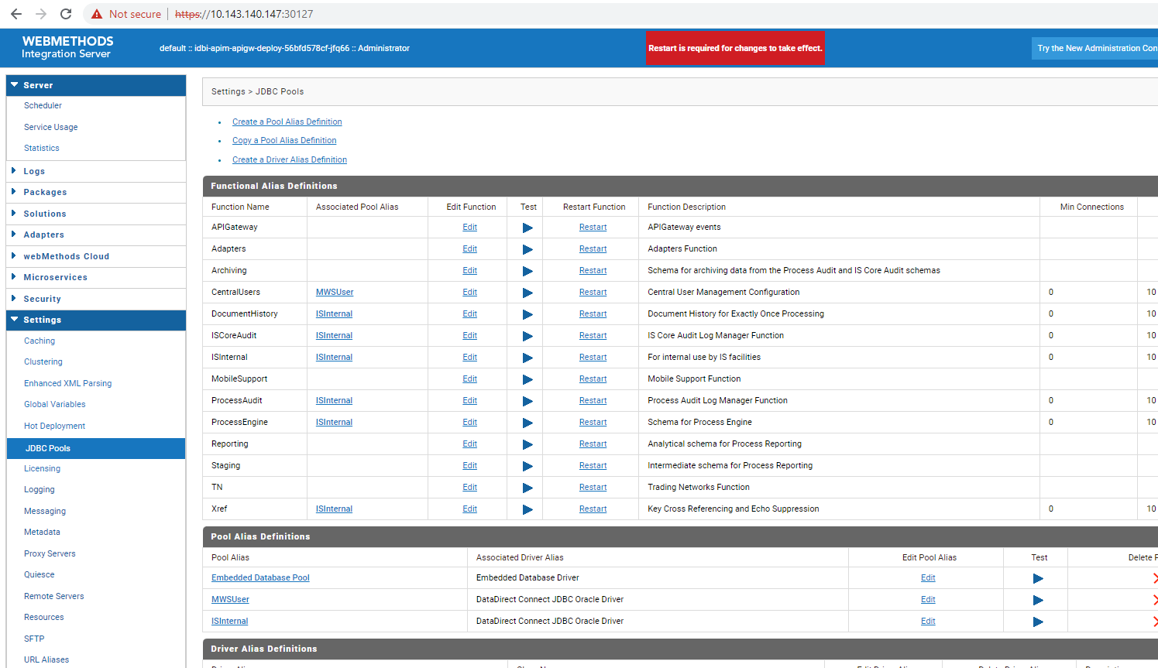
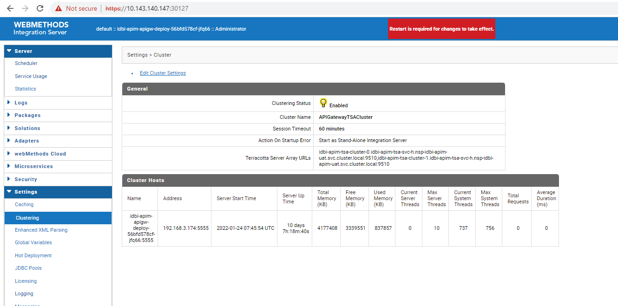

APIGW UI

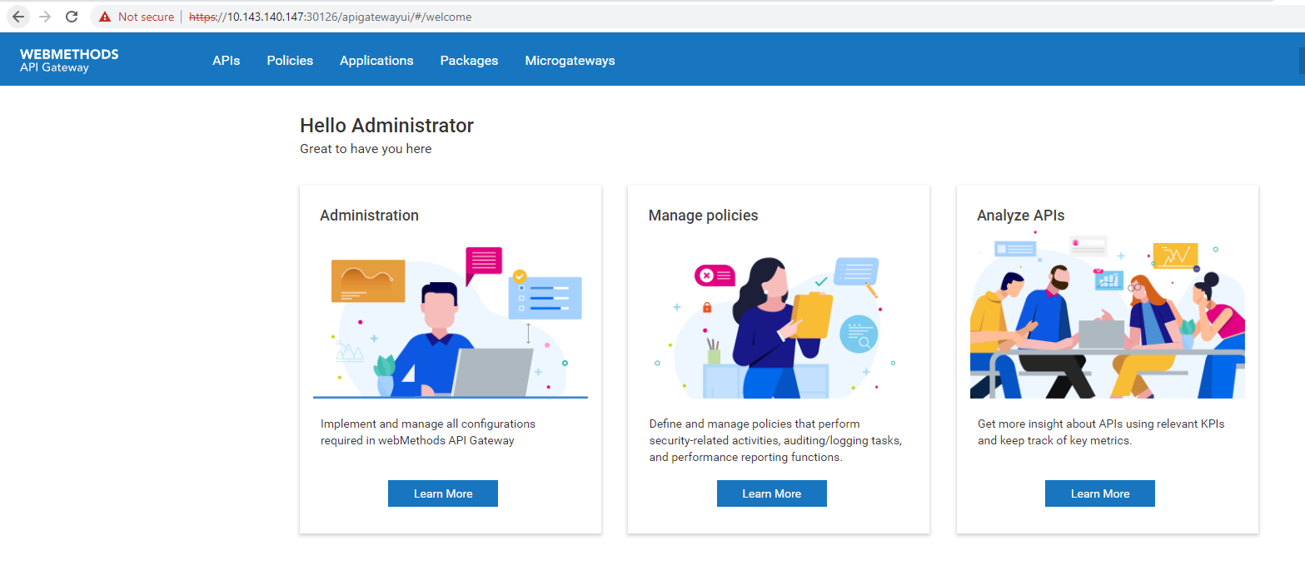
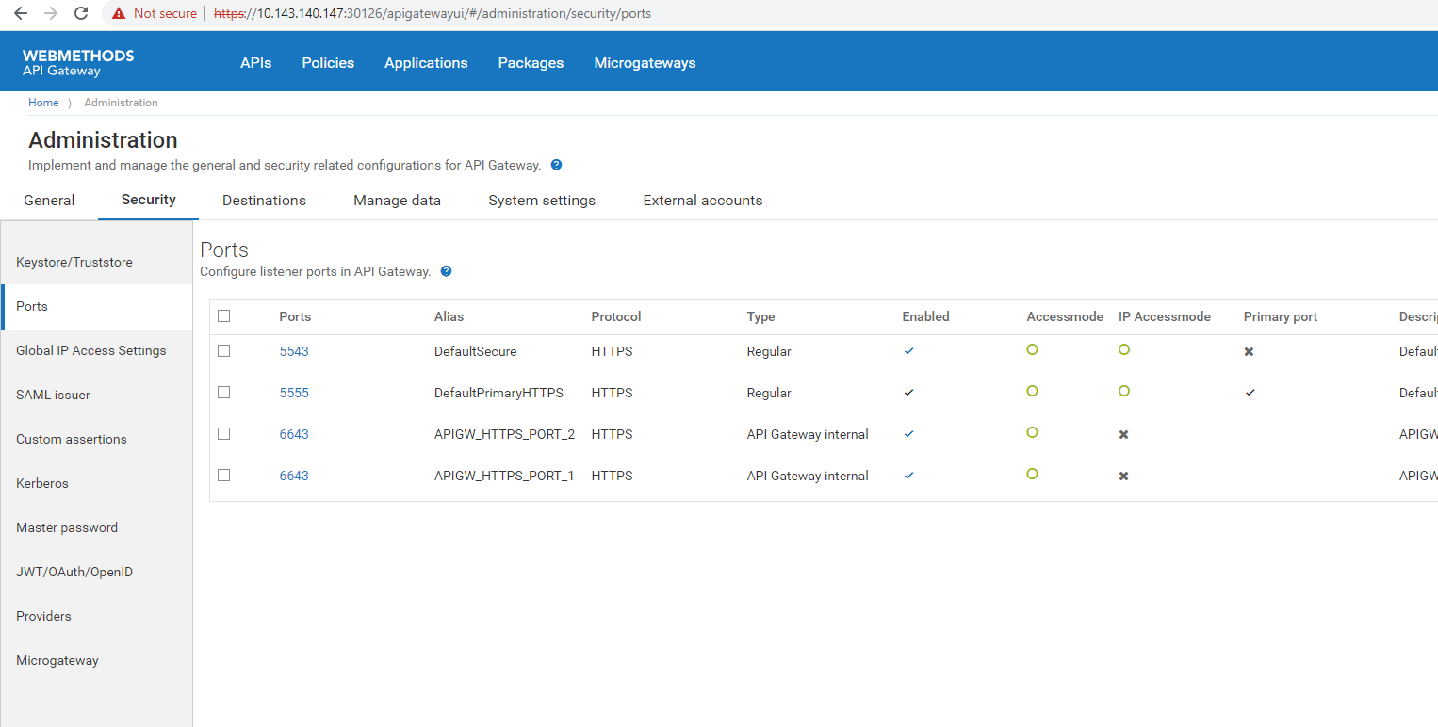

IS

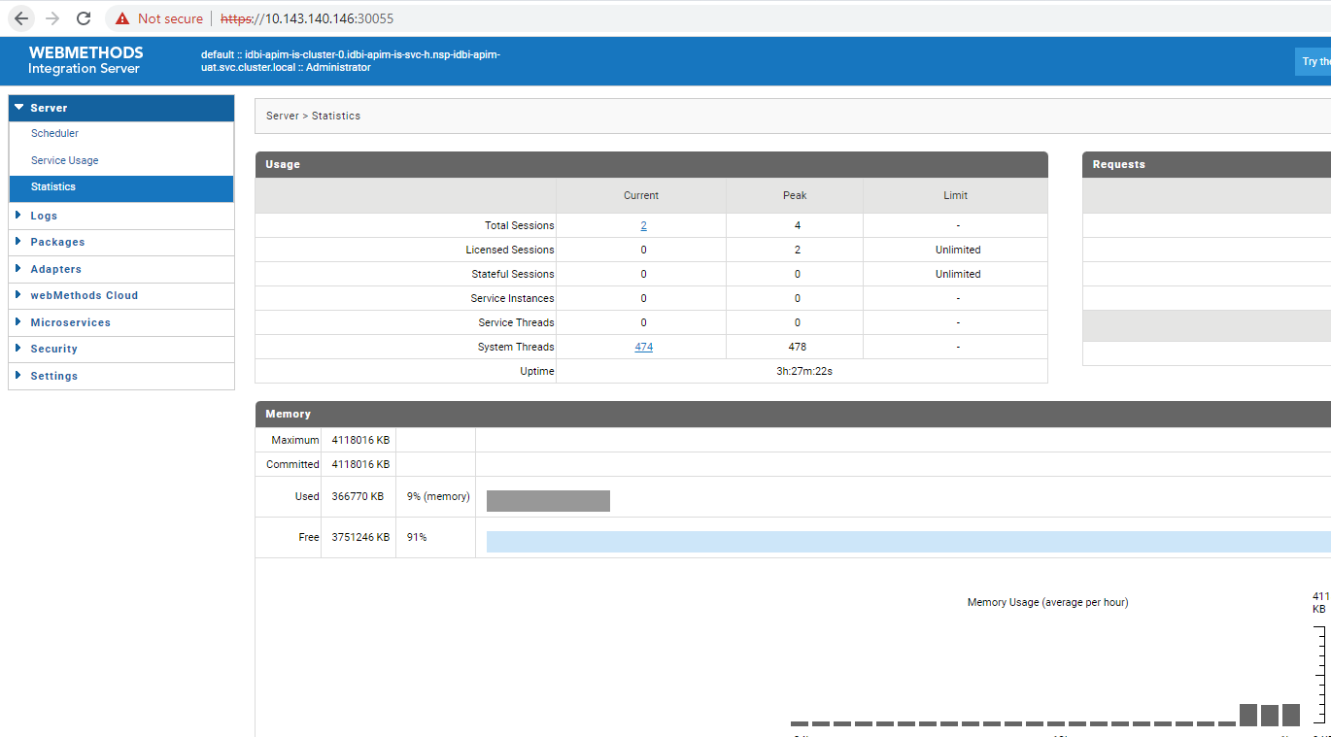
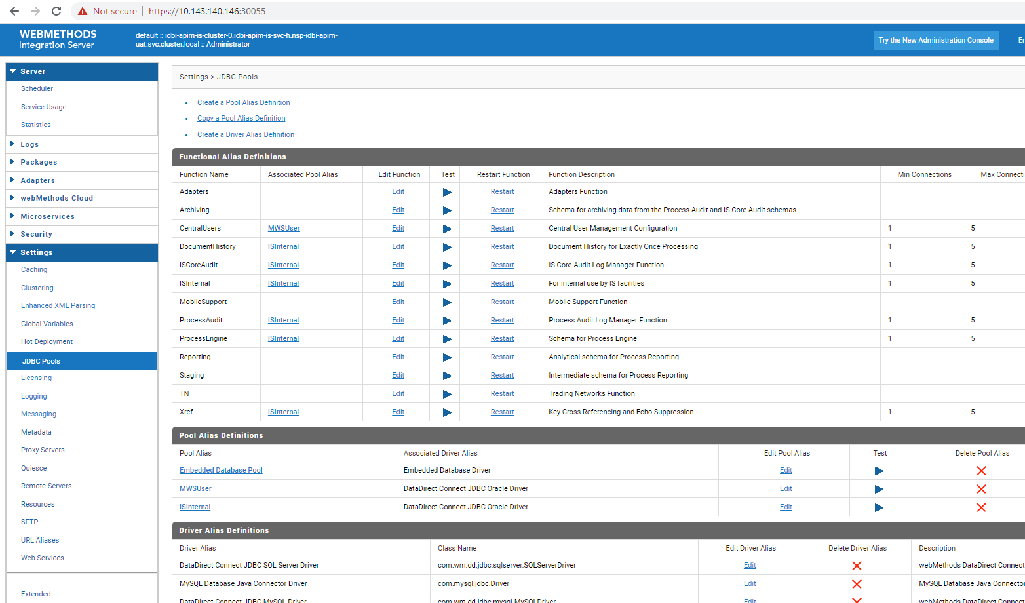

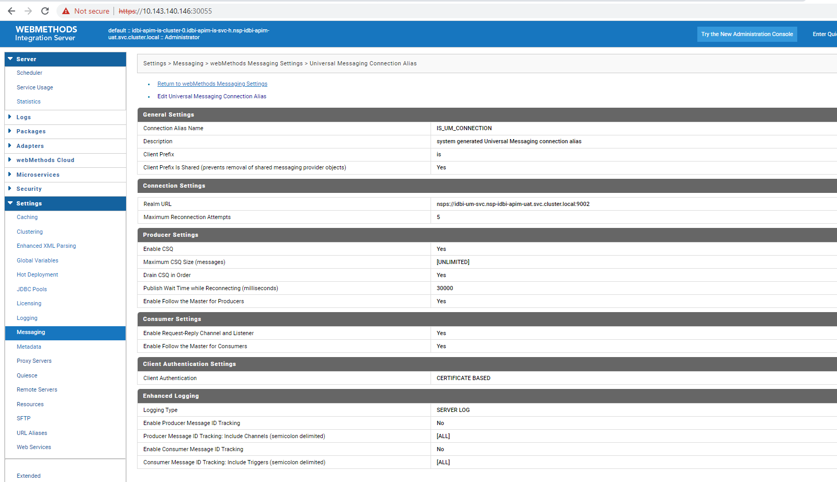

MSR
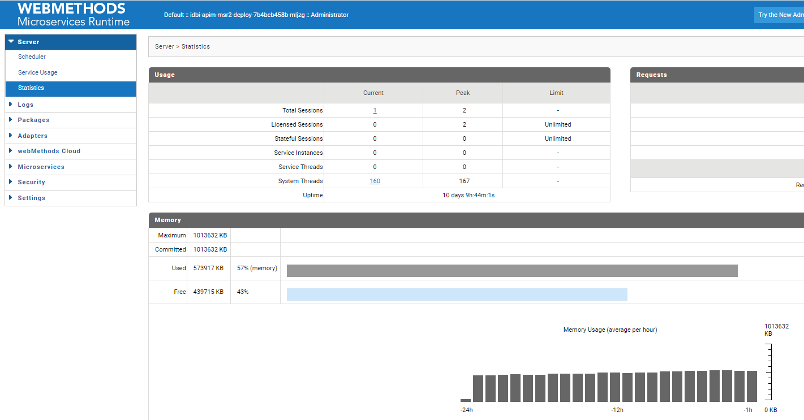

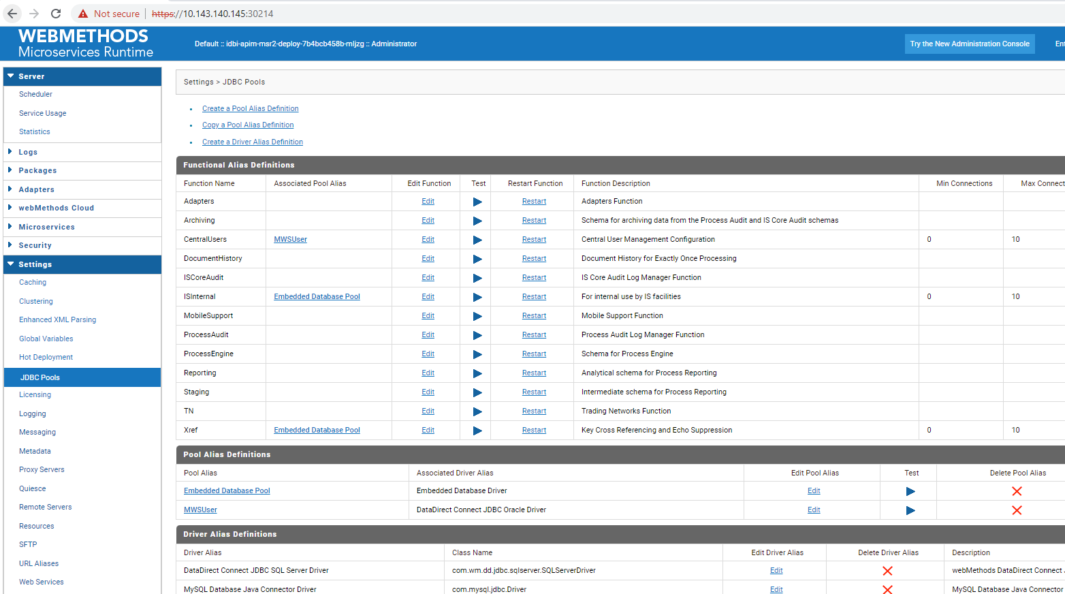
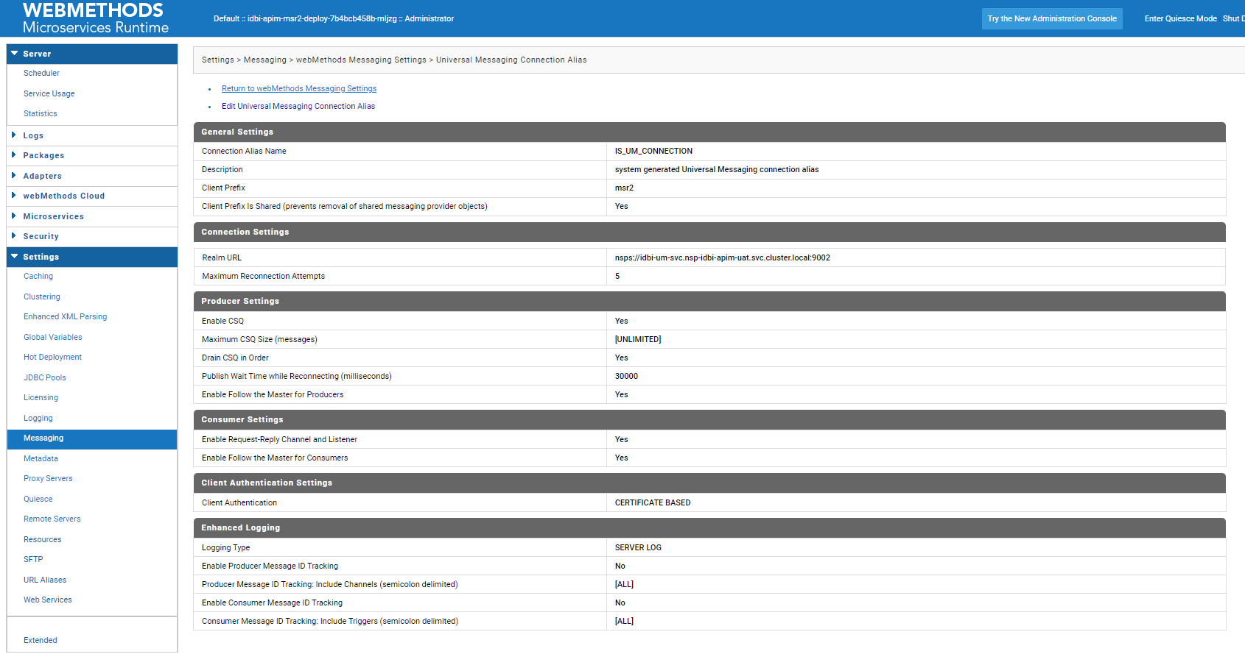

MWS
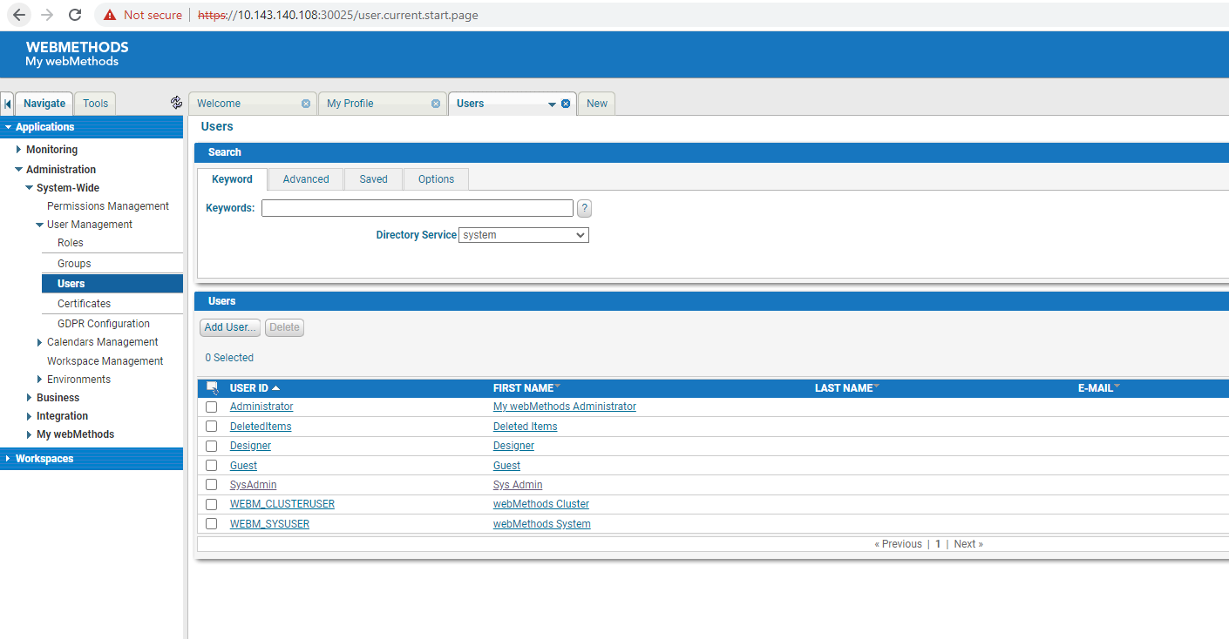

PROD
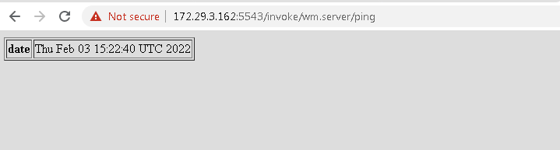

APIGW IS
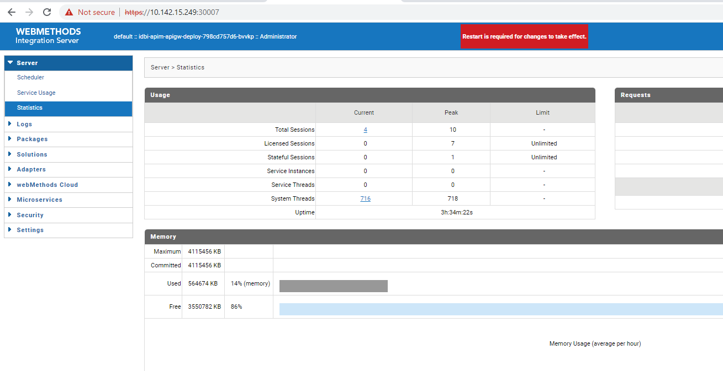

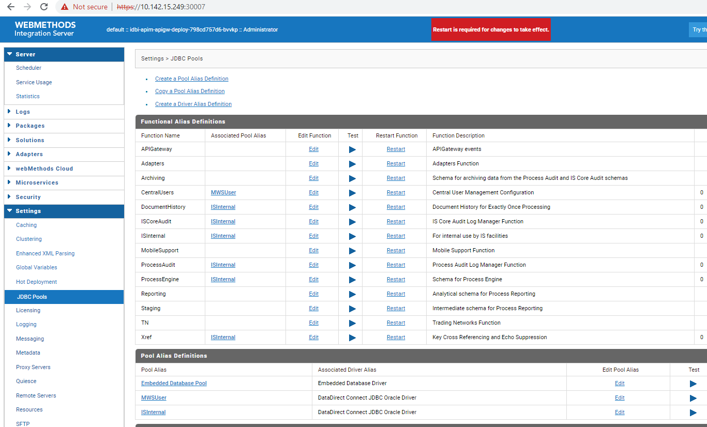

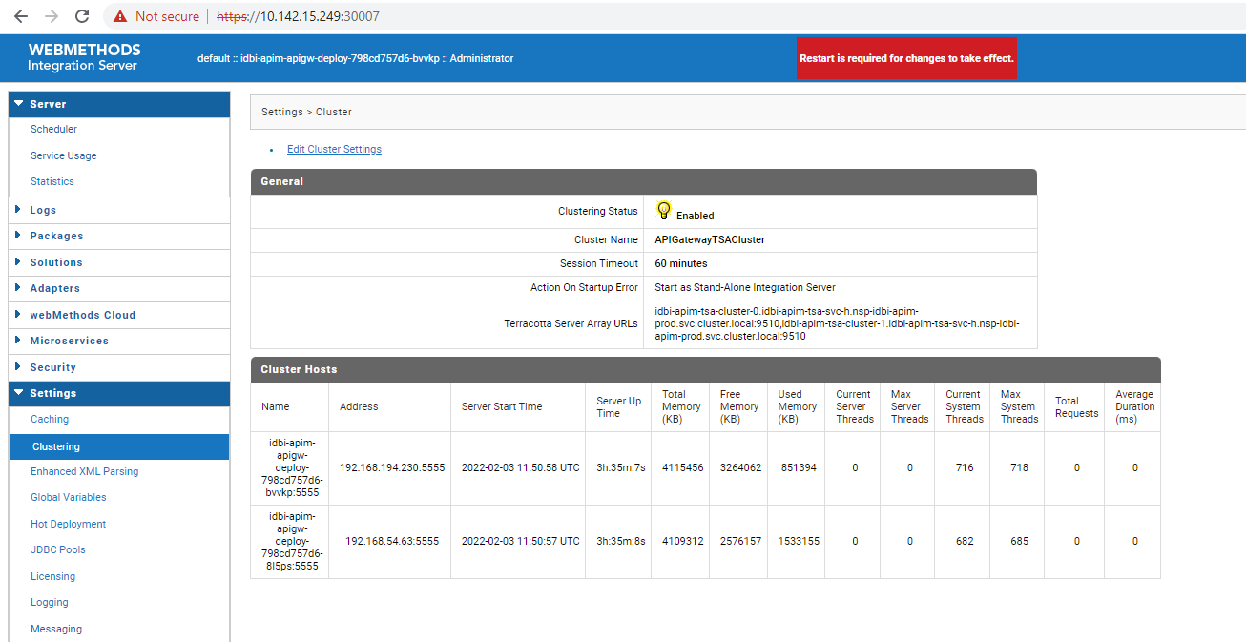
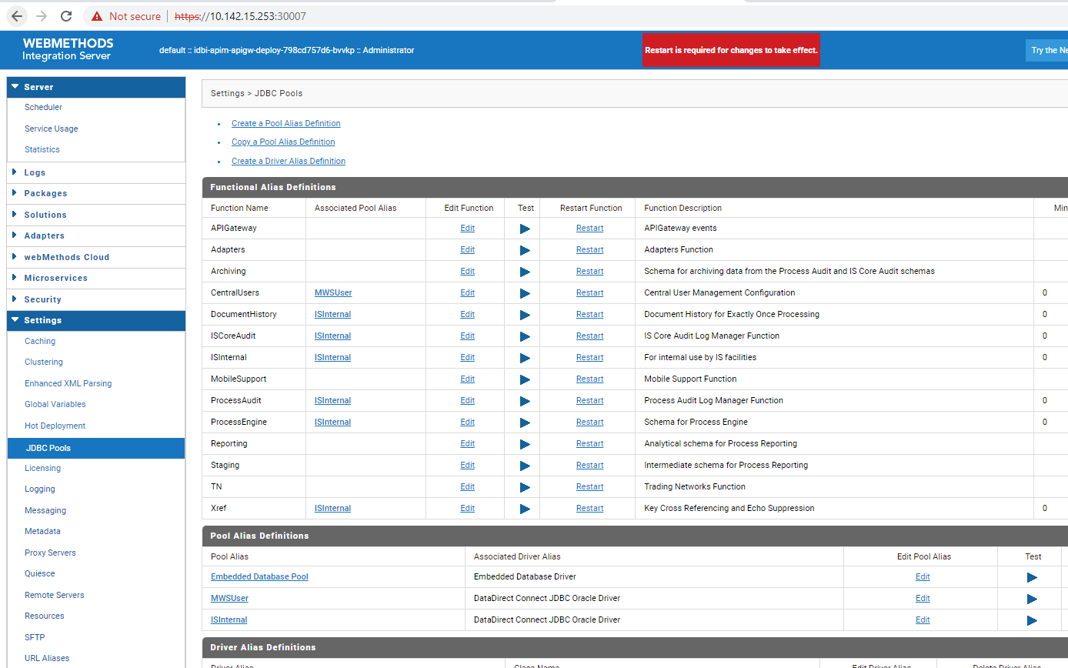

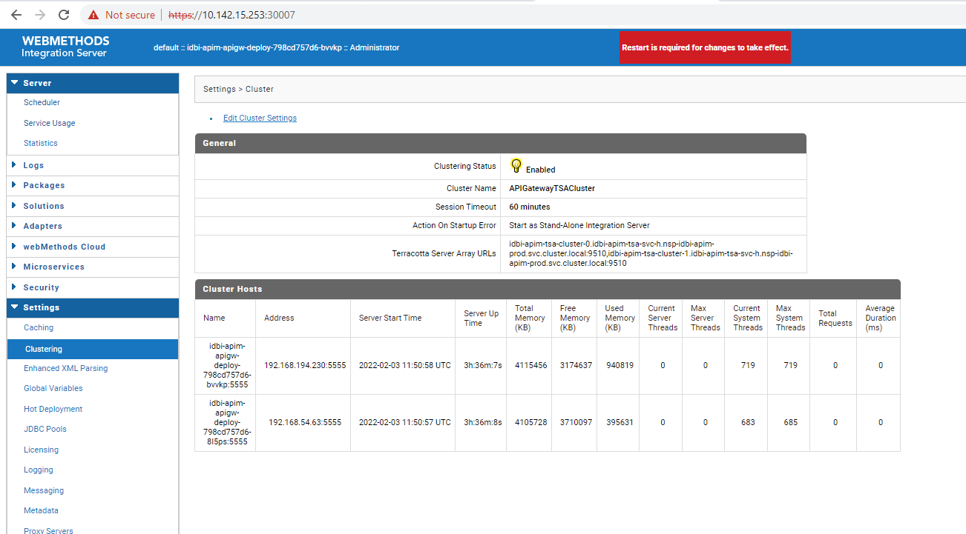

APIGW UI
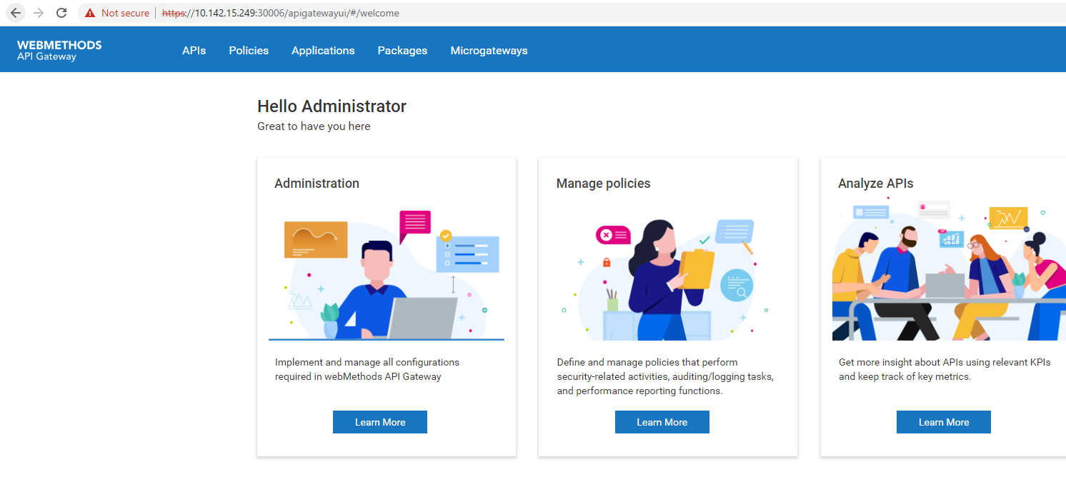

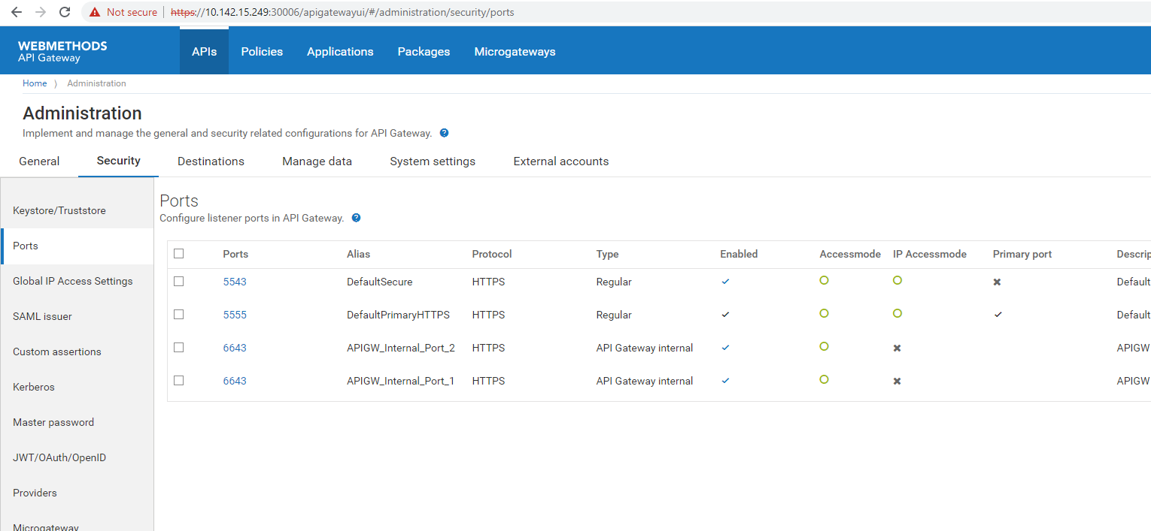
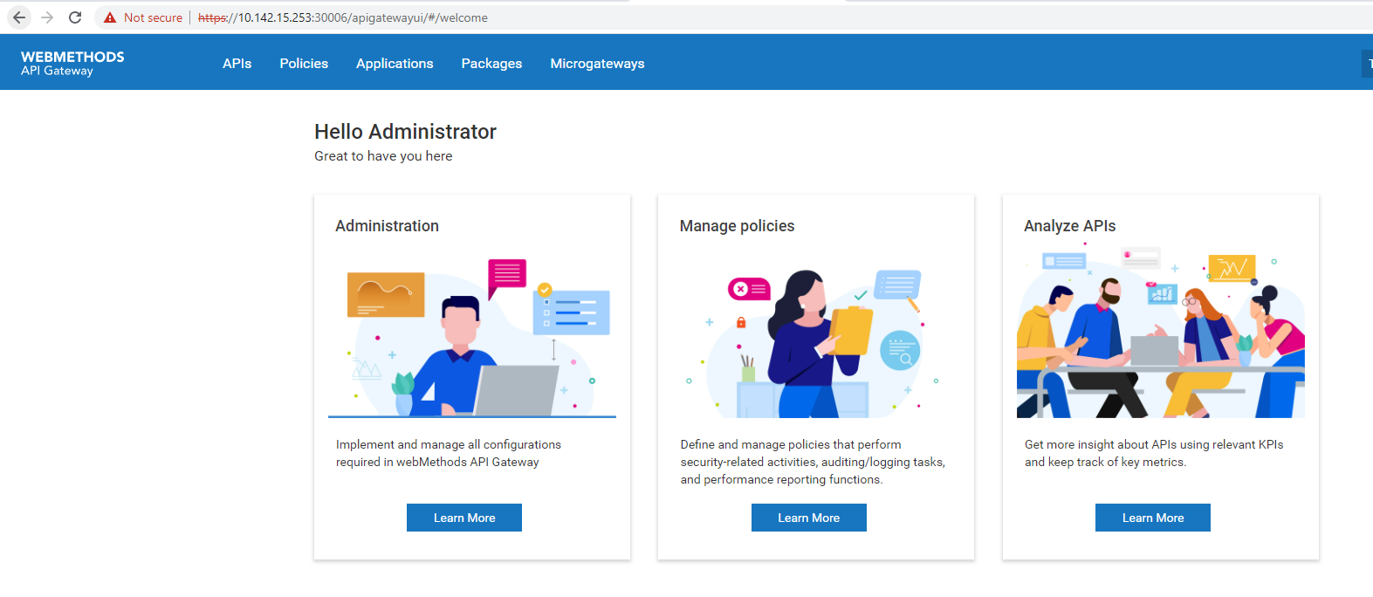

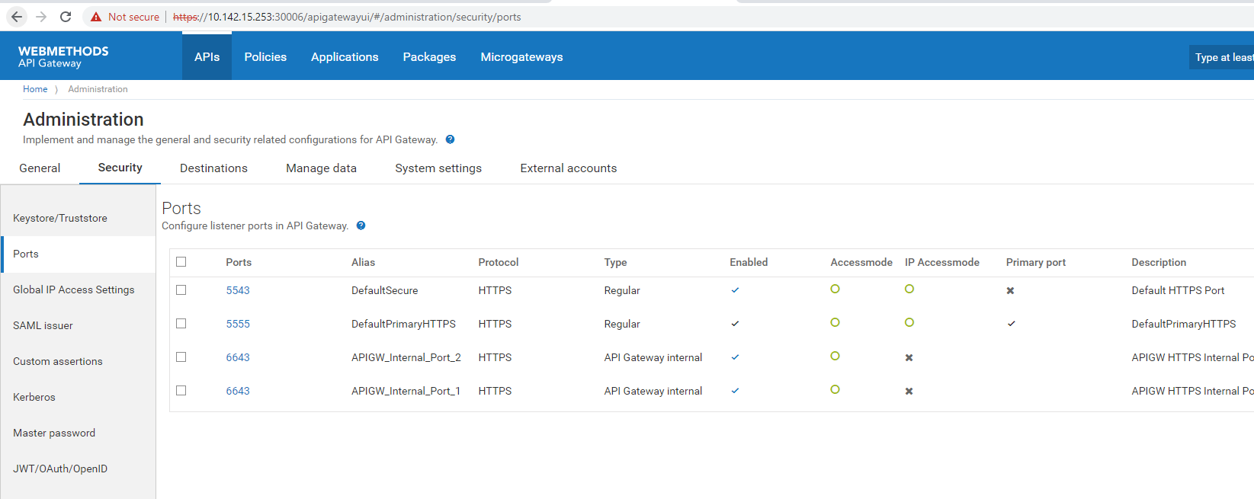

IS

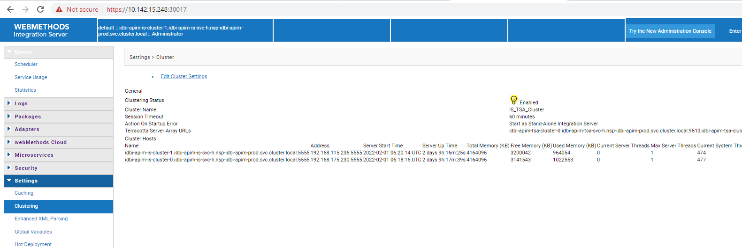
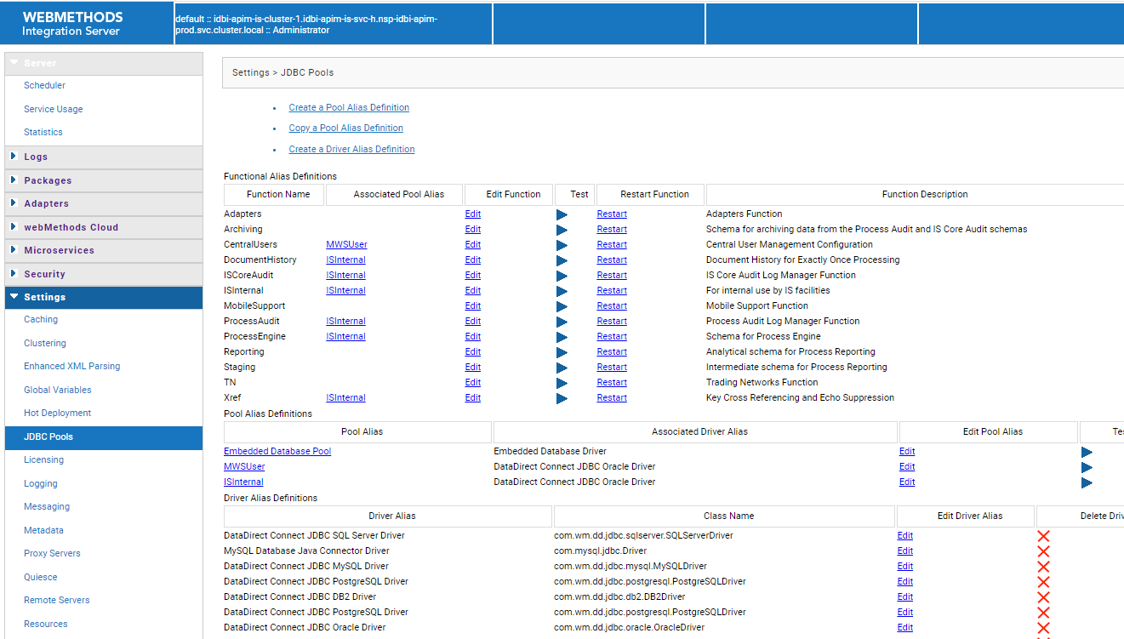
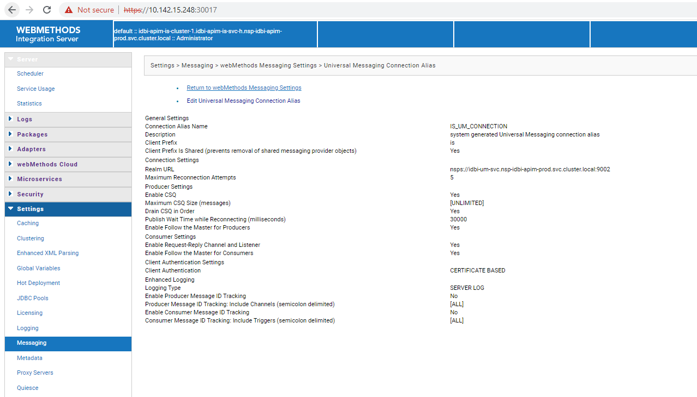

MSR

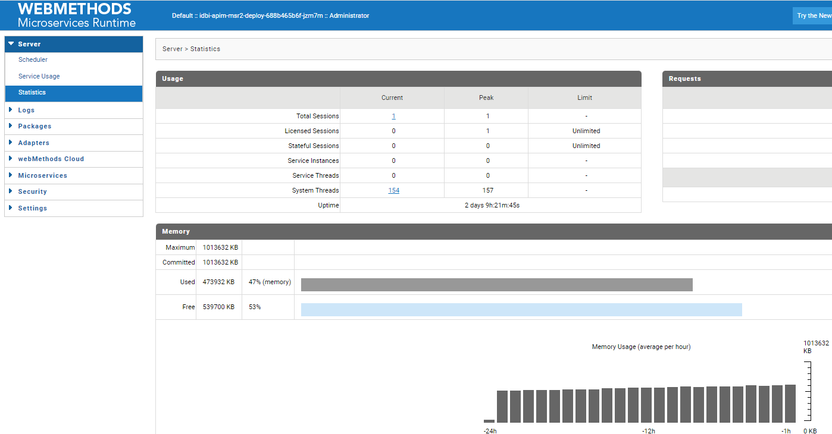

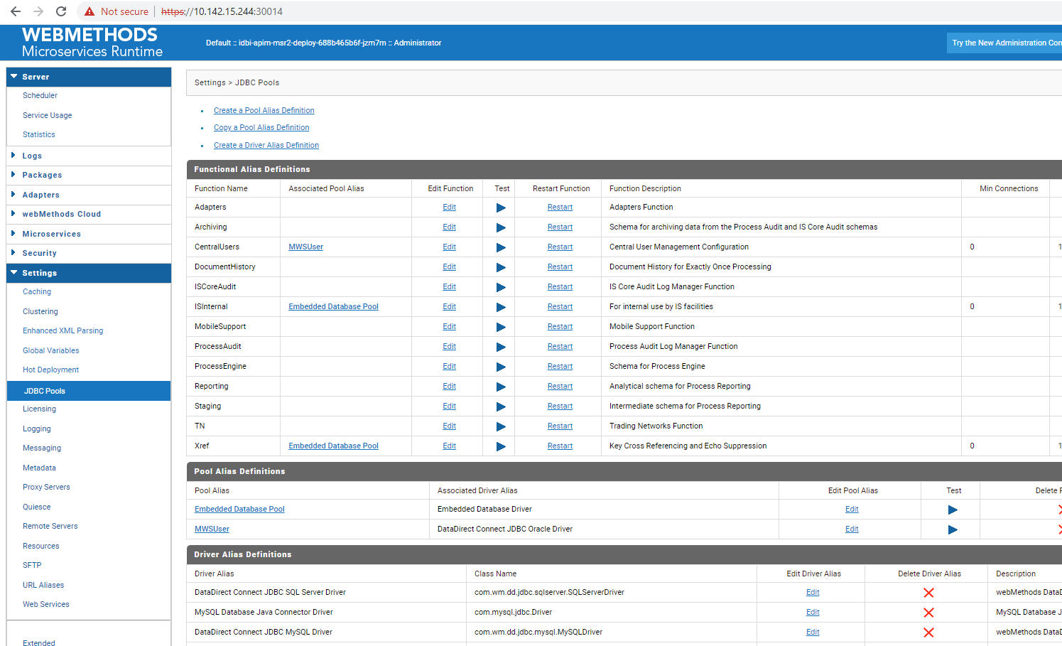
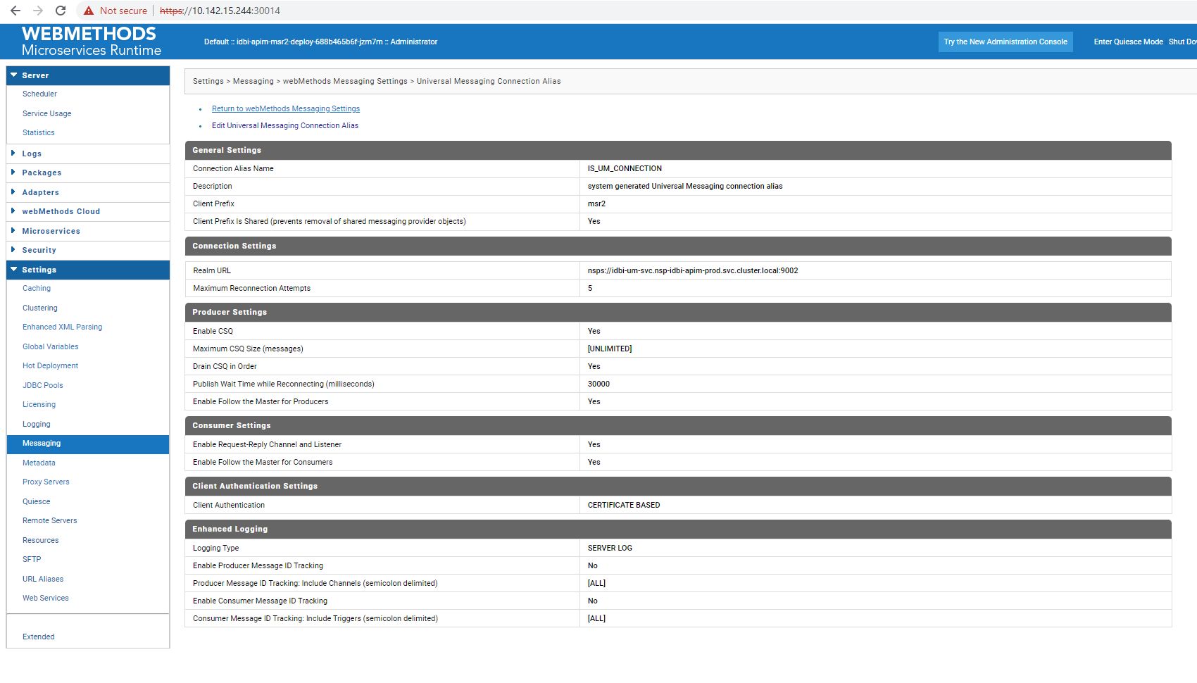

MWS

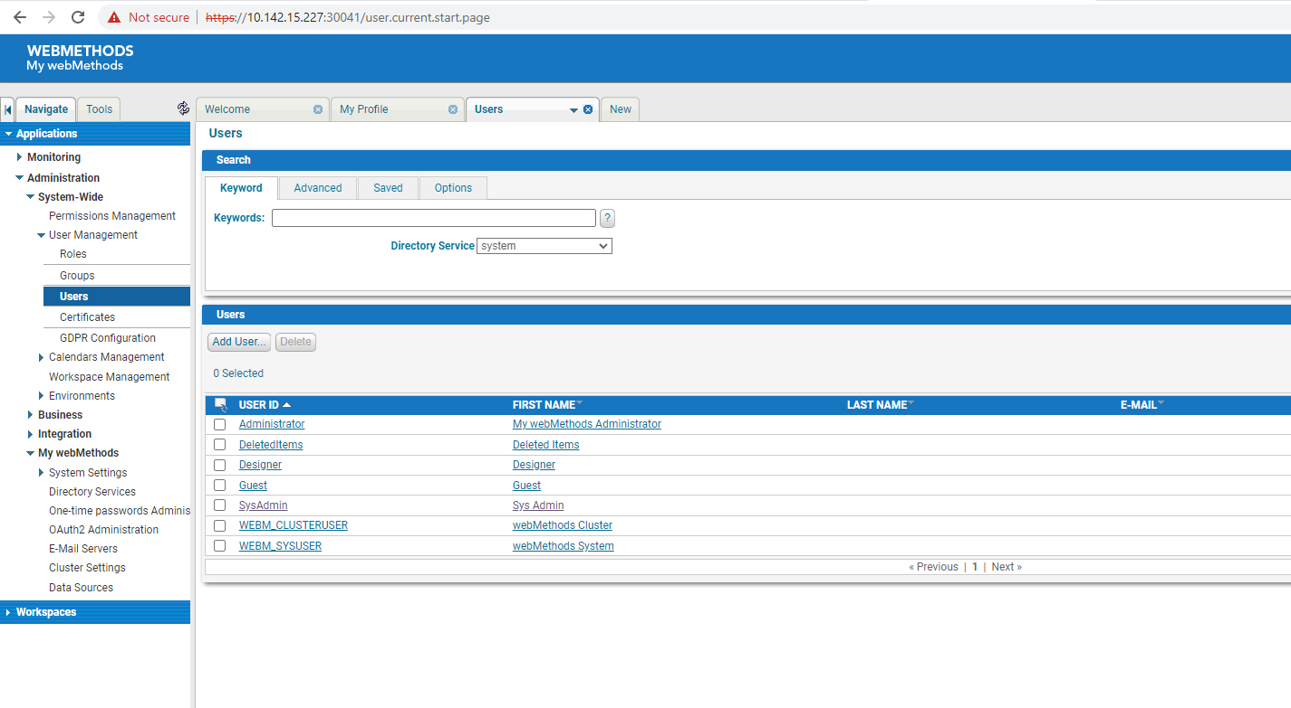

SandBox Prod
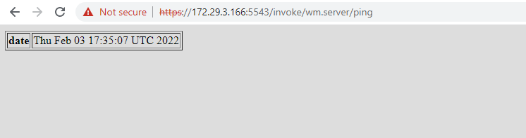

APIGW IS
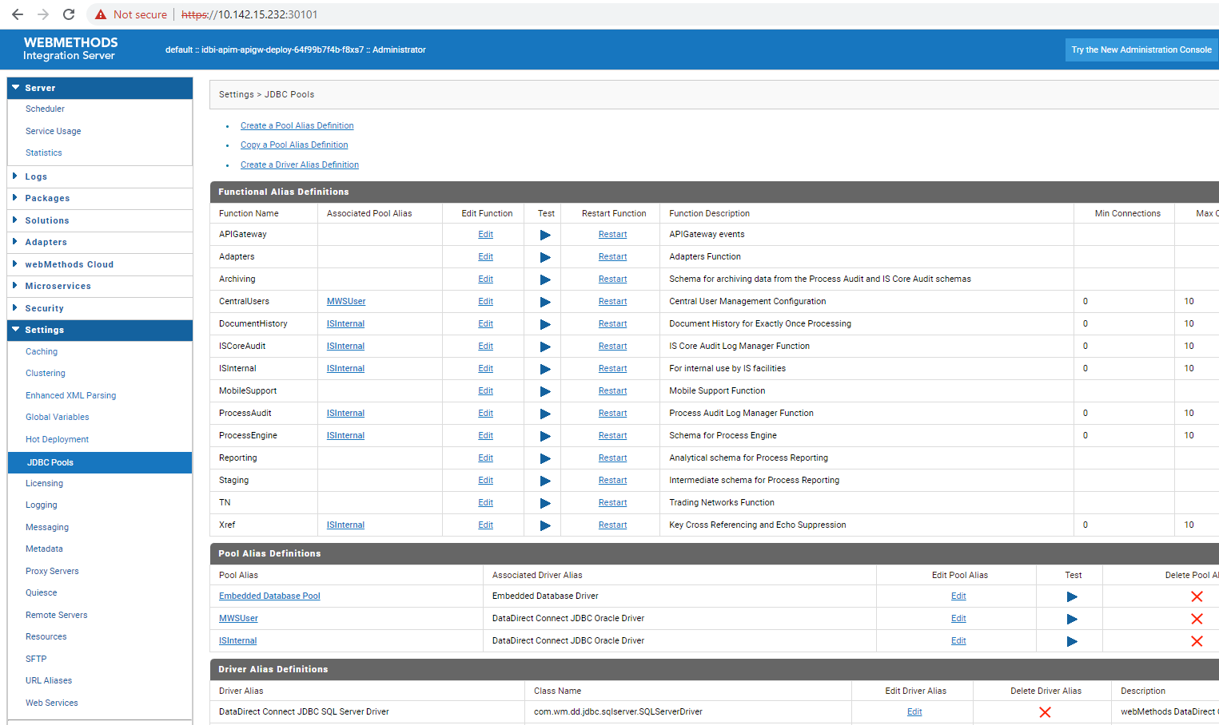

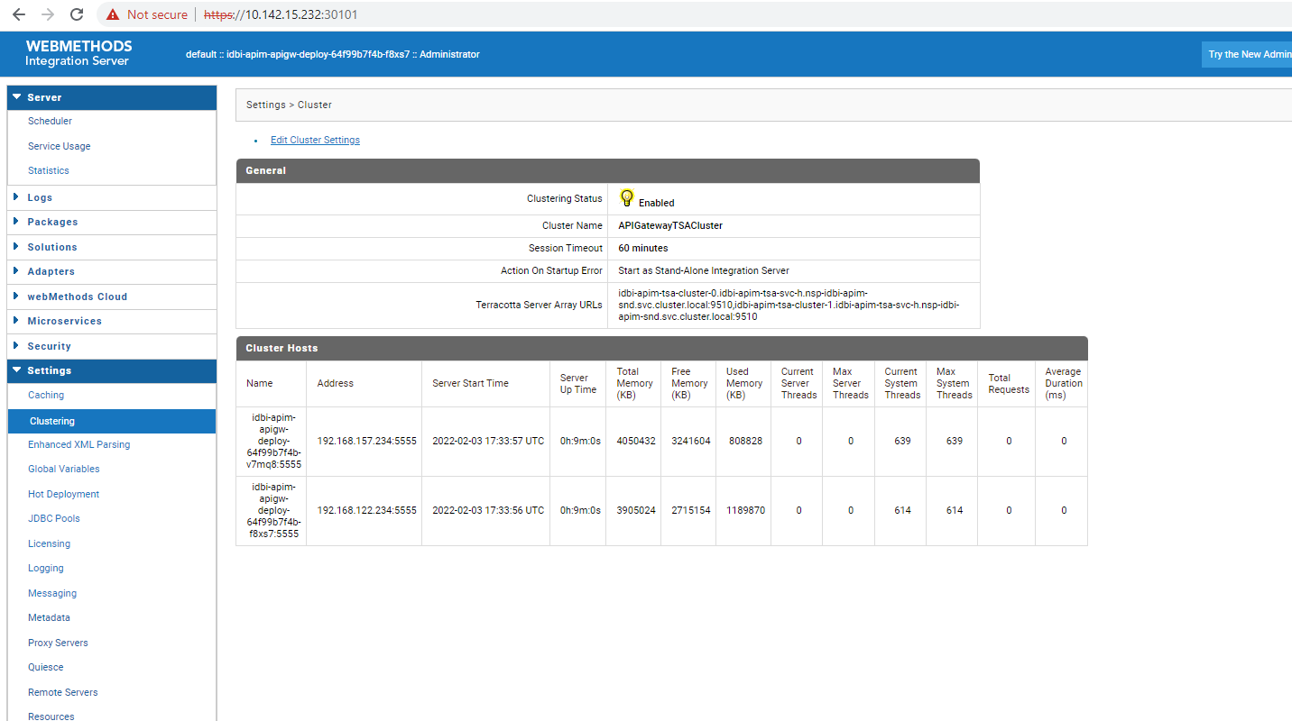

APIGW UI
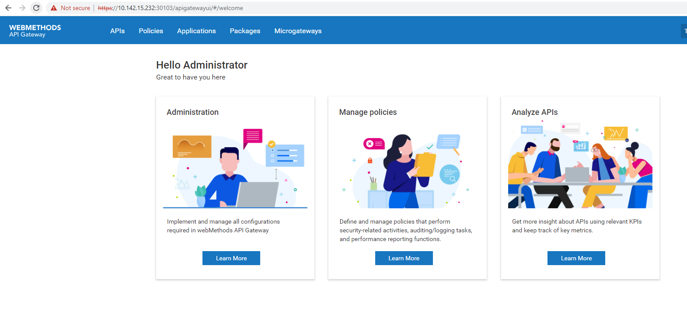

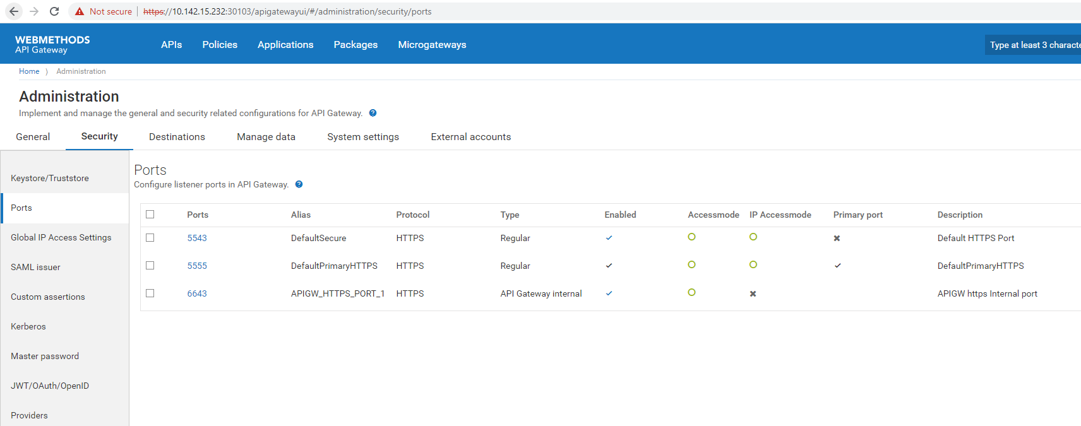

IS

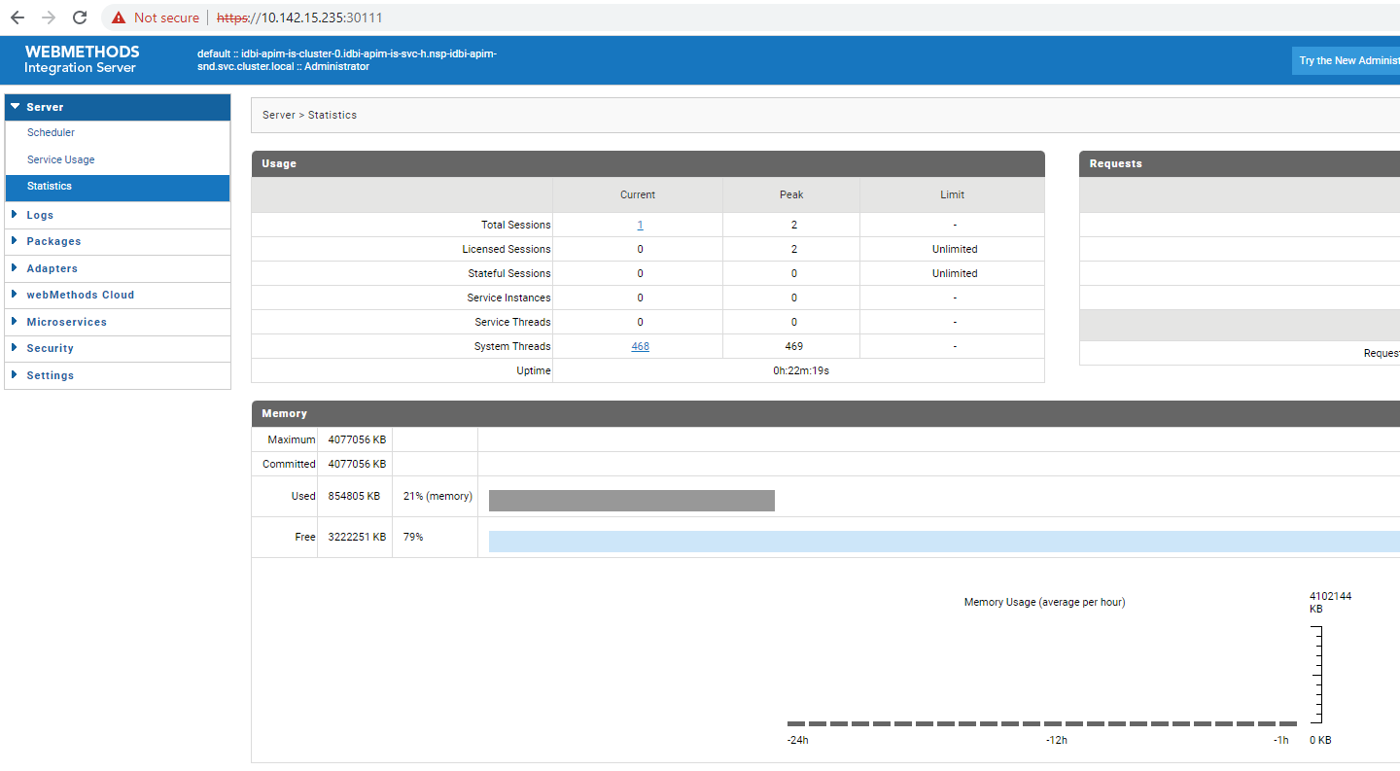

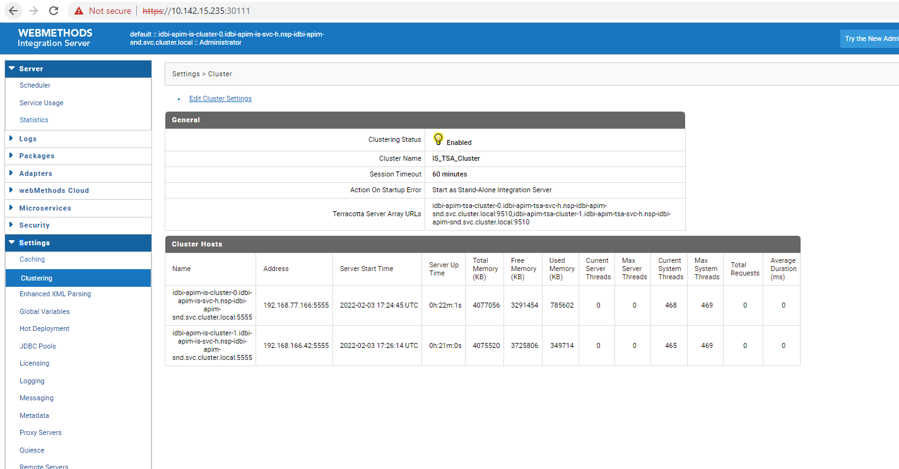
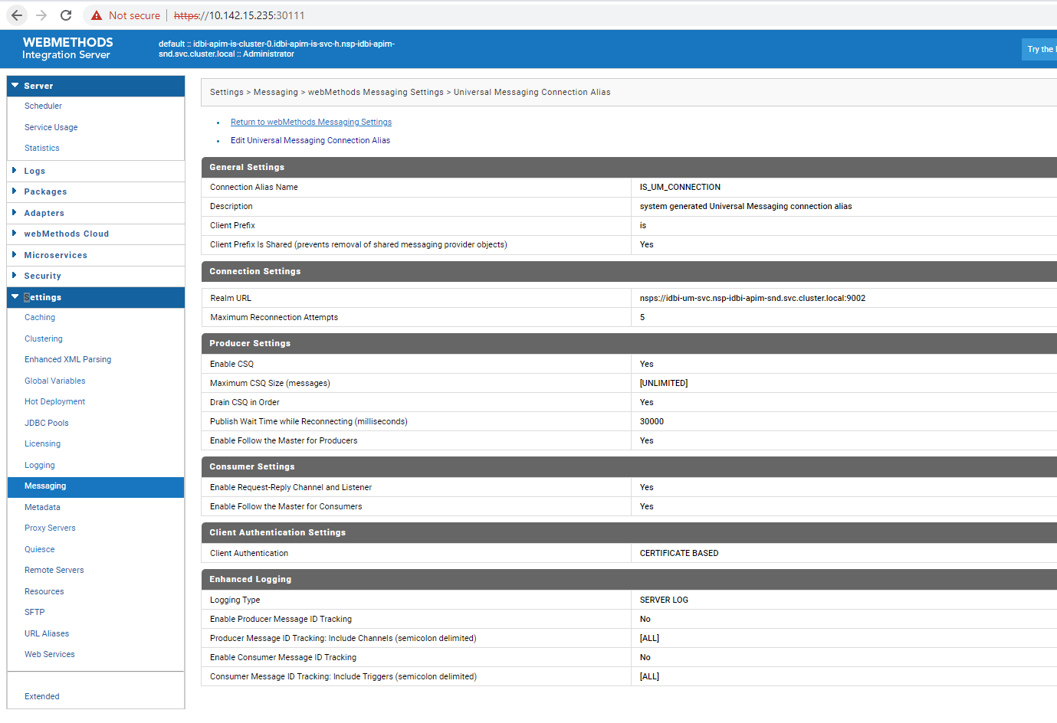

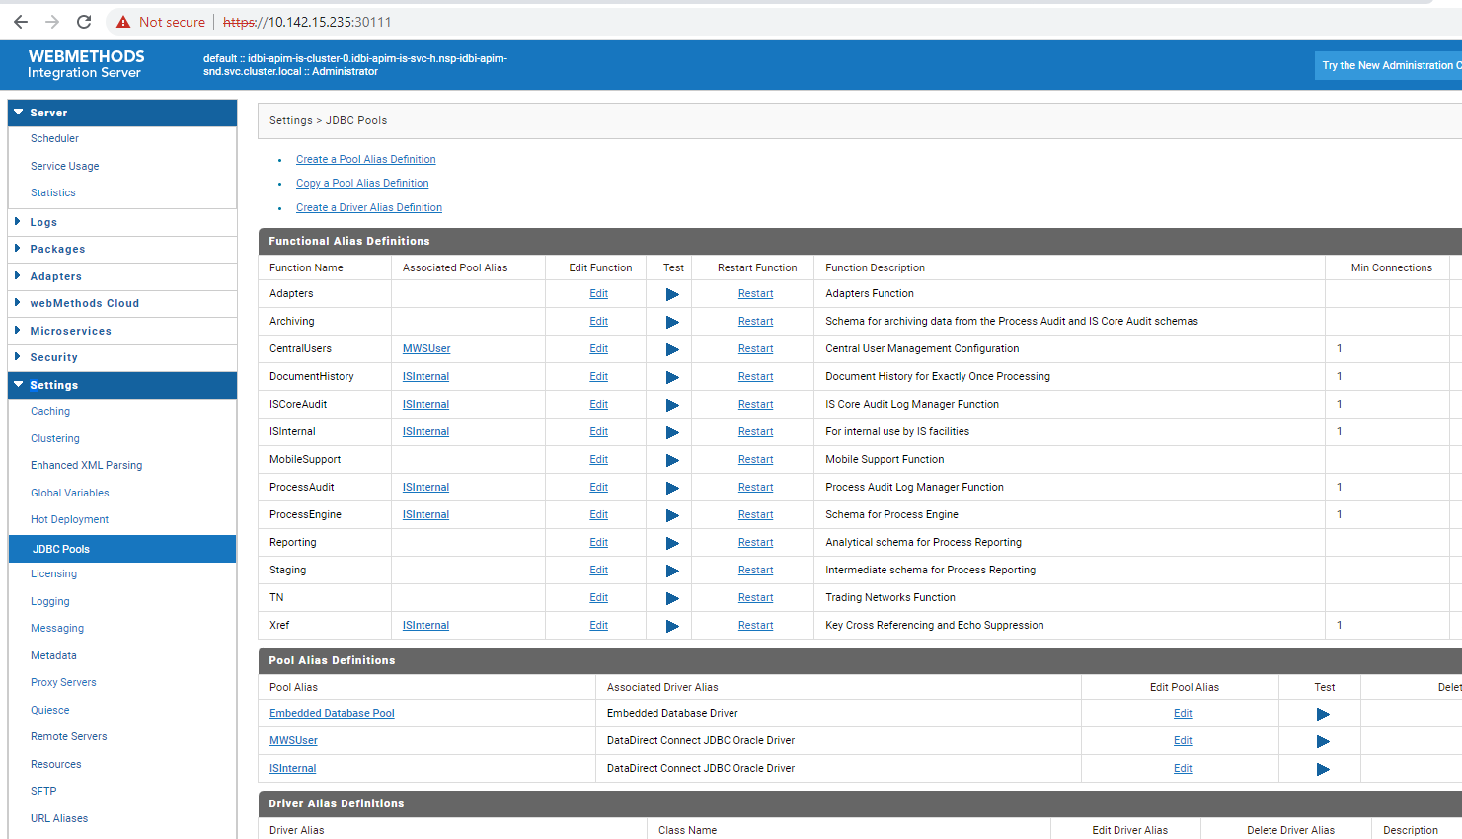

MSR

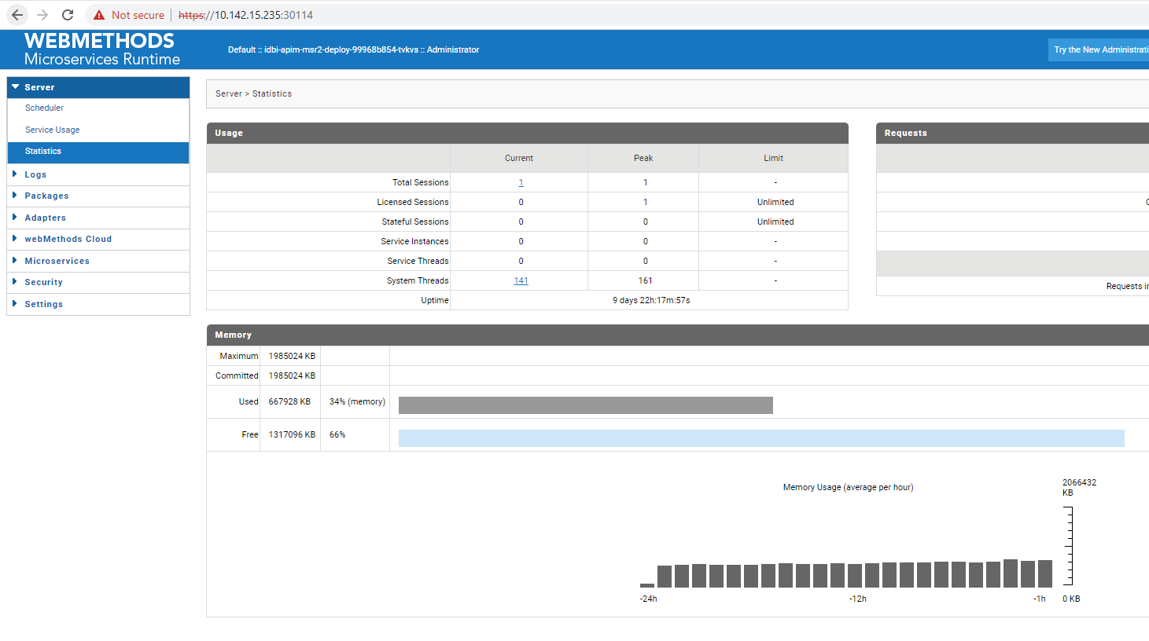
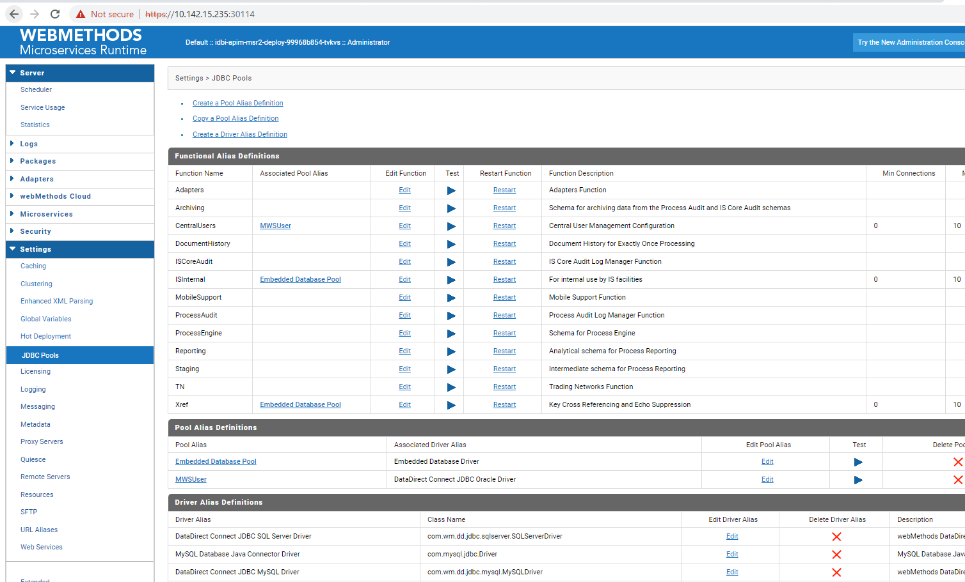
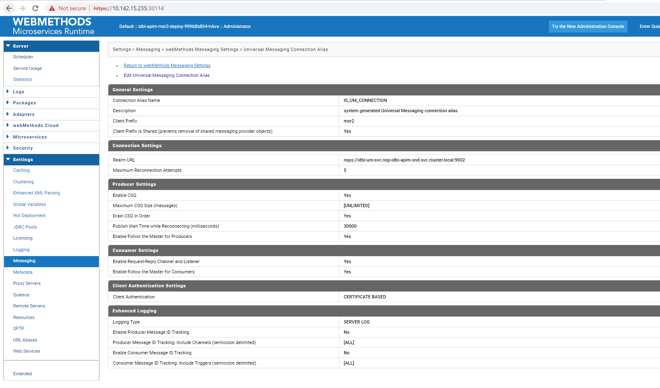

MWS
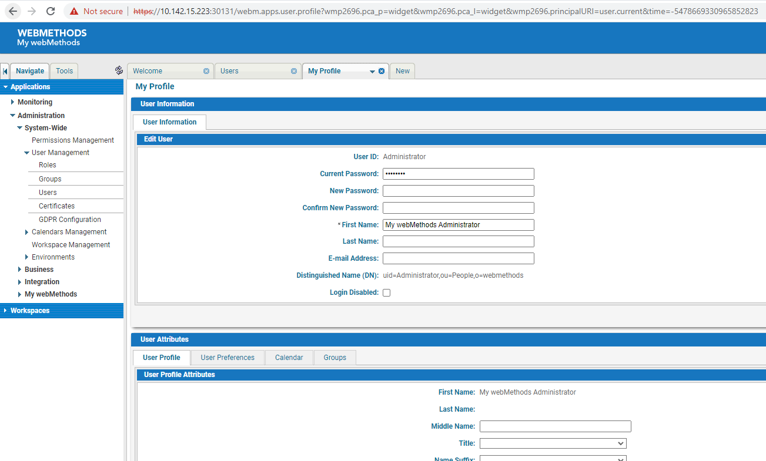

DR
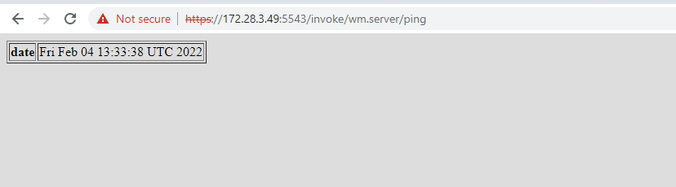

APIGW IS

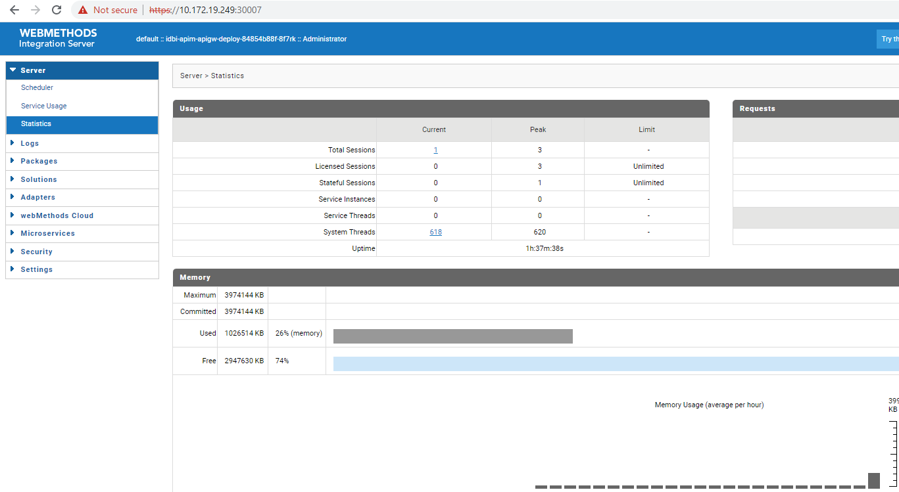
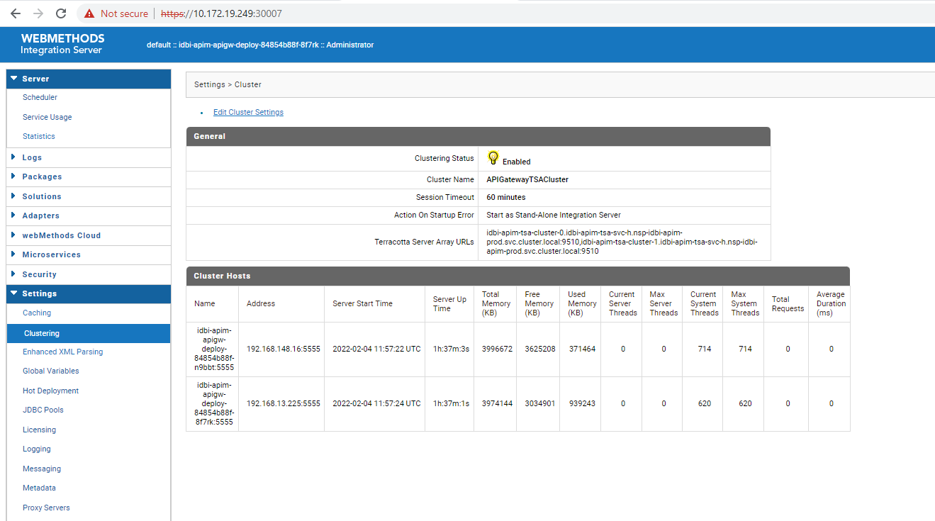

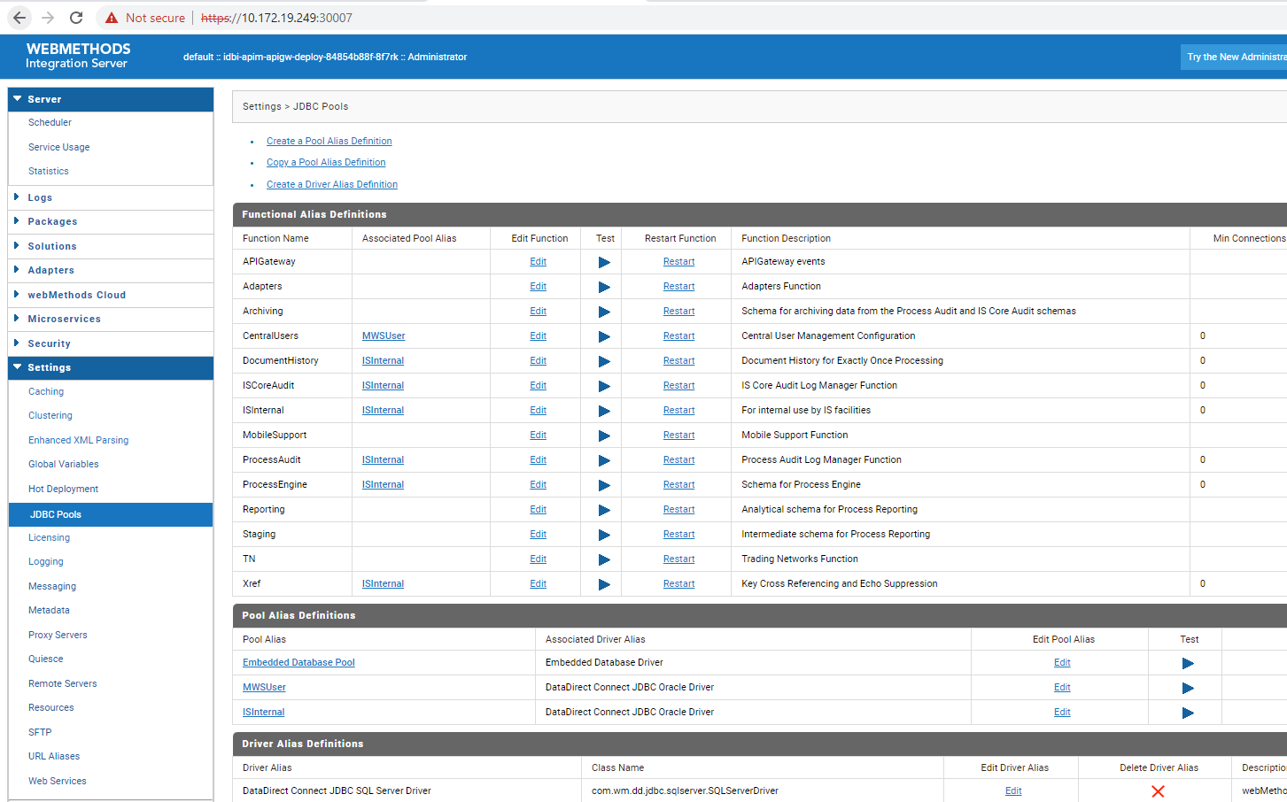
APIGW UI
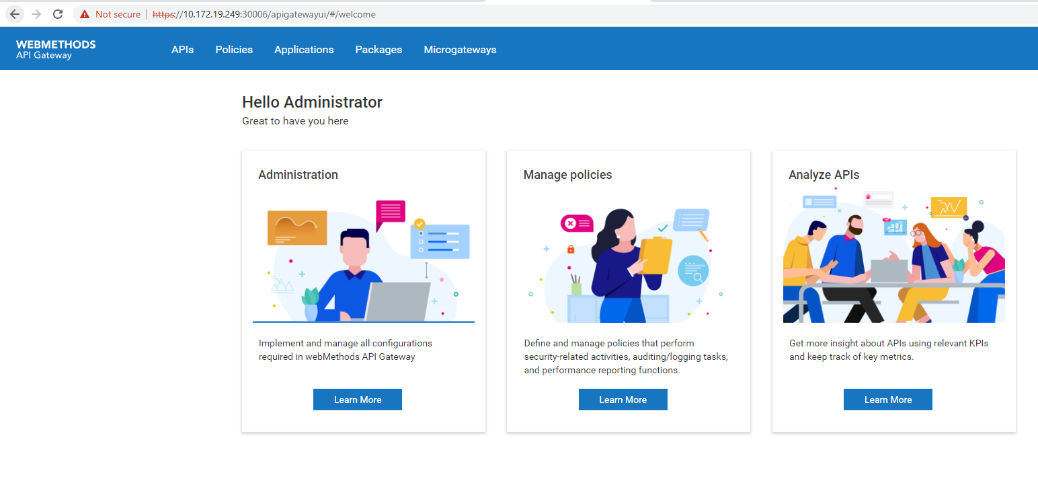
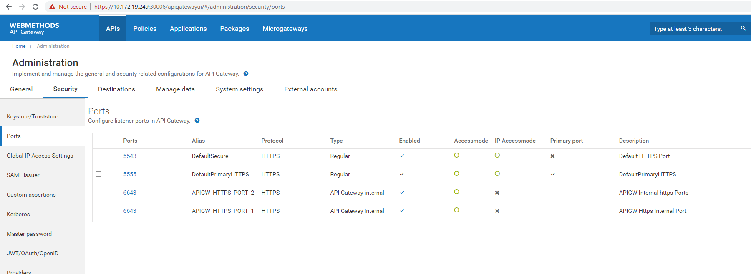

IS
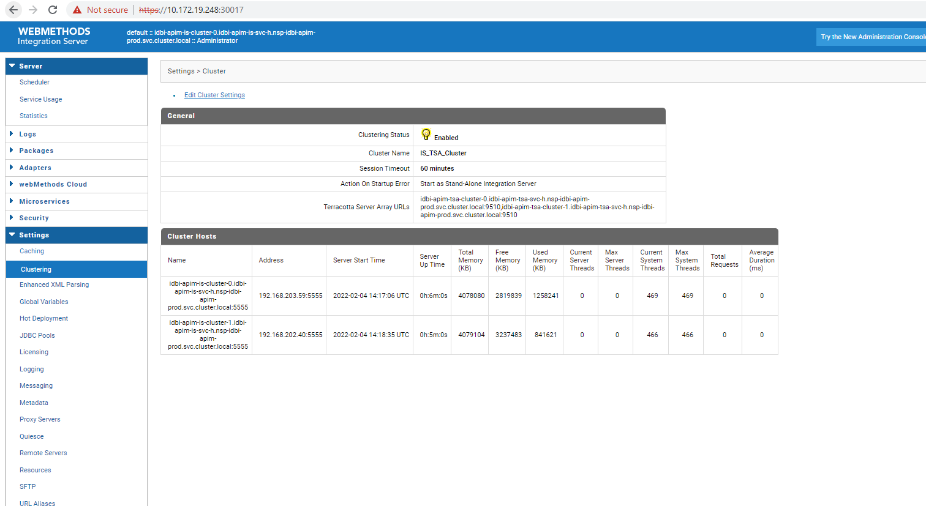
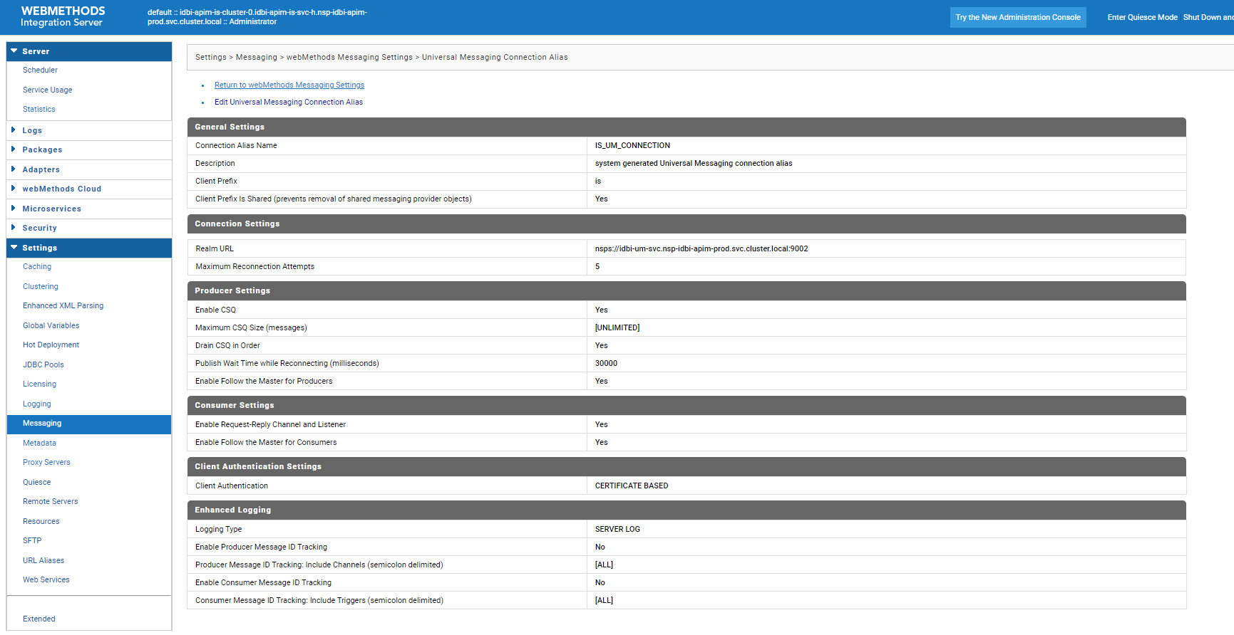
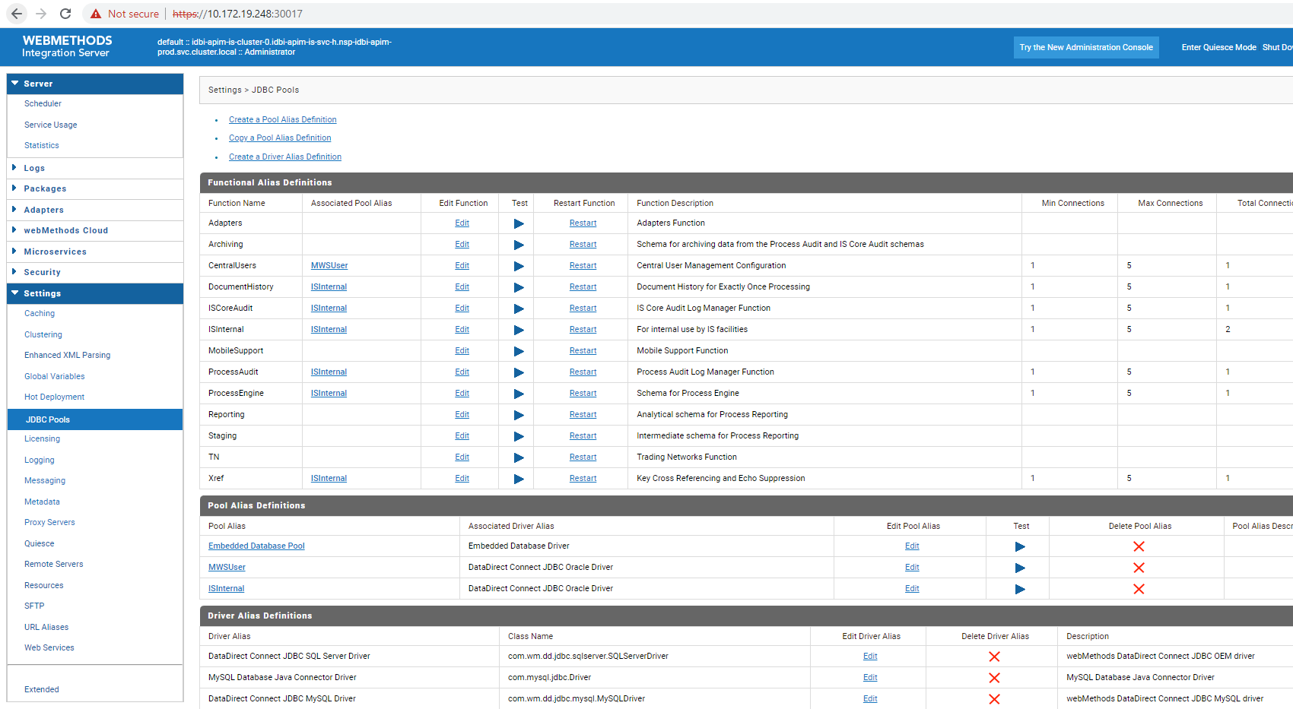

MSR
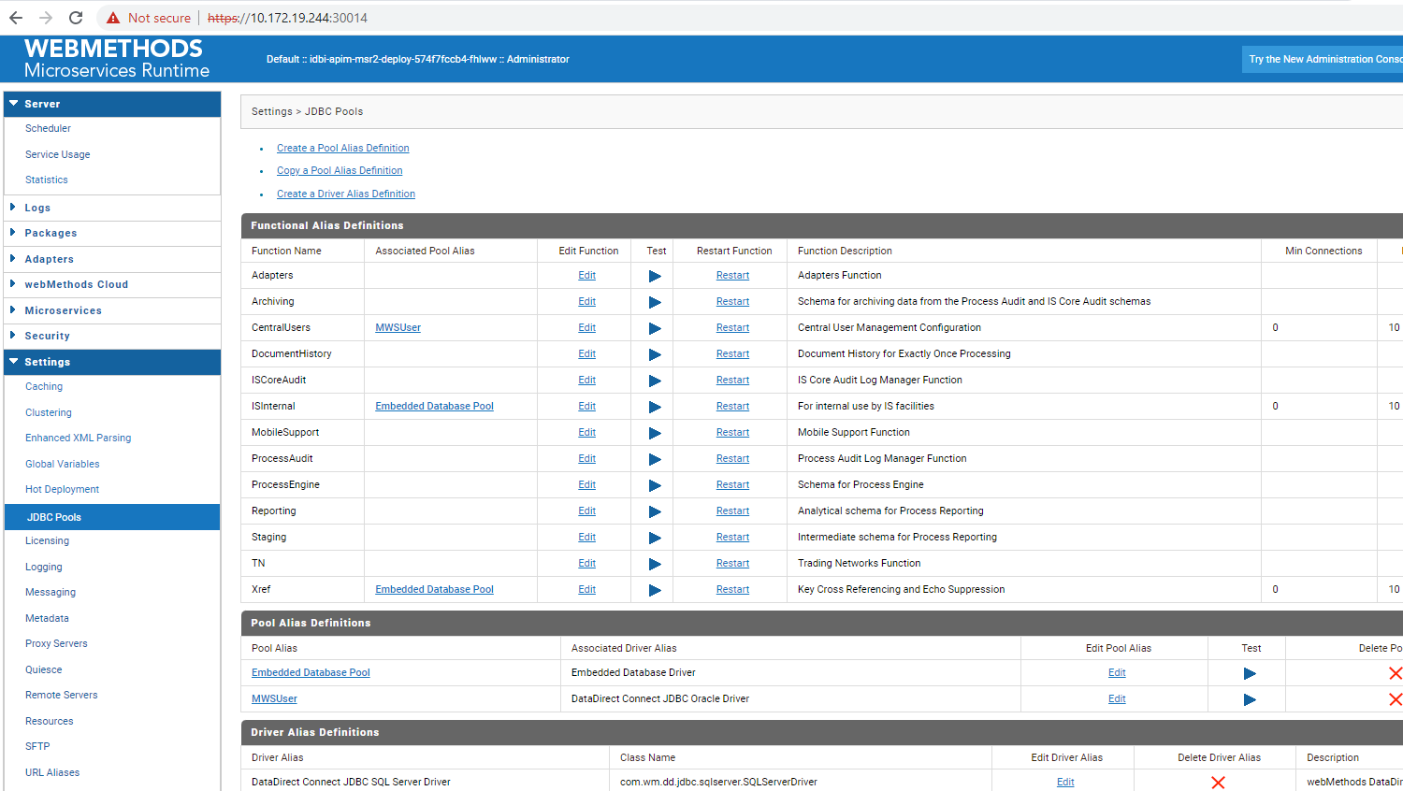
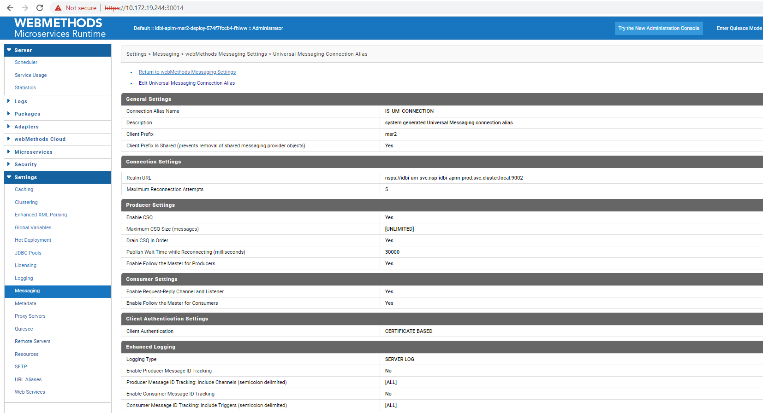

SandBox DR
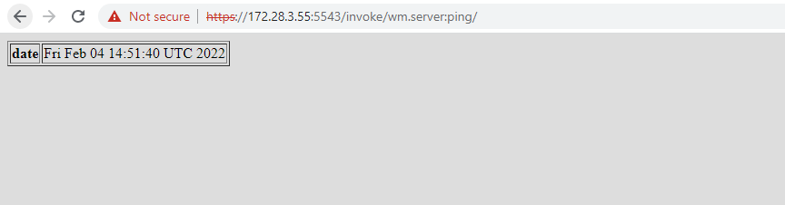

APIGW IS
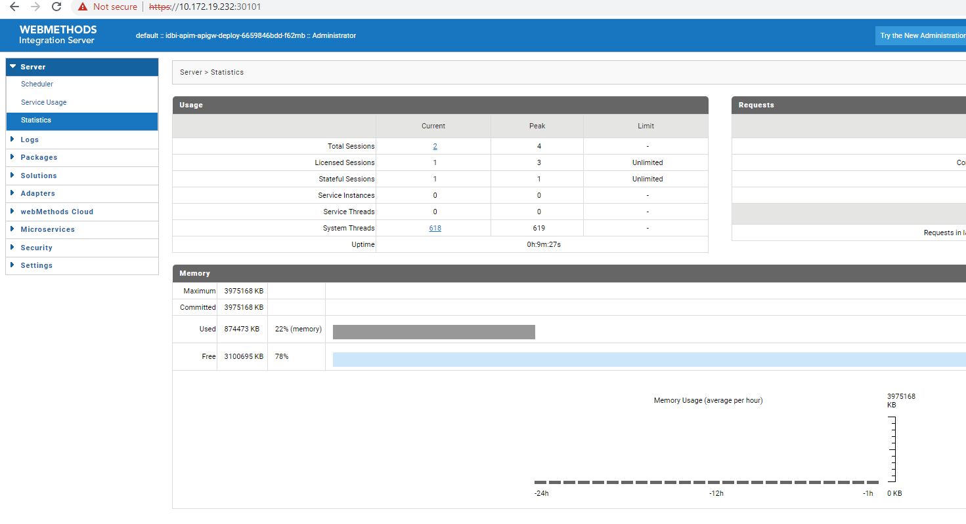
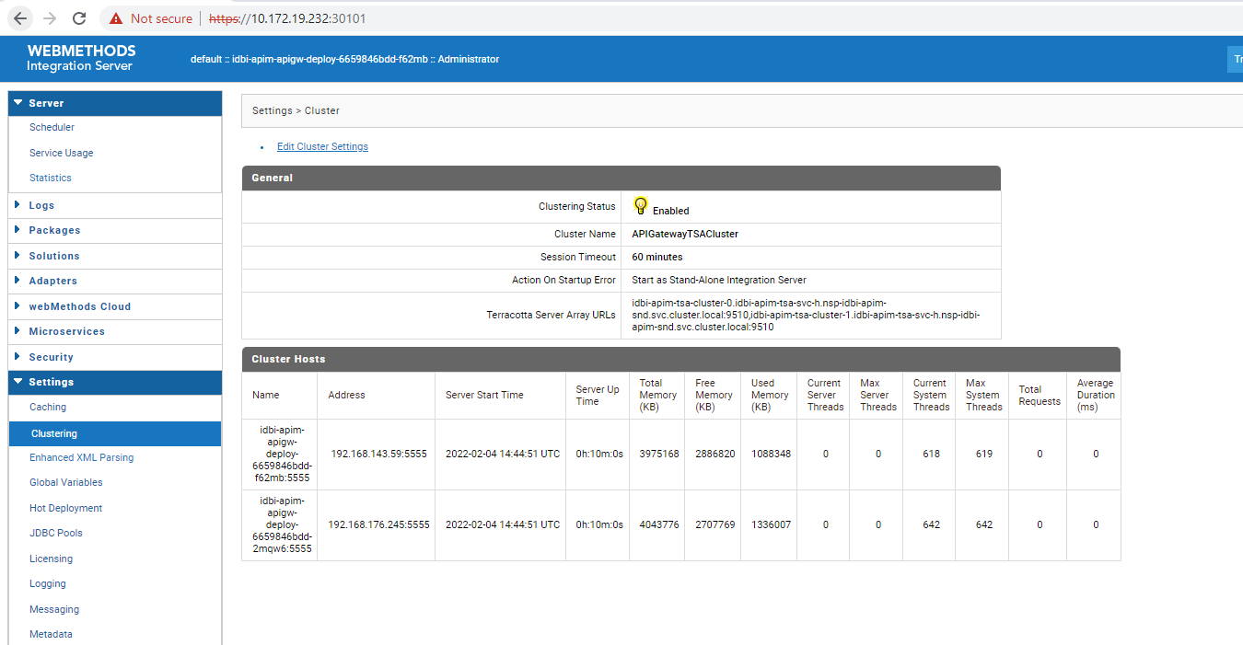
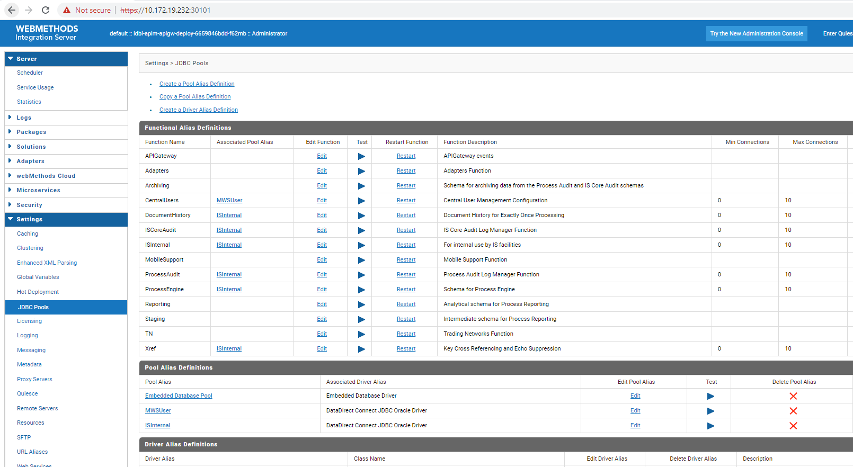

APIGW UI
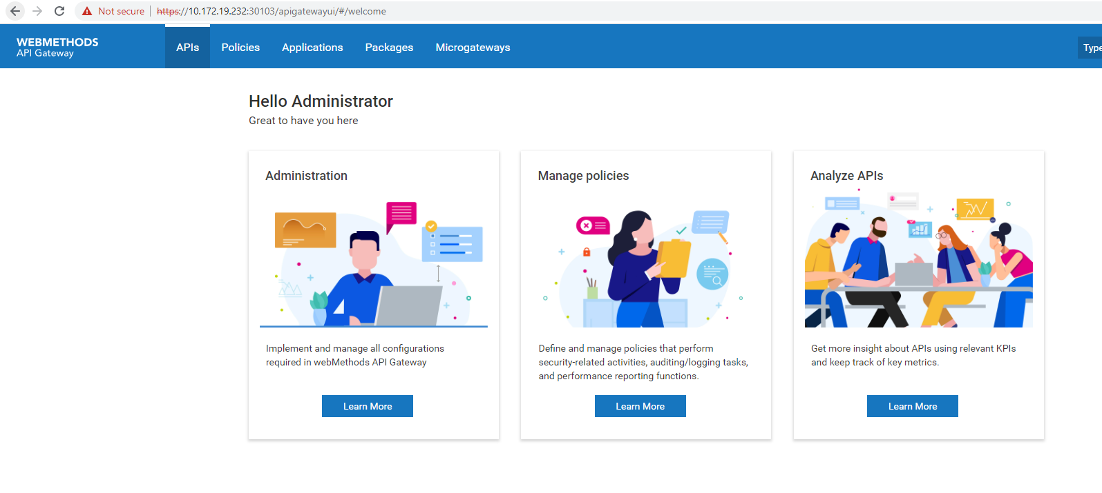
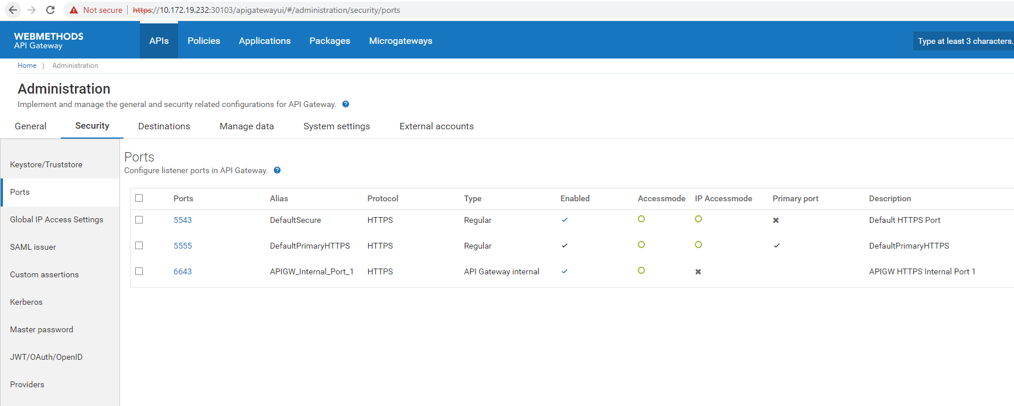

IS
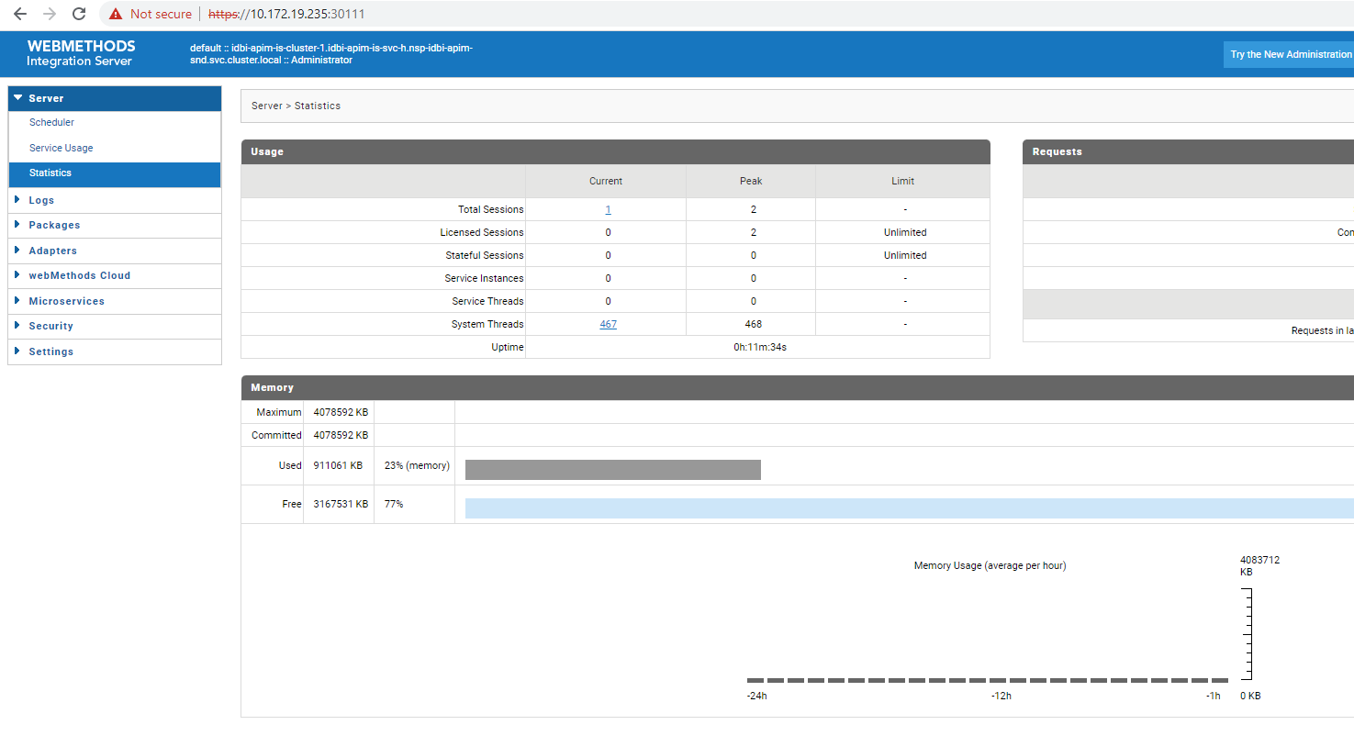

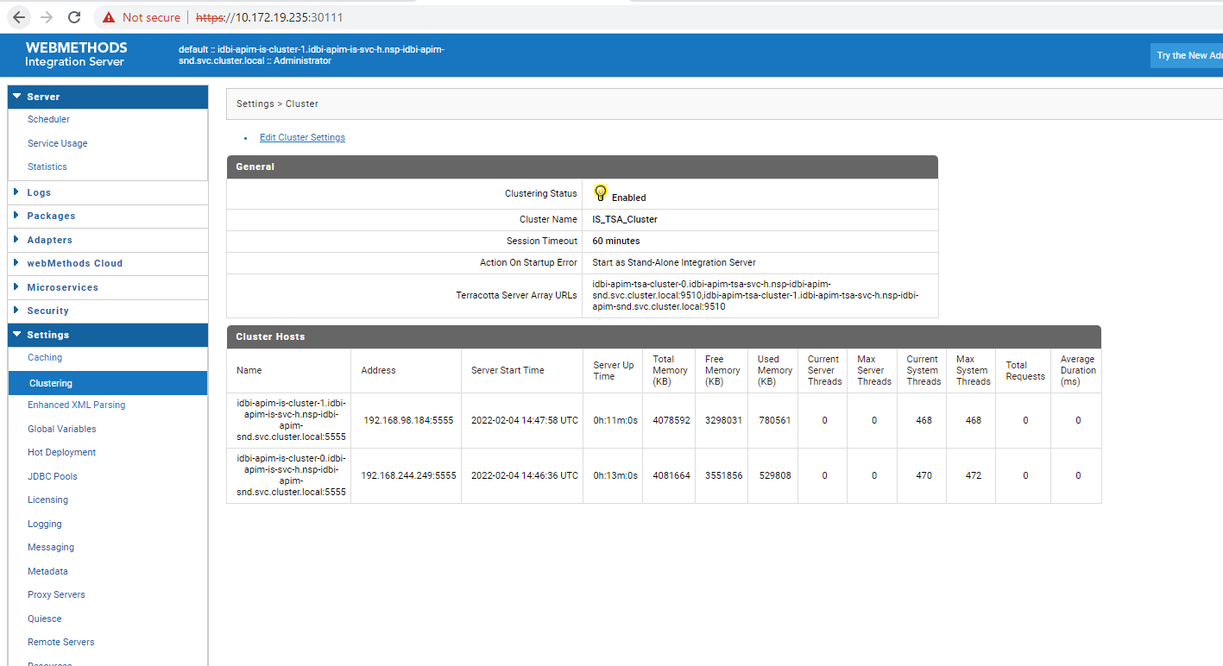

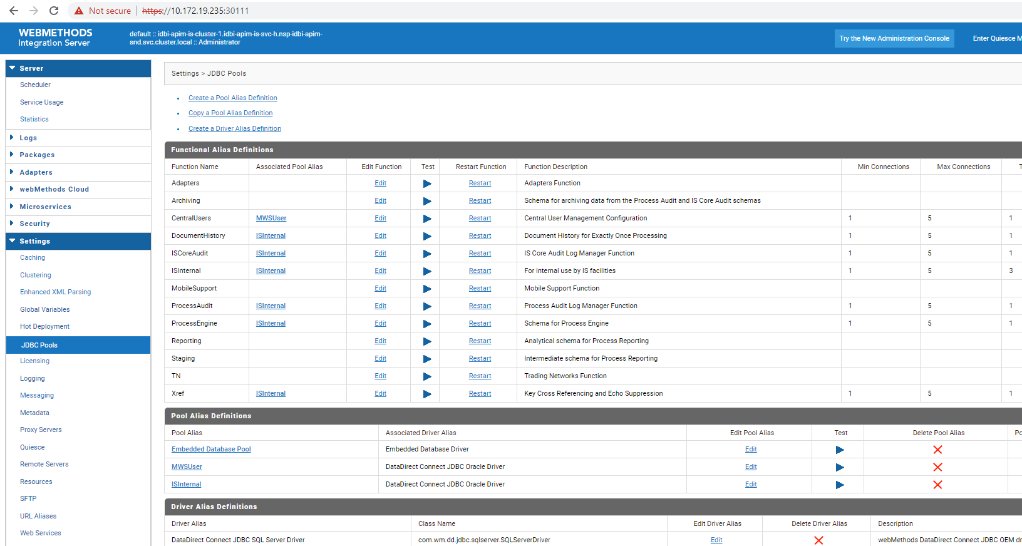
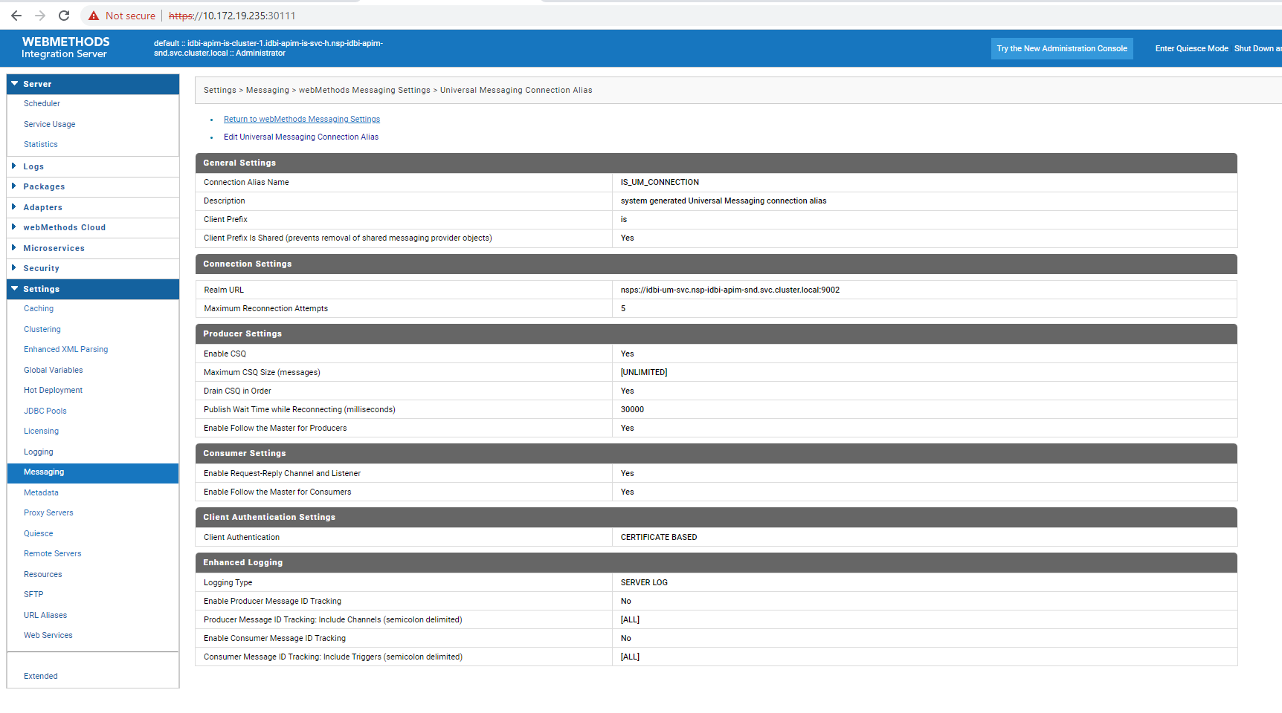

MSR
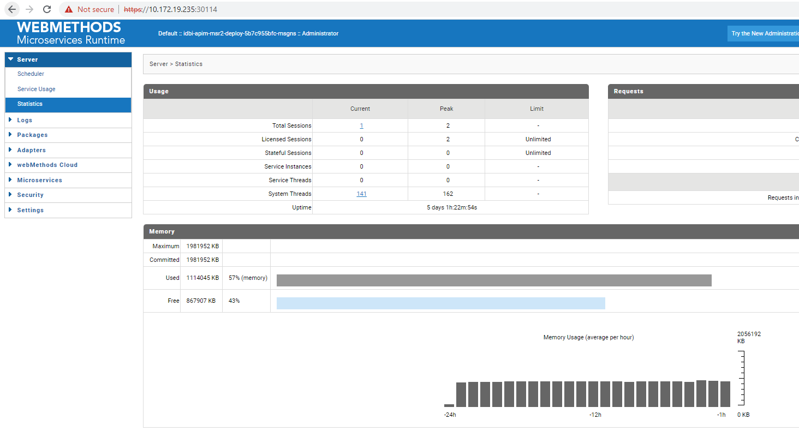
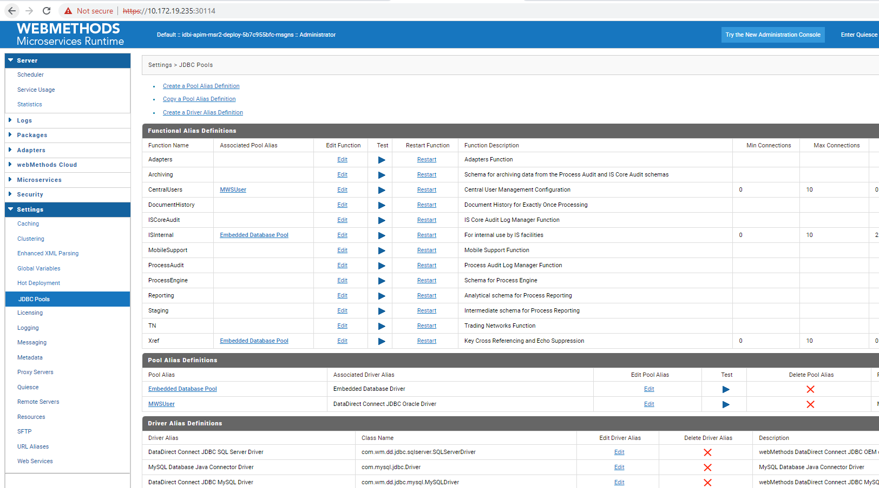

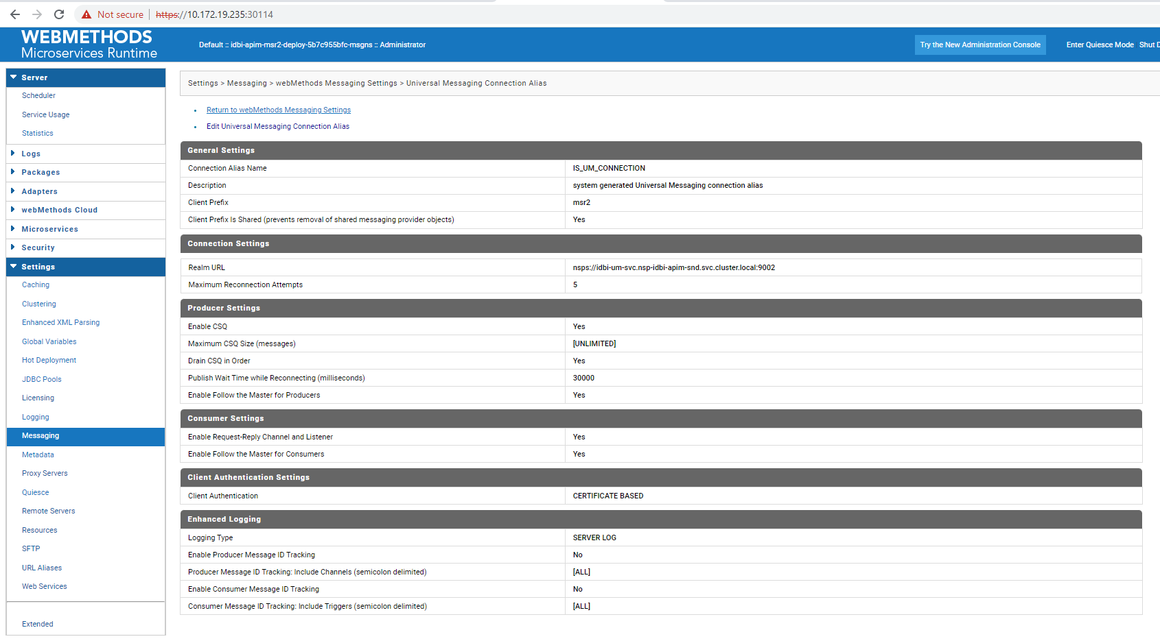

Operations and Maintenance

Fix Installation and DockerImage Recreation

The base image created might change in future, if any new fixes need to be applied. Once the fixes are applied you will have to re-create the Docker image for each the component to which the fix has been applied.

For applying the component level fixes do the following. Pre-requisite, ensure that the necessary fix image has been downloaded from empower and moved to the GIT repo server.

- Login to the baseVM or the Reference server.
- Switch to “sagadmin” user.
- Go to the root installation directory /data/softwareag
- Go to the component directory where fix has to be applied
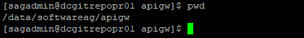
- Every sub directory has another directory called SAGUpdateManager

- Go to bin
- Run the script ./UpdateManagerCMD.sh
- Follow the instruction
- Select Manage Fixes and continue
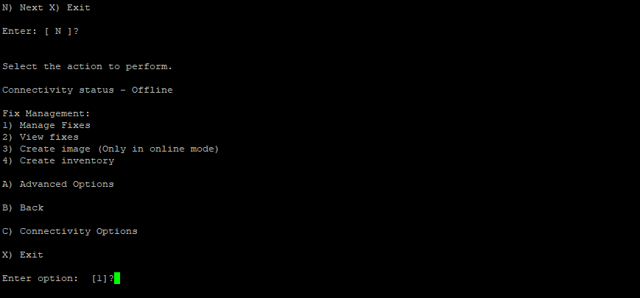
- Then select “Install fixes from image”

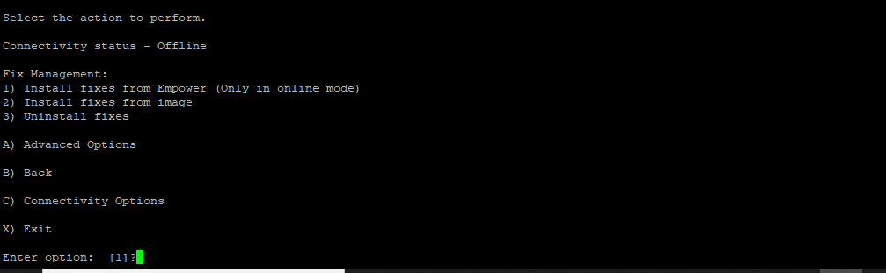
- Give the full path of the fixes image that you have downloaded from empower
- Follow the instruction in the menu and it will install the fixes.

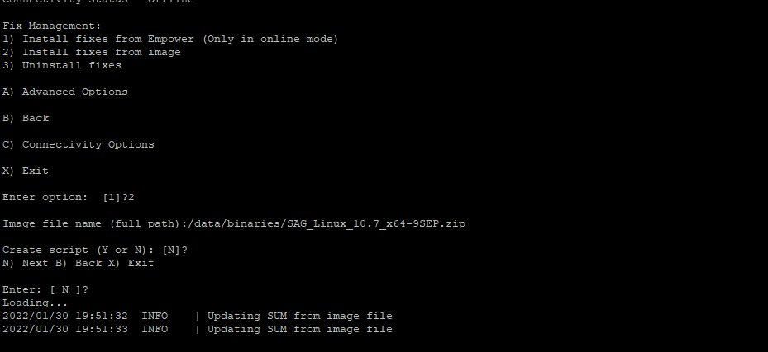
- It will then display the list of fixes to be installed

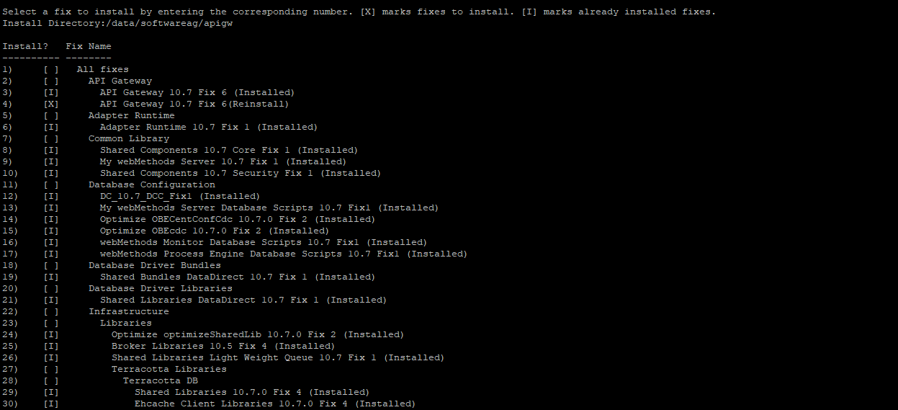
- Select the fixes that you want to install

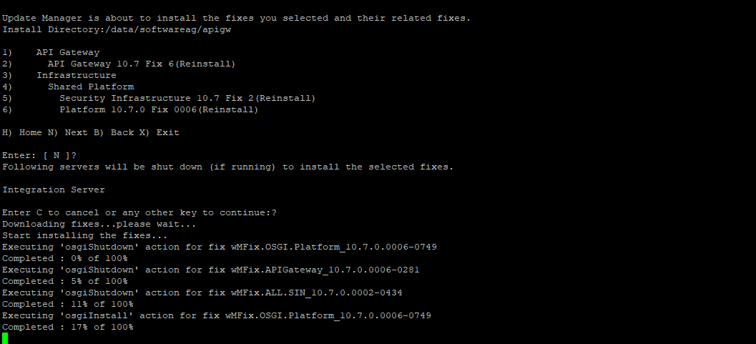

- It completes the fix installation

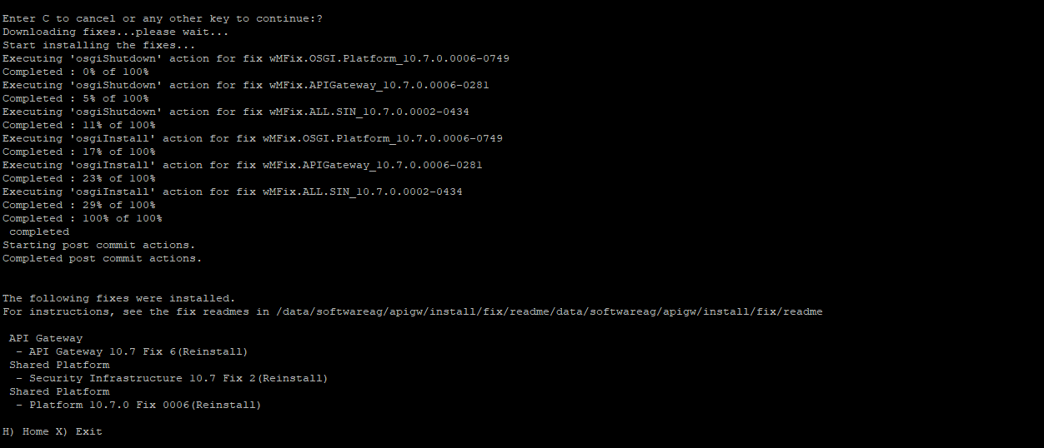
- Now repeat the step for other components
- Once the fixes are applied. Follow the section “Webmethods Docker Image Creation” to re-create the image.

Note: for some of the products we are first creating the Dockerfile and then generating the image. However, now you can directly create the image and don't have to re-create the Dockerfile.

Archiving Log and Database

As mentioned earlier, to maintain the historical log, we have persisted the APIGW, IS, MSR and MWS application logs to the local hostPath and hence, it is advisable to create a housekeeping cronjob and enable a script for archiving these logs. Below are the directory structure for the log location. Note these logs are created only to the worker node where the Pod is scheduled to be deployed specifically. Meaning the logs for APIGW can be found only in the APIGW dedicated worker node.

Below are the directory structure for each of the component where the Log archiving needs to be implemented.

APIGW

/data/apigw/is-logs
/data/apigw/is-profile-logs

IS

/data/is/is-logs
/data/is/is-profile-logs

MSR

/data/msr2/is-logs

MWS

/data/mws/logs

The MWS provides the feature for enabling the DB archive. To enable the DB archive you need to follow the below.
- Login to the MWS
- Go to Administration > Business > Data Management > Archive Audit Data

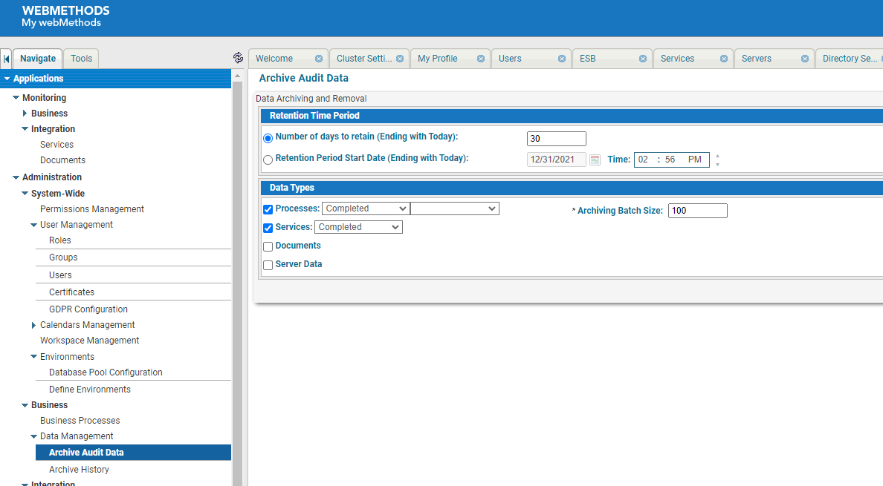

- You can select to archive both Process and Service or either of them.
- Select the days to retain or schedule it based on retenction period start date
- Click on Archive and Delete or Delete Only option

API Portal

The below log directories for API Portal need to be archived

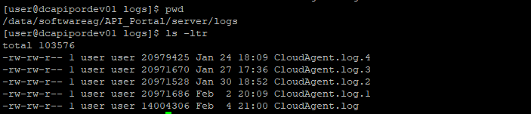
/data/softwareag/API_Portal/server/bin/work/work_loadbalancer_m/httpd/logs

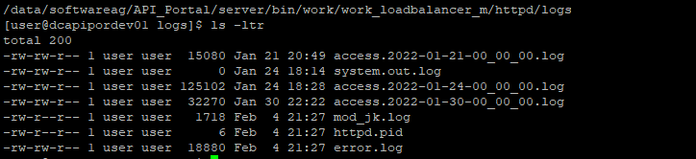

UM

The data directory and the UM log is mounted on the Persistent volume using the NFS mount.

For UM the logs need to be archived from the below location for each of the environment

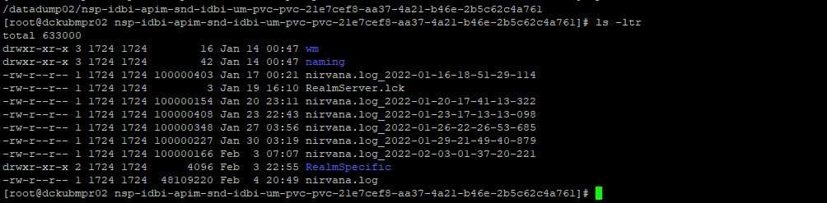
TSA

Whichever is the clustered environment (UAT, PROD, DR, SB-PROD and SB-DR) the data directory is mounted on the Persistent volume using the NFS mount and in case of 2 node TSA setup, two PV is created. Hence the data needs to be archived from the below location for different environment.

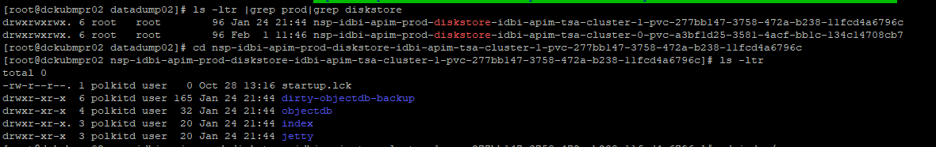

Certificate Renewal:

The certificates used here for setup are self-signed certificate. These certificates have expiry and should be renewed before expiry. The certificate creation would follow the similar approach based on the document “CertificateCreation.txt”

DEV:
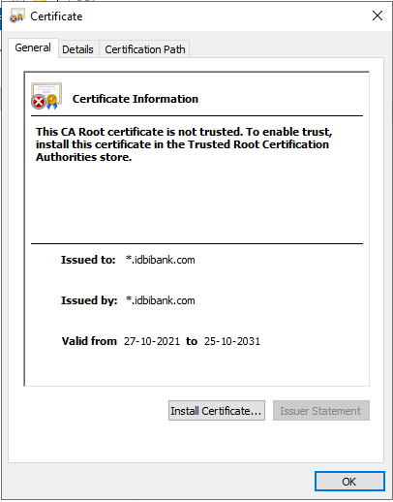
Prod & DR
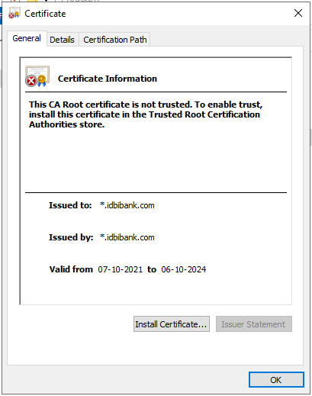
SIT:
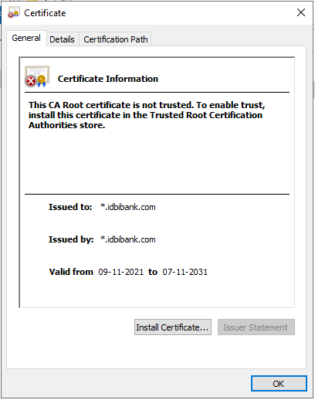
Sandbox Prod & DR:
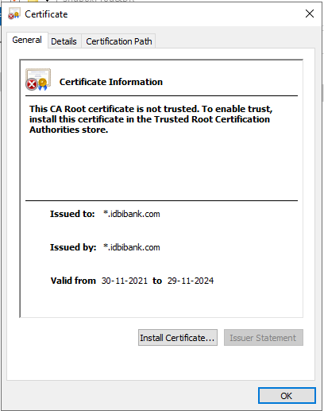
Training
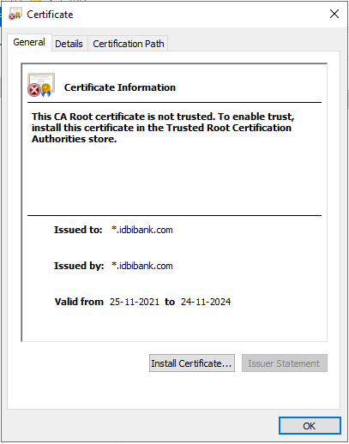
UAT
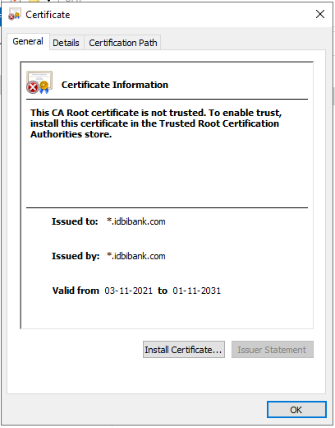
Once the certificates are generated. You will have to create the Keystore and Truststore and re-import the new certificate as configMap as per the command shared earlier.

kubectl -n nsp-idbi-apim-snd create cm idbi-apim-default-truststore-config –from-file=/data/K8S_Scripts/SB-DR/certs/truststore.jks

kubectl -n nsp-idbi-apim-snd create cm idbi-apim-default-keystore-config --from-file=/data/K8S_Scripts/SB-DR/certs/keystore.jks

